Welcome & Announcements, Friendship Information, & Sharing Christ’s Peace
Prelude: “The Prayer” Sager / Foster
Let us prepare our hearts and minds for worship.

Call to Worship - (by David Beswick on RE-Worship blog)
Leader: Lord, as we search now, let us find you.
People: As we knock, open the door to us.
Leader: Let us know you, that we may praise you;
People: Let us love you, that we may serve you.

*Opening Hymn: “Joyful Joyful We Adore Thee” Blue Hymnal, #464

*Prayer of Confession (Unison)
God of all time and of each moment. We are an impatient people. We want results. We seek solutions. And sometimes we are dissatisfied when your answers don’t seem to come in our time or in the way we want them to come. Forgive us. Open our eyes to your blessing, even in the storm and the rain, even in the darkness and fear, even in the loss and pain. Help us to hold on to you. Help us to believe. We pray through Jesus Christ, your Son, our Lord. Amen.

*Silent Reflection

*Assurance of Pardon

*Gloria Patri (Glory Be to the Father…) Blue Hymnal, #579

Scripture “I Samuel 1:10-20” (page 419)
“Luke 11:1-13” (page 1613)
“James 5:13-18” (page 1885)
Leader: The word of the Lord.
People: Thanks be to God.

Children's Time
Please join in singing one verse of Jesus Loves Me as the children come forward.

Special Music: "Someone is Praying for You"

Sermon: “Does Prayer Work?” Rev. Kimby Young
*Profession of Faith The Apostle's Creed Blue Hymnal, top page 14

*Hymn “Seek Ye First” Blue Hymnal, #333

Pastoral Prayer & Lord’s Prayer: Please Pray for the Family of Naomi Salser, Debi Crowell Crist, George, Lucy, Karen Elliott, Jerry Lane, Jane McGuire, Pam Wilson, Brandon, Hudson Inglehart, Ruth Bowlin, John Freund, Stan Knoche, Glenn Schulz, Boston DeWald, Callen Brunker, Beth Ekdohl, Lanny John Turner, Roy Barnett, Larry Bartel, Byron McManus, Margaret Davidson, Brenda Polsen, Ann Ferguson, Keith W. Smith, Roland Jack, Rob Kuhauz, Denny Harris, Richard Hatfield, Jackson Tijerina

Offertory: “Hear My Prayer” D. Owens

*Doxology Blue Hymnal, #592

Prayer of Dedication

*Closing Hymn: “Open My Eyes That I May See” Blue Hymnal, #324

Benediction

Postlude: “God Answers Prayer” D. Allen
*Those who are comfortably able will please stand

Kimby Young, Pastor; Marilyn Wolf, Worship Assistant; Robyn Forkner, Pianist
Rhonda Atwater, Special Music; Alice Rollf, Organist
Heather Rutler, Worship Transcription

Ushers for July 2017
Tropansky Family; Larry Atwater; George Frame; Cameron & Mike McGuire

Wednesday, July 19, Prayer Circle 12:00 PM
Wednesday, July 19, Prayer Circle 5:30 PM
Saturday, July 22, Parents Night Out 6:00 – 10:00 PM

Parents Night Out – July 22, 6-10 p.m. Sponsored by EPIC middle school. Cost is $10 per child or $25 per family. RSVP needed, Contact Nancy: nanfalkner@gmail.com or (913) 945-0629 or Amber: amberc@pmtsoverlandpark.com or (913) 449-5203.

Prayer Circles – Every Wednesday in July and August at noon and 5:30 p.m. a group will gather in the chapel at church to pray. You may come once or any time you are available. If it is your lunch hour from work, you may bring your lunch and join us.

Johnson County Fair Parade - Saturday, August 5. If you would like to work on a team to put together an entry for the 2017 parade, please contact pastor Kimby Young.

College Plus - Group for summer – If you are interested or if you know someone who might be interested, contact Kimby at kimby@fpcgardner.org or 913-481-7076.

Walking Group Forming – You’ll Never Walk Alone
The group could walk once a week, every other week or once a month, depending on interest expressed. This might turn into a group that could lead our church in the fall CROP walk or other walking fundraisers in the area. Contact Kimby if you are interested.

Pulpit Supply - Next week we will welcome Rev. Jay McKell, honorably retired, to preach while Kimby is away for vacation. Jay is the founding pastor of Grace Covenant Presbyterian Church of Overland Park, KS. Jay also helped to moderate session for a short time after Ron Lavoie left. Jay and his wife Elizabeth have come to worship here, and are known to many in the congregation. Please plan to attend and welcome Jay.

Neutral Pulpit - July 30 - We had a request from the Presbytery to allow a person to preach here while being considered as pastor by another church. The PNC will come worship with us to hear the person. We carry on regular worship and have the gift of a guest preacher. We will not be able to publish the name or anything about the person ahead of time to respect the confidentiality of the process.

Financial Report - The monthly income and expenses of the congregation are printed in the newsletter for the previous months. Newsletters are available in the narthex. A full report is available upon request from the treasurer or the Congregational Life Pillar.

Music Ministry – Todd Burd has officially resigned from FPC as Director of Music Ministries. Session has officially hired Dean Faulk as our permanent part time Director of Music Ministries starting August 1, 2017.

Sunday, July 16, 2017
9:00 AM

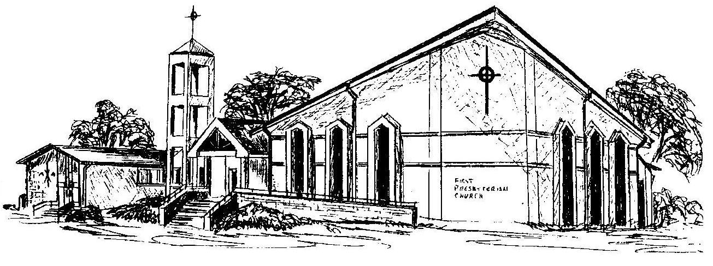

First Presbyterian Church
In the heart of Gardner since 1866 ~ Serving from the heart of God

Welcome - Thank you for joining us for worship today. Please fill out a visitor information card found in the pew racks and place those in the offering plate so that we may follow up with you in the future. Your presence with us today has been a blessing to us, we hope that you have felt the presence of God and the welcome of this congregation.

