Welcome
Prelude “Praise the Everlasting Father”
Gertrude Haupt Richolson
Let us prepare our hearts and minds for worship.

Call to Worship
Leader: We gather in the name of the One who saves us, Jesus Christ our Lord.
People: We worship together because we are strengthened by one another.
Leader: Jesus says “Love one another as I have loved you.”
People: We share that love of Jesus in the world, by the grace of God.

*Opening Hymn: “How Great Thou Art” Red Hymnal, #4

*Prayer of Confession (Unison) (inspired by Ephesians 4:1-16; Abingdon Worship)
God of unity and love, place within each of us a spirit of hope and community. Redirect us when we speak without love or act without humility. Create in us willing hearts to live in patience and gentleness. Raise us up to be your children, growing toward maturity in faith. Strengthen this church, that we may be a model of your love for all the world to see. In Christ’s name, we pray. Amen.

*Silent Reflection

*Assurance of Pardon

* Gloria Patri (Glory Be to the Father…) Red Hymnal, #623

Children’s Time

Scripture “Acts 4:32-39” (page 1697)
“Philippians 4:4-9” (page 1830)
“Colossians 3:12-17” (page 1834)
Leader: The word of the Lord.
People: Thanks be to God.

Anthem “You Are Mine”
Words and Music by David Haas / arr. by Mark Hayes

Sermon “How to Live in Love” Rev. Kimby Young
*Profession of Faith The Apostle's Creed Red Hymnal, inside back cover
I Believe in God the Father Almighty, Maker of heaven and earth, And in Jesus Christ his only Son our Lord; who was conceived by the Holy Ghost, born of the Virgin Mary, suffered under Pontius Pilate, was crucified, dead, and buried; he descended into hell; the third day he rose again from the dead; he ascended into heaven, and sitteth on the right hand of God the Father Almighty; from thence he shall come to judge the quick and the dead. I believe in the Holy Ghost; the holy catholic Church; the communion of saints; the forgiveness of sins; the resurrection of the body; and the life everlasting. Amen

*Hymn “They’ll Know We are Christians By Our Love” Red Hymnal, #284

Pastoral Prayer & Lord’s Prayer

Offertory Meditation “Let the Peace of God Rule in Your Heart” Denny Cagle

*Doxology

*Prayer of Dedication

*Closing Hymn: “Take My Life and Let It Be” Red Hymnal, #379 1, 2, 3, 6

*Benediction

Postlude “Short Postlude”
Edouard Batiste / arr. by Lee Ellis
*Those who are comfortably able will please stand.

Rev. Kimby Young, Pastor; Larry Schick, Worship Assistant
Dean Faulk, Music Ministries; Chancel Choir
Alice Rollf, Organist
Mike McGuire and Brad Cornell, Slide Production
Theo Borge, Tech, and Videographer; Kim Liu, Sound

Childcare is always available in the nursery (off the hall to the west of the sanctuary). Children are welcome to stay in the sanctuary thru the whole service, or to leave at any time. Allison Perry is our primary childcare attendant.

Offering Plates are at the entrance of each aisle for your contributions to the work of the church.

Gardner Multi Service Center collection is ongoing every week and is always in need of any non-perishable food. Bring something every week or once a month.

Fair Trade Products for Sale on Sundays Coffee, tea, chocolate, nuts, olive oil, dried fruit, baking products, and a few other items are for sale each Sunday at church.

Harvesters Food Distribution is always seeking volunteers. Every 3rd Saturday at Trade Net Parking lot and every 4th Wednesday at Divine Mercy Parish. Distribution begins at about 1 p.m.

Session has established a "Suggestion Box" just outside the office for ideas, comments, questions, and thoughts. Contents will be reviewed at session meetings on the 2nd Monday of each month. Names are helpful if we need to follow up, but you may remain anonymous.

PW Annual Spring Brunch on Saturday, April 27th 9:30 am in Fellowship Hall.

Funeral dinner volunteers - We are updating our list of people willing to bring food for funeral dinners. We call people from the list when there is a need and people respond as they are able at the time. A signup sheet is in the narthex near the devotional books. Even if you have been on the list before, please sign up again to confirm your willingness to be called.

Joy Closet is in need of someone to work in the sporting goods, Pricing all goods and putting them out on the sale floor. This would need done probably twice a week. Need a Cashier for Wednesdays 1:00 - 4:00pm. Need a Cashier Assistant for every Other Thursday 10:00 - 1:00 assisting Doc. If you or anyone you know is interested in helping in any of these areas please have them contact Ginger Crist.

Old Hymns Old Friends Revival on Sunday, May 5th at 2:00 p.m. Frist Baptist Church, 325 E. Shawnee, Gardner, KS. Please join them for an afternoon of old hymns and fellowship.
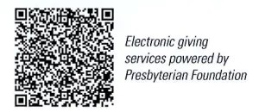
First Presbyterian Church
In the heart of Gardner since 1866 ~ Serving from the heart of God

Sunday, April 21, 2024
8:45 AM
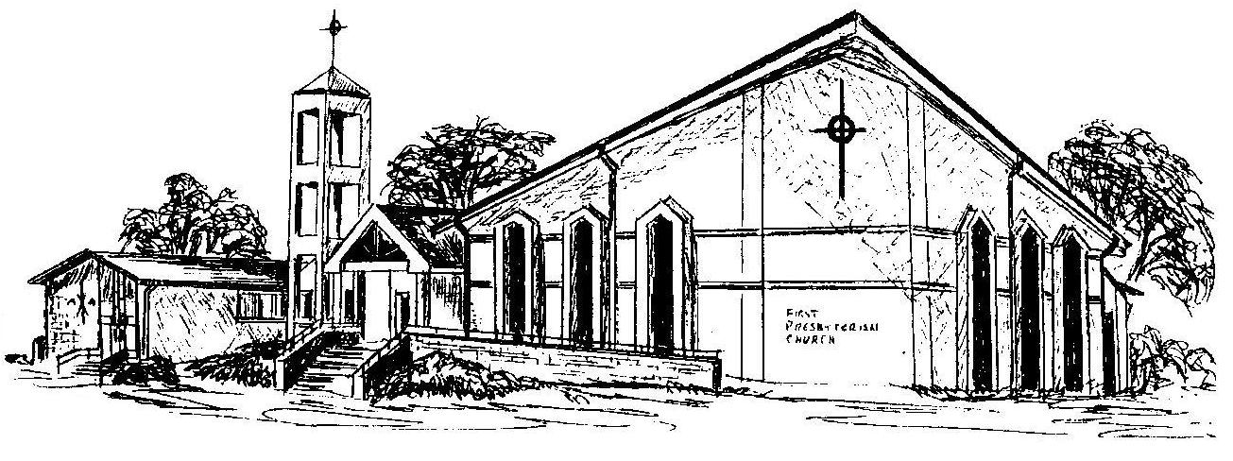

Welcome - Thank you for joining us for worship today. Please fill out a visitor information card found in the pew racks and place those in the offering plate so that we may follow up with you in the future. Your presence with us today has been a blessing to us, we hope that you have felt the presence of God and the welcome of this congregation.

