Welcome

Prelude Jesu, Joy of Man's Desiring---J.S. Bach
Let us prepare our hearts and minds for worship.

Call to Worship and Lighting of the Advent Wreath – Karl & Kim Allen
Leader: Jesus said, “I am the Light of the World, whoever follows me will not walk in darkness, but will have the light of life.”
People: Today, we light the first candle on our Advent wreath.
Leader: We remember the prophets’ hope based on God’s promise to send a Messiah, one who would bring peace and love to the world.
People: The first light reminds us that God’s promises are still true for us today.
Leader: Wait and hope, for Jesus Christ is coming.
People: Come Lord Jesus, Light of the World!

*Opening Hymn “Oh Come All Ye Faithful” Red Hymnal, #145

*Prayer of Confession (Unison)
Hope of the World, through long generations, prophets foretold your coming. Those same prophets call us to live in your light and walk in your ways. Again and again you tell us “Do not be afraid.” Yet we fear the darkness, even though your light is stronger. We doubt your presence, even when your Spirit fills us with grace. Make us bold to share the hope you have given in Jesus Christ our Prince of Peace, born to save the world. Amen.

*Silent Reflection

*Assurance of Pardon

*Gloria Patri (Glory Be to the Father…) Red Hymnal, #62

Children’s Time

Scripture “Isaiah 40: 1-11” (page 1119)
“Luke 1: 67-79 (page 1590)
Leader: The Word of the Lord.
People: Thanks be to God.

Anthem

Sermon “Songs of Hope” Rev. Kimby Young

*Profession of Faith The Apostle's Creed Red Hymnal, inside back cover
I Believe in God the Father Almighty, Maker of heaven and earth,
And in Jesus Christ his only Son our Lord; who was conceived by the Holy Ghost, born of the Virgin Mary, suffered under Pontius Pilate, was crucified, dead, and buried; he descended into hell; the third day he rose again from the dead; he ascended into heaven, and sitteth on the right hand of God the Father Almighty; from thence he shall come to judge the quick and the dead.
I believe in the Holy Ghost; the holy catholic Church; the communion of saints; the forgiveness of sins; the resurrection of the body; and the life everlasting. Ame

*Hymn “O Come, O Come Emmanuel” Red Hymnal #123

Offertory Meditation: “A Simple Prayer” Edvard Grieg / arr. by Lani Smith

*Doxology

The Sacrament of Holy Communion
(All bread is gluten free. Prepacked elements in the back.)
Invitation
Great Prayer and The Lord’s Prayer
Words of Institution – Breaking of Bread
Communion of the People
Prayer of Thanksgiving

*Closing Hymn: “Come, Thou Long Expected Jesus” Red Hymnal #124

*Benediction

Postlude “Hail to the Lord's Anointed”
Gesangbuch der H.W.K.Hofkapelle / arr. by Henry Balcombe
*Those who are comfortably able will please stand.

Childcare is available in the nursery (off hall west of the sanctuary). Children are welcome to stay in the sanctuary, or to leave at any time. Allison Perry is our primary childcare attendant.

Offering Plates are at the entrance of each aisle for your contributions to the work of the church.

Gardner Multi Service Center collection is ongoing every week and is always in need of any non-perishable food. Bring something every week or once a month.

Fair Trade Products for Sale on Sundays Coffee, tea, chocolate, nuts, olive oil, dried fruit, baking products, and a few other items are for sale each Sunday at church.

Harvesters Food Distribution is always seeking volunteers. Every 3rd Saturday at Trade Net Parking lot and every 4th Wednesday at Divine Mercy Parish. Distribution begins at about 1 p.m.

FPC at the Joy Closet on the 4th Saturday of every month. Come anytime 10:00 – 2:00 p.m.

Joy Closet needs volunteers anyone age 14 and up they can use your help. Stop in and fill out a volunteer card and you will be contacted to set up training.

Choirs meet on Wednesday’s Bell Choir at 6:00 p.m. in Chapel, Chancel Choir at 7:00 p.m. in Sanctuary, Christmas Cantata at 8:00 p.m.

Christmas Poinsettias for Sanctuary cost $13.00 in memory of or in honor of someone special due by Monday, December 4.

Advent Devotionals are available in the narthex.

Mrs. Claus will visit Sunday School - Sunday, December 10, 10 a.m. Fellowship Hall

Hot Chocolate Tasting - New Fair Trade Products - December 10 - 9:45 to 11 a.m.

Cantata - Song of Joy - December 17 - 10 a.m. - one worship service
Children's Christmas Pageant in worship - December 24 - 10 a.m.
Christmas Eve - Worship with candlelight and communion - 4:30 p.m.
New Year's Eve Worship - December 31 - 10 a.m. - one worship service

First Presbyterian Church
In the heart of Gardner since 1866 ~ Serving from the heart of God

Sunday, December 3, 2023
First Sunday of Advent
8:45 AM

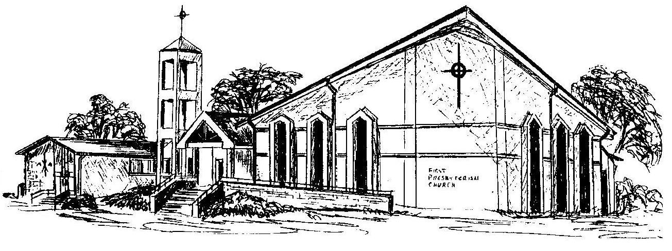

Welcome - Thank you for joining us for worship today. Please fill out a visitor information card found in the pew racks and place those in the offering plate so that we may follow up with you in the future. Your presence with us today has been a blessing to us, we hope that you have felt the presence of God and the welcome of this congregation.

Rev. Kimby Young; Rhonda Atwater, Worship Assistant
Dean Faulk, Music Ministries, Chancel Choir; Alice Rollf, Organist
Mike McGuire and Brad Cornell, Slide Production
Davis Tropansky & Theo Borge, Tech and Videographer; Kim Liu, Sound

