Welcome

Prelude “Praise to the King” Worship Medley
Let us prepare our hearts and minds for worship.

Call to Worship
Leader: Come to worship Jesus Christ, Alpha and Omega, the one who is, who was, and who is to come.
People: We come to worship Jesus Christ, the faithful witness, the firstborn of the dead, the ruler of the kings of the earth!
Leader: We worship Jesus Christ, Bread of Heaven, God with us, Good Shepherd, True Vine!
People: We praise Jesus Christ the Eternal Word, the Great I AM, Wonderful Counselor, Prince of Peace!
Leader: We come to worship Jesus Christ, King of kings and Lord of lords!
People: To Jesus Christ be glory and dominion forever and ever! Amen.

*Opening Hymn “All Creatures of Our God and King” Red Hymnal, #64

*Prayer of Confession (Unison)
King of Kings, Lord of Lords, God of all our days, you have blessed us in so many ways and we are grateful. Sometimes we forget your love and presence all around us, and we dwell on the difficulties and darkness. Shine your light of grace that we may see your bounty. Inspire us again that we may share your blessing in the world. Return us to you that we may live to your glory, through Jesus Christ our Lord. Amen.

*Silent Reflection

*Assurance of Pardon

*Gloria Patri (Glory Be to the Father…) Red Hymnal, #62

Children’s Time

Scripture “Matthew 25:31-40” (page 1542)
Leader: The Word of the Lord.
People: Thanks be to God.

Anthem “Adore”
Words and Music by Graham Kendrick and Martin Chalk arr. by Marty Hamby

Sermon “Call of the King” Rev. Kimby Young

*Profession of Faith The Apostle's Creed Red Hymnal, inside back cover
I Believe in God the Father Almighty, Maker of heaven and earth,
And in Jesus Christ his only Son our Lord; who was conceived by the Holy Ghost, born of the Virgin Mary, suffered under Pontius Pilate, was crucified, dead, and buried; he descended into hell; the third day he rose again from the dead; he ascended into heaven, and sitteth on the right hand of God the Father Almighty; from thence he shall come to judge the quick and the dead.
I believe in the Holy Ghost; the holy catholic Church; the communion of saints; the forgiveness of sins; the resurrection of the body; and the life everlasting. Amen

*Hymn “Crown Him with Many Crowns” Red Hymnal, #234

Pastoral Prayer & Lord’s Prayer

Offertory Meditation: “Great is Thy Faithfulness” William M. Runyan

*Doxology

*Prayer of Dedication

*Closing Hymn: “Rejoice Ye Pure In Heart” Red Hymnal, #562

*Benediction

Postlude “Majesty” Jack Hayford
*Those who are comfortably able will please stand.

Rev. Kimby Young; Wayne Rollf, Worship Assistant
Dean Faulk, Music Ministries, Chancel Choir; Alice Rollf, Organist
Mike McGuire and Brad Cornell, Slide Production
Davis Tropansky & Theo Borge, Tech and Videographer; Kim Liu, Sound

Congregational Meeting, Sunday, November 26 9:40 a.m. Session has called a congregational meeting for the purpose of electing officers for 2024. Elder nominees include Ginger Crist, Lynn Moldrup, Larry Schick, and Poppy Zurcher. Deacon nominees are Sandy Nellor, Joseph Kioko and Judy Mason, as well as Shana Devlin and Kelly Johnson renewing for a second term. Nominating Committee members at large 2024 to be elected are Paula Waters, Larry Atwater, Robin Tropansky, Phil Lenahan, and Lois Barber.
Childcare is available in the nursery (off hall west of the sanctuary). Children are welcome to stay in the sanctuary, or to leave at any time. Allison Perry is our primary childcare attendant.

Offering Plates are at the entrance of each aisle for your contributions to the work of the church.

Gardner Multi Service Center collection is ongoing every week and is always in need of any non-perishable food. Bring something every week or once a month.

Fair Trade Products for Sale on Sundays Coffee, tea, chocolate, nuts, olive oil, dried fruit, baking products, and a few other items are for sale each Sunday at church.

Harvesters Food Distribution is always seeking volunteers. Every 3rd Saturday at Trade Net Parking lot and every 4th Wednesday at Divine Mercy Parish. Distribution begins at about 1 p.m.

FPC at the Joy Closet on the 4th Saturday of every month. Come anytime 10:00 – 2:00 p.m.

Joy Closet needs volunteers anyone age 14 and up they can use your help. Stop in and fill out a volunteer card and you will be contacted to set up training.

Choirs meet on Wednesday’s Bell Choir at 6:00 p.m. in Chapel, Chancel Choir at 7:00 p.m. in Sanctuary, Christmas Cantata at 8:00 p.m.

Presbyterian Women Holiday “High Tea” on Saturday, Dec. 2nd at 2:00 pm, in the home of Poppy Zurcher. Join us for food and fellowship; cookie exchange and white elephant exchange. Sign up in the Narthex.

Christmas Poinsettias for Sanctuary cost $13.00 in memory of or in honor of someone special due by Monday, December 4.

No Children’s Sunday School today, November 26th.

Mrs. Claus will visit Sunday School - Sunday, December 10, 10 a.m. Fellowship Hall

Hot Chocolate Tasting - New Fair Trade Products - December 10 - 9:45 to 11 a.m.

Join us in decorating the sanctuary and narthex - Friday, December 1, 3 p.m. until finished. Oliver Schwabb (486-8562).

Cantata - Song of Joy - December 17 - 10 a.m. - one worship service
Children's Christmas Pageant in worship - December 24 - 10 a.m.
Christmas Eve - Worship with candlelight and communion - 4:30 p.m.
New Year's Eve Worship - December 31 - 10 a.m. - one worship service

First Presbyterian Church
In the heart of Gardner since 1866 ~ Serving from the heart of God

Sunday, November 26, 2023
Christ the King Sunday
8:45 AM

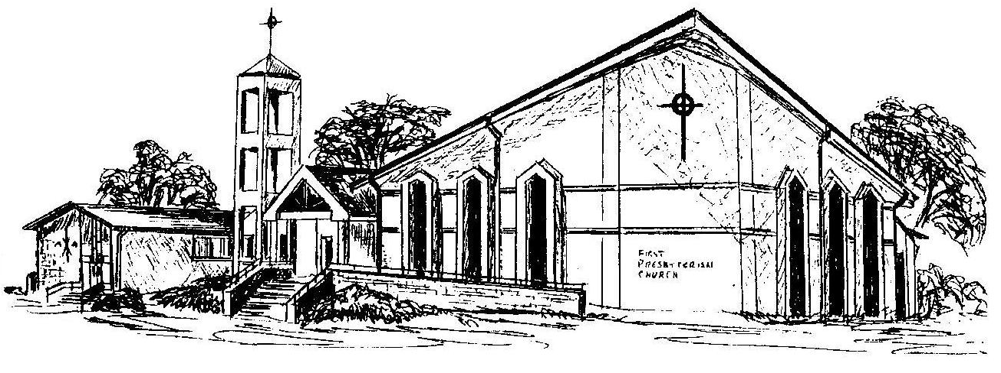

Welcome - Thank you for joining us for worship today. Please fill out a visitor information card found in the pew racks and place those in the offering plate so that we may follow up with you in the future. Your presence with us today has been a blessing to us, we hope that you have felt the presence of God and the welcome of this congregation.

