Welcome
(Children and youth are invited to join in our Palm Processional. Go to the narthex just outside the sanctuary during the Prelude to receive a palm branch and instructions.)

Prelude: “The Holy City”
Stephen Adams / arr. by Ellen Jane Lorenz
Let us prepare our hearts and minds for worship.

Call to Worship
Leader: Blessed is the One who comes in the name of our God!
People: Blessed is Christ who came in the power of God’s name and the nature of God’s love!
Leader: Blessed is Jesus who lived in courage that we might learn to live in peace!
People: Hosanna in the Highest! Blessed is our King and our God!

The Story of Jesus in Word and Song
Narrators: Cindy Rollf and Larry Schick
“Prepare Ye/ Prepare the Way of the Lord”
“A New Hallelujah with All Hail the Power of Jesus Name” – Chesley Jones, solo
“Crown Him King of Kings”
“I Quietly Turned to You” – Linda Wolf, solo.

Opening Prayer

*Hymn: “Hosanna, Loud Hosanna” Red Hymnal, #174

Scripture “Mark 11:1-11” (page1572)
Scripture “Matthew 16:13-16” (page 1524)
Leader: The word of the Lord.
People: Thanks be to God.

Sermon: “Who Do You Say I Am?” Rev. Kimby Young

*Hymn “Ride On! Ride On in Majesty” Insert

Pastoral Prayer & Lord’s Prayer:

Offertory Meditation “O Divine Redeemer”
Charles F. Gounod / arr. by Rob Roy Peery

*Doxology

*Prayer of Dedication

*Closing Hymn: “All Glory Laud and Honor” Red Hymnal, #173

Benediction

Postlude: “A King Rides Forth Today” John M. Rasley
*Those who are comfortably able will please stand

Rev. Kimby Young, Pastor
Dean Faulk, Music Ministries; Alice Rollf, Organist
Cindy Rollf and Larry Schick, Narrators
Chesley Jones, Solo; Linda Wolf, Solo
Mike McGuire and Brad Cornell, Slide Production
Theo Borge, Tech, and Videographer; Kim Liu, Sound

Holy Week Worship Schedule and Scripture
March 28 – Mandy Thursday 7:00 p.m. Worship & Communion – John 13: 1-7, 31-35
March 29 – Good Friday – 7:00 p.m. Worship Service – Mark 15:16-39
March 31 – Easter – two services – 8:45 a.m. and 10:30 a.m. Celebration of the Resurrection

Childcare is always available in the nursery (off the hall to the west of the sanctuary). Children are welcome to stay in the sanctuary thru the whole service, or to leave at any time. Allison Perry is our primary childcare attendant.

Offering Plates are at the entrance of each aisle for your contributions to the work of the church.

Gardner Multi Service Center collection is ongoing every week and is always in need of any non-perishable food. Bring something every week or once a month.

Fair Trade Products for Sale on Sundays Coffee, tea, chocolate, nuts, olive oil, dried fruit, baking products, and a few other items are for sale each Sunday at church.

Harvesters Food Distribution is always seeking volunteers. Every 3rd Saturday at Trade Net Parking lot and every 4th Wednesday at Divine Mercy Parish. Distribution begins at about 1 p.m.

Flowering the cross – On Easter Sunday, bring a fresh flower from your garden to flower the cross in memory of a loved one. We will have flowers if you do not have one to bring.

OGHS collection is received on March 31, Easter – 0r anytime before. Mark check OGHS.

Mission fundraiser for hygiene kits $5.00, woman/girls health kits $25.00.

Black Out Drapes - For Lent each year we raise curtains over the stained glass windows as reminders of the deepening season. As a Lenten discipline we are called to awareness of light and darkness in the world as we seek God's presence in our daily lives, and as we look forward in hope to the celebration of the resurrection of Jesus Christ

Session has established a "Suggestion Box" just outside the office for ideas, comments, questions and thoughts. Contents will be reviewed at session meetings on the 2nd Monday of each month. Names are helpful if we need to follow up, but you may remain anonymous.

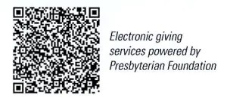
First Presbyterian Church
In the heart of Gardner since 1866 ~ Serving from the heart of God

Palm Sunday
Sunday, March 24, 2024
8:45 AM

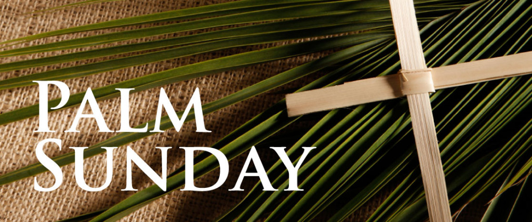

Welcome - Thank you for joining us for worship today. Please fill out a visitor information card found in the pew racks and place those in the offering plate so that we may follow up with you in the future. Your presence with us today has been a blessing to us, we hope that you have felt the presence of God and the welcome of this congregation.

