Welcome
Prelude
Let us prepare our hearts and minds for worship.

Call to Worship
Leader: God who waits on the mountain of holiness -
People: Our Awesome God calls us.
Leader: God who shines in cloud and fire -
People: Our Brilliant God stirs us.
Leader: Arise, People of God, respond to God’s movement among us.
People: With confidence in God, we gather to worship and serve.

*Opening Hymn: “Holy, Holy, Holy” Red Hymnal, #262

*Prayer of Confession (Unison)
God of transfiguration and transformation, we seek an experience of your presence. We seek revelation and truth, mystery and power, wisdom and purpose. Stay with us always, as we worship here, and as we go out in the world to share the challenge of living our faith. Turn our fear to courage and our confusion to confidence. Shine in our hearts and in our lives, as your glory shines in the face of Christ. Amen.

Silent Reflection

*Assurance of Pardon

* Gloria Patri (Glory Be to the Father…) Red Hymnal, #623

Children’s Time

Scripture “Exodus 34:29-35” (page 142)
“Kings 19:11-13” (page 559)
“Luke 9:28-36” (page 1609)
Leader: The word of the Lord.
People: Thanks be to God.

Anthem

Sermon “Out of the Ordinary” Rev. Kimby Young

*Profession of Faith The Apostle's Creed Red Hymnal, inside back cover
I Believe in God the Father Almighty, Maker of heaven and earth, And in Jesus Christ his only Son our Lord; who was conceived by the Holy Ghost, born of the Virgin Mary, suffered under Pontius Pilate, was crucified, dead, and buried; he descended into hell; the third day he rose again from the dead; he ascended into heaven, and sitteth on the right hand of God the Father Almighty; from thence he shall come to judge the quick and the dead. I believe in the Holy Ghost; the holy catholic Church; the communion of saints; the forgiveness of sins; the resurrection of the body; and the life everlasting. Amen

*Hymn “Take Time to Be Holy” Red Hymnal, #441

Offertory Meditation

*Doxology

The Sacrament of Holy Communion
(All bread is gluten free. Prepacked elements are available in the back.)
Invitation
Great Prayer and The Lord’s Prayer
Words of Institution – Breaking of Bread
Communion of the People
Prayer of Thanksgiving

*Closing Hymn: “In Remembrance” Red Hymnal, #322

*Benediction

Postlude
*Those who are comfortably able will please stand.

Rev. Kimby Young, Pastor; Alice Rollf, Worship Assistant
Chancel Choir; Dean Faulk, Music Ministries
Harlan Plunkett, Organist; Robyn Forkner, Pianist
Mike McGuire and Brad Cornell, Slide Production; Kim Liu, Sound

Childcare is always available in the nursery (off the hall to the west of the sanctuary). Children are welcome to stay in the sanctuary thru the whole service, or to leave at any time. Allison Perry is our primary childcare attendant.

Worship Bags for Children are available outside the north door to the sanctuary. Choose books, crayons, pencils, Legos, stuffed toys and other items to fill your bag to use during worship.

Offering Plates are at the entrance of each aisle for your contributions to the work of the church.

Gardner Multi Service Center collection is ongoing every week and is always in need of any non-perishable food. Bring something every week or once a month.

Fair Trade Products for Sale on Sundays Coffee, tea, chocolate, nuts, olive oil, dried fruit, baking products, and a few other items are for sale each Sunday at church.

Harvesters Food Distribution is always seeking volunteers. Every 3rd Saturday at Trade Net Parking lot and every 4th Wednesday at Divine Mercy Parish. Distribution begins at 1 p.m.

A "Suggestion Box" is outside the office for ideas, comments, questions, and thoughts. Contents will be reviewed at session meetings on the 2nd Monday of each month.

Joy Closet – Our mission center thrift store provides free clothing to a variety of needs Volunteers are trained in a variety of jobs and work at different times. Our church provides all volunteers on the fourth Saturday of each month.

Presbyterian Women’s Bible Study each Thursday in Fellowship Hall at 6:30 p.m. All women welcome.

Traveling Day Camp Registration is open.

Chocolate Tasting Fair Trade Products Sunday, March 2 between services.

Women’s Fellowship Group will begin on Wednesday, March 5, 2025, at 10:00 a.m. in the Fellowship Hall. Mark your calendar. All women are welcome.

ASH WEDNESDAY March 5 – Two Options
Drive through prayer and sacrament 5:30 – 6:30 p.m.
Worship in the Sanctuary 7:00 – 8:00 p.m.

The congregation is invited to a 95th birthday cake Celebration for Mary Barbara Allen on March 9th from 2-4 pm in Fellowship Hall. No gifts please.

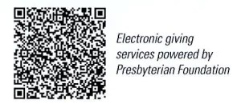
First Presbyterian Church
In the heart of Gardner since 1866 ~ Serving from the heart of God

Sunday, March 2, 2025
Transfiguration Sunday
Celebrating the Gifts of Women
8:45 AM
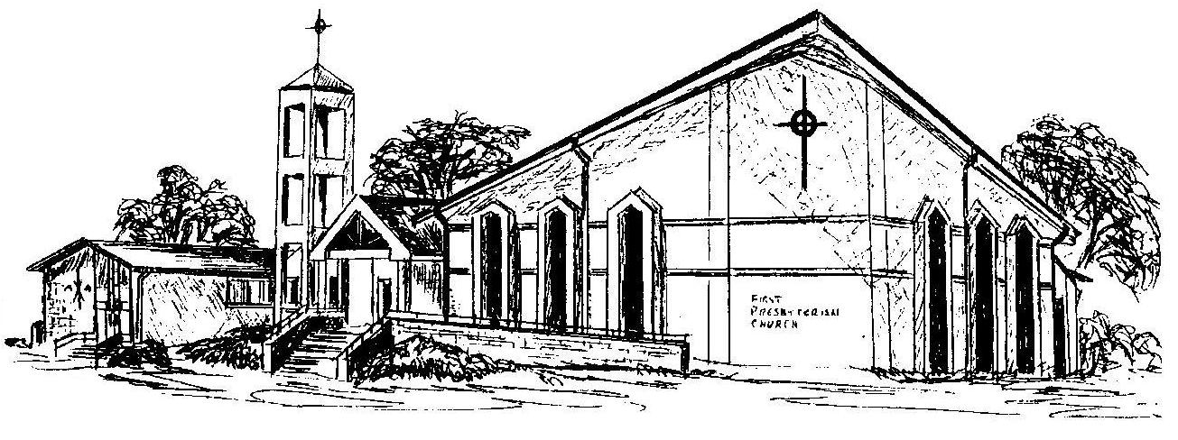

Welcome - Thank you for joining us for worship today. Please fill out a visitor may follow up with you in the future. Your presence with us today has been a blessing to us, we hope that you have felt the presence of God and the welcome of this congregation.

