Welcome
Prelude “O Lord Most Holy”
Cesar Franck / arr. by Brent Jorgenson
Let us prepare our hearts and minds for worship.

Call to Worship (adapted from Bruce Prewer)
Leader: Remember that it is not we who chose Christ, but Christ who chose us.
People: We are not here because of our goodness but because of Christ’s grace.
Leader: We have not come to be entertained but to worship God.
People: Together we worship God offering all that we are.
.

*Opening Hymn: “He Leadeth Me” Red Hymnal, # 461

*Prayer of Confession (Unison) (adapted from Amy Loving, Worship Closet.)
Lord, we confess that we love our lives as they are. We struggle with even the idea of change. But we know that the life we cling to is only a half-life. Only you, O Lord, can give us true life in full. Forgive us for holding onto the wrong things. Teach us by your Spirit to let go of our agendas and assumptions. Help us to let go of our self-righteousness and false notions of power. Give us the strength and courage to try new things. Encourage us – and even push us –to let go of ourselves so we can fully embrace you, Holy God. We pray these things in the name of Christ Jesus. Amen.

*Silent Reflection

*Assurance of Pardon

* Gloria Patri (Glory Be to the Father…) Red Hymnal, #623

Children’s Time

Scripture “Mark 10:35-45” (page 1571)
Leader: The word of the Lord.
People: Thanks be to God.

Anthem

Sermon “Holding On and Letting Go” Rev. Kimby Young
*Profession of Faith The Apostle's Creed Red Hymnal, inside back cover
I Believe in God the Father Almighty, Maker of heaven and earth, And in Jesus Christ his only Son our Lord; who was conceived by the Holy Ghost, born of the Virgin Mary, suffered under Pontius Pilate, was crucified, dead, and buried; he descended into hell; the third day he rose again from the dead; he ascended into heaven, and sitteth on the right hand of God the Father Almighty; from thence he shall come to judge the quick and the dead. I believe in the Holy Ghost; the holy catholic Church; the communion of saints; the forgiveness of sins; the resurrection of the body; and the life everlasting. Amen

*Hymn “Jesus Calls Us” Red Hymnal, #375

Pastoral Prayer & Lord’s Prayer

Offertory Meditation “Lenten Offertory” Gertrude Haupt Richolson

*Doxology

*Prayer of Dedication

*Closing Hymn: “In the Garden” Red Hymnal, #425

*Benediction

Postlude “Lead On, O King Eternal”
Henry T. Smart / arr. by Lani Smith
*Those who are comfortably able will please stand.

Rev. Kimby Young, Pastor; Carl Frahme, Worship Assistant
Dean Faulk, Music Ministries; Alice Rollf, Organist; Chancel Choir
Mike McGuire and Brad Cornell, Slide Production
Theo Borge, Tech, and Videographer; Kim Liu, Sound

Childcare is always available in the nursery (off the hall to the west of the sanctuary). Children are welcome to stay in the sanctuary thru the whole service, or to leave at any time. Allison Perry is our primary childcare attendant.

Offering Plates are at the entrance of each aisle for your contributions to the work of the church.

Gardner Multi Service Center collection is ongoing every week and is always in need of any non-perishable food. Bring something every week or once a month.

Fair Trade Products for Sale on Sundays Coffee, tea, chocolate, nuts, olive oil, dried fruit, baking products, and a few other items are for sale each Sunday at church.

Harvesters Food Distribution is always seeking volunteers. Every 3rd Saturday at Trade Net Parking lot and every 4th Wednesday at Divine Mercy Parish. Distribution begins at about 1 p.m.

Presbyterian Women Bible Study has begun on Thursdays, at 7:00 p.m.in Fellowship Hall lesson is “Worth More Than Rubies” by Christina Patterson.

Monday Night Bible Study group has started a new study: Angels: 8 Studies for Individuals or Groups, on Feb. 12. This group meets every other Monday evening at 5:30pm via Zoom. If interested, please contact Jennifer Waites (jwaitemail@hotmail.com).

OGHS collection is collected on March 31, you can ear mark check OGHS.

Mission fundraiser for hygiene kits $5.00, woman/girls health kits $25.00.

Black Out Drapes - For Lent each year we raise curtains over the stained glass windows as reminders of the deepening season. As a Lenten discipline we are called to awareness of light and darkness in the world as we seek God's presence in our daily lives, and as we look forward in hope to the celebration of the resurrection of Jesus Christ

Holy Week Worship Schedule and Scripture
March 24 – Palm Sunday 8:45 and 11:00 a.m.; Fellowship Hour between services
March 28 – Mandy Thursday 7:00 p.m. Worship & Communion – John 13: 1-7, 31-35
March 29 – Good Friday – 7:00 p.m. Worship Service – Mark 15:16-39
March 31 – Easter – two services – 8:45 a.m. and 10:30 a.m. Celebration of the Resurrection

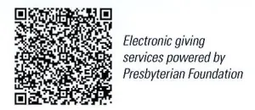
First Presbyterian Church
In the heart of Gardner since 1866 ~ Serving from the heart of God

Sunday, March 10, 2024
4th Sunday of Lent
8:45 AM
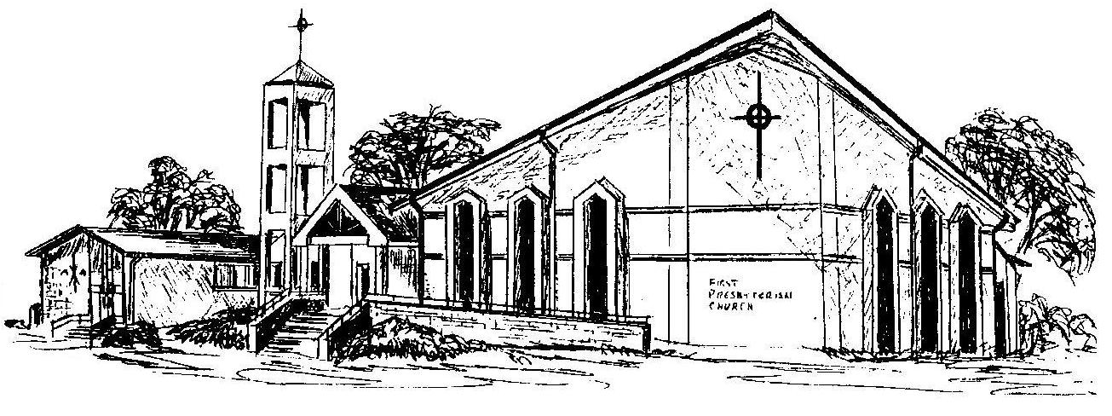

Welcome - Thank you for joining us for worship today. Please fill out a visitor information card found in the pew racks and place those in the offering plate so that we may follow up with you in the future. Your presence with us today has been a blessing to us, we hope that you have felt the presence of God and the welcome of this congregation.

