Welcome
Prelude
Let us prepare our hearts and minds for worship.

Leader: Mothers and fathers, sisters and brothers, Come.
People: We are the family of God.
Leader: Children of God, we gather to worship the One who loves us.
People: We praise God who calls us to love one another.

*Opening Hymn: “For the Beauty of the Earth” Red Hymnal, #560

*Prayer of Confession (Unison)
Mothering God, we know how you love us, nurture us, guide us and call us into one family of faith. Sometimes we fail to be aware of the diversity among us. Sometimes we overlook the pain or fear, loss or challenge of another. Often we assume too much. Often we hurt one another. Forgive us. Remind us of your gifts to us and your grace for us. Empower us to extend your love to include everyone. We pray in Jesus name. Amen.

*Silent Reflection

*Assurance of Pardon

*Gloria Patri (Glory Be to the Father…) Red Hymnal, #623

Children’s Time

Scripture “Ecclesiastes 3:1-8” (page 1037)
“2 Timothy 1:3-7” (page 1852)
Leader: The word of the Lord.
People: Thanks be to God.

Anthem “What A Day Medley”
arr. by Nick Robertson

Sermon “Seasons of Love” Rev. Kimby Young

*Profession of Faith The Apostle's Creed Red Hymnal, inside back cover
I Believe in God the Father Almighty, Maker of heaven and earth, And in Jesus Christ his only Son our Lord; who was conceived by the Holy Ghost, born of the Virgin Mary, suffered under Pontius Pilate, was crucified, dead, and buried; he descended into hell; the third day he rose again from the dead; he ascended into heaven, and sitteth on the right hand of God the Father Almighty; from thence he shall come to judge the quick and the dead. I believe in the Holy Ghost; the holy catholic Church; the communion of saints; the forgiveness of sins; the resurrection of the body; and the life everlasting. Amen

*Hymn “A Christian Home” Red Hymnal, #535

Pastoral Prayer & Lord’s Prayer

Offertory Meditation:

*Doxology

*Prayer of Dedication

*Closing Hymn: “Now Thank We All Our God” Red Hymnal, #556

*Benediction

Postlude
*Those who are comfortably able will please stand.

Rev. Kimby Young, Pastor; Poppy Zurcher Worship Assistant
Dean Faulk, Music Ministries; Chancel Choir
Harlan Plunkett, Organist; Robyn Forkner, Pianist
Mike McGuire and Brad Cornell, Slide Production; Kim Liu, Sound

Childcare is always available in the nursery (off the hall to the west of the sanctuary). Children are welcome to stay in the sanctuary thru the whole service, or to leave at any time. Allison Perry is our primary childcare attendant.

Worship Bags for Children are available outside the north door to the sanctuary. Choose books,
crayons, pencils, Legos, stuffed toys and other items to fill your bag to use during worship.

Offering Plates are at the entrance of each aisle for your contributions to the work of the church.

Gardner Multi Service Center collection is ongoing every week and is always in need of any non-perishable food. Bring something every week or once a month.

Fair Trade Products for Sale on Sundays Coffee, tea, chocolate, nuts, olive oil, dried fruit, baking products, and a few other items are for sale each Sunday at church.

Harvesters Food Distribution is always seeking volunteers. Every 3rd Saturday at Trade Net Parking lot and every 2nd Thursday at Divine Mercy Parish. Distribution begins at 1 p.m.

Joy Closet – Our mission center thrift store provides free clothing to a variety of needs. Our church provides all volunteers on the fourth Saturday of each month.

A "Suggestion Box" is outside the office for ideas, comments, questions and thoughts. Contents will be reviewed at session meetings on the 2nd Monday of each month.

Mission Pillar Hygiene Kits - raising funds now $5 per kit - goal of over 200 kits. Assemble kits on Saturday July 12 (time TBD) at Heart to Heart International warehouse. Please mark your donations to "FPC" for "Mission Kits."

Kimby will take vacation from May 19-25. Guest Preacher on Sunday, May 25 is Susan Cox.

Worship Service on Sunday, May 25 at 10:00 a.m. Memorial Day Weekend.

Sunday, June 1 Ice cream social between services.

Ladies Community Luncheon at Divine Mercy Parish on Saturday, June 14, 2025, 11:30 a.m., 555 W Main Street. Come for fun and fellowship.

First Presbyterian Church
In the heart of Gardner since 1866 ~ Serving from the heart of God

Sunday, May 11, 2025
Mother’s Day
8:45 AM

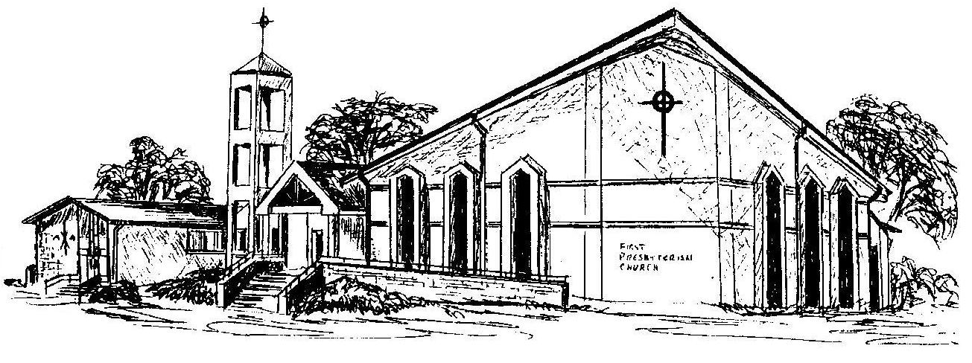

Welcome - Thank you for joining us for worship today. Please fill out a visitor information card found in the pew racks and place those in the offering plate so that we may follow up with you in the future. Your presence with us today has been a blessing to us, we hope that you have felt the presence of God and the welcome of this congregation.

