Welcome
Prelude “Medley---Sing His Praises”
Let us prepare our hearts and minds for worship.

Call to Worship: (Inspired by Ecclesiastes 3:1-11)
Leader: For everything there is a season: And a time for every matter under heaven:
People: God has made everything suitable for its time. God has put a sense of past and future into our minds.
Leader: Now is a time to thank God for the past and to look to the future God has planned.
People: Now is a time to gather in worship, to praise God and to open our hearts.

*Opening Hymn: “God of the Ages” Red Hymnal, #568

*Prayer of the Confession (Unison)
Our hope is in You, Lord. Our strength is in You, Lord. Our life is in You, Lord. Yet at times we try to make our own way and push our own agendas. Forgive us. Open our eyes and our hearts to Your guidance. Help us to hear You. Show us Your way as we seek to follow Jesus. Lead us where You would have us go. By Your grace and to Your glory. Amen.

*Silent Reflection

*Assurance of Pardon

* Gloria Patri (Glory Be to the Father…) Red Hymnal, #623

Children’s Time

Scripture “Jeremiah 29:11” (page 1221)
“Esther 4:12-14 ” (page 780)
“Romans 8:24-39” (page 1757)
Leader: The word of the Lord.
People: Thanks be to God.

Music “Because He Lives ”
Words by Gloria and William J. Gaither / arr. by William J. Gaither

Sermon “Into the Future – God’s Plan ” Rev. Kimby Young

*Profession of Faith The Apostle's Creed Red Hymnal, inside back cover
I Believe in God the Father Almighty, Maker of heaven and earth, And in Jesus Christ his only Son our Lord; who was conceived by the Holy Ghost, born of the Virgin Mary, suffered under Pontius Pilate, was crucified, dead, and buried; he descended into hell; the third day he rose again from the dead; he ascended into heaven, and sitteth on the right hand of God the Father Almighty; from thence he shall come to judge the quick and the dead. I believe in the Holy Ghost; the holy catholic Church; the communion of saints; the forgiveness of sins; the resurrection of the body; and the life everlasting. Amen

*Hymn “Pass It On” Red Hymnal, #309

Pastoral Prayer & Lord’s Prayer

Offertory Meditation “Holy Spirit, Faithful Guide”
Marcus M. Wells / arr. by Robert J. Hughes

*Doxology

*Prayer of Dedication

*Closing Hymn: “I Love to Tell the Story” Red Hymnal, #297

*Benediction

Postlude “Wherever He Leads I'll Go”
B.B. McKinney and Ken Barker
*Those who are comfortably able will please stand

Rev. Kimby Young, Pastor; Tina Fraser, Worship Assistant
Rhonda Atwater, Solo; Vanessa Marriott, Piano Accompanist
Dean Faulk, Music Ministries; Alice Rollf, Organist
Mike McGuire and Brad Cornell, Slide Production; Kim Liu, Sound

Childcare is always available in the nursery (off the hall to the west of the sanctuary). Children are welcome to stay in the sanctuary thru the whole service, or to leave at any time. Allison Perry is our primary childcare attendant.

Worship Bags for Children are available outside the north door to the sanctuary. Choose books, crayons, pencils, Legos, stuffed toys and other items to fill your bag to use during worship.

Offering Plates are at the entrance of each aisle for your contributions to the work of the church.

Gardner Multi Service Center collection is ongoing every week and is always in need of any non-perishable food. Bring something every week or once a month.

Fair Trade Products for Sale on Sundays Coffee, tea, chocolate, nuts, olive oil, dried fruit, baking products, and a few other items are for sale each Sunday at church.

Harvesters Food Distribution is always seeking volunteers. Every 3rd Saturday at Trade Net Parking lot and every 4th Wednesday at Divine Mercy Parish. Distribution begins at about 1 p.m.

A "Suggestion Box" is outside the office for ideas, comments, questions, and thoughts. Contents will be reviewed at session meetings on the 2nd Monday of each month.

Elder On Call Mitch McSwane will be in the narthex this Sunday morning between services to answer questions and hear ideas or concerns.

Women Fellowship Group will meet on Wednesday, September 4 at 10:00 a.m. in Fellowship Hall. We will enjoy a morning of fellowship and devotions by Teri Winegar. Sharon Frahme will provide refreshments. This group is open to all women of the church. Please plan to attend.

Pack Hygiene Kits for Heart to Heart International September 7 – Travel 9:30 a.m.
Packing time 10:00-noon. Sign up to carpool and attend.

Women's Book/Bible Study to begin Thursday, September 12 at 6:30pm in Fellowship Hall for 7 weeks. See Paula Waters to purchase a book for $10 "The God We Can Know" by Rob Fuquay.

Called Congregational Meeting, Sunday, September 15 at 9:45 a.m. Session has called a congregational meeting for the purpose of electing officers for 2025.

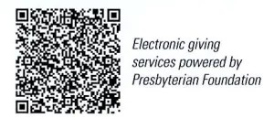
First Presbyterian Church
In the heart of Gardner since 1866 ~ Serving from the heart of God

Sunday, August 25, 2024
8:45 AM

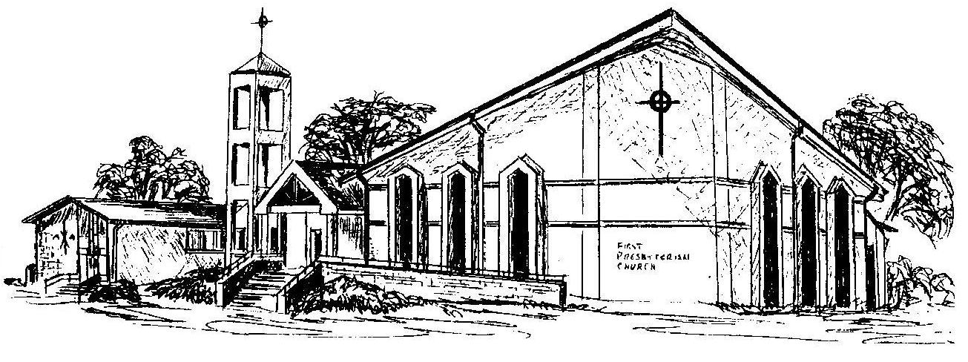

Welcome - Thank you for joining us for worship today. Please fill out a visitor information card found in the pew racks and place those in the offering plate so that we may follow up with you in the future. Your presence with us today has been a blessing to us, we hope that you have felt the presence of God and the welcome of this congregation.

