Welcome

Prelude “Bless the Lord” A Medley
Let us prepare our hearts and minds for worship.

Call to Worship
Leader: In the beginning God created all things, and God saw that they were good.
People: At our beginning, God created us – unique, irreplaceable, loved, wanted and treasured by God.
Leader: In the image of God, we were created. We were born into the world to live that image of God.
People: As children of God, beloved of Christ, we live God’s love in the world as we serve God faithfully. Let us worship God.

*Opening Hymn: “All Creatures of Our God and King” Red Hymnal, # 64

*Prayer of Confession (Unison)
Creator God, we are grateful that you made us, that you placed us in the world, that you blessed us with life and all good gifts. Forgive us when we have wasted your gifts of creativity and possibility. Forgive us when we have failed to see your grace in the people around us. Forgive us when we have held back that spark given by your Spirit, when we have failed to love as you love. Inspire us again that we might be all you have created us to be. In the name of Jesus Christ we pray and seek to live. Amen.

*Silent Reflection

*Assurance of Pardon

*Gloria Patri (Glory Be to the Father…) Red Hymnal, #623

Children’s Time

Scripture “Genesis 1:26-28” (page 3)
“Romans 8:28-30” (page 1757)
“Colossians 1:15-20” (page 1832)
Leader: The word of the Lord.
People: Thanks be to God.

Music “How Long has it Been” arr. by Mosie Lister

Sermon: “Show Your ID - Imago Dei” Rev. Kimby Young

*Profession of Faith The Apostle's Creed Red Hymnal, inside back cover
I Believe in God the Father Almighty, Maker of heaven and earth, And in Jesus Christ his only Son our Lord; who was conceived by the Holy Ghost, born of the Virgin Mary, suffered under Pontius Pilate, was crucified, dead, and buried; he descended into hell; the third day he rose again from the dead; he ascended into heaven, and sitteth on the right hand of God the Father Almighty; from thence he shall come to judge the quick and the dead. I believe in the Holy Ghost; the holy catholic Church; the communion of saints; the forgiveness of sins; the resurrection of the body; and the life everlasting. Amen

*Hymn “May Jessus Christ be Praised” Red Hymnal, #87 vs.1, 5, 6

Pastoral Prayer & Lord’s Prayer

Offertory Meditation: “Children of the Heavenly Father” Swedish Folk Melody

*Doxology

*Prayer of Dedication

*Closing Hymn: “I Sing the Mighty Power of God” Red Hymnal, #59

*Benediction

*Postlude “Savior, Like a Shepherd Lead Us”
William B. Bradbury / adapted by Chester Nordman
*Those who are comfortably able will please stand.

Rev. Kimby Young, Pastor; Jennifer Waites, Worship Assistant
Dean Faulk, Music Ministries; Alice Rollf, Organist; Robyn Forkner, Pianist
Rhonda Atwater, Solo; Vanessa Marriott, Piano Accompanist
Mike McGuire and Brad Cornell, Slide Production; Kim Liu. Sound

Childcare is always available in the nursery (off the hall to the west of the sanctuary). Children are welcome to stay in the sanctuary thru the whole service, or to leave at any time. Allison Perry is our primary childcare attendant.

Worship Bags for Children are available outside the north door to the sanctuary. Choose books, crayons, pencils, Legos, stuffed toys and other items to fill your bag to use during worship.

Offering Plates are at the entrance of each aisle for your contributions to the work of the church.

A "Suggestion Box" is outside the office for ideas, comments, questions, and thoughts. Contents will be reviewed at session meetings on the 2nd Monday of each month.

Elder On Call Mitch McSwane will be in the narthex this Sunday morning between services to answer questions and hear ideas or concerns.

Womens Fall Book/Bible Study through October 24th at 6:30 p.m. in Fellowship Hall. Study book “The GOD We Can Know” by Rob Fuquay.

On-line Bible study group will start a new study, "From Beginning to Forever - A Study of the Grand Narrative of Scripture", on Oct. 8th. Meeting on Tuesday evening at 6:00 p.m. Interested in joining should email Jennifer Waites at jwaitemail@hotmail.com.

Women of Faith Book Club The next book club will be held on Thursday, December 5 at 6:30p.m. at the home of Jennifer Waites. The book is "Two from Galilee" by Marjorie Holmes. All are welcome. Please join us.

Mitten Tree Watch for the Mitten Tree in early November. New stocking hats, mittens and gloves will be collected for students in need.

Bell Choir will rehearse at 6:00 p.m., Christmas Cantata will rehearse 7:00 p.m., Choir will rehearse 8:00 p.m.

Faith and Blue Event – today, October 13 - 1:00 – 3:00 p.m. at the Gardner Justice Center.

Trunk or Treat and Chili Supper October 27
Bring candy any time.
5-6:00 p.m. – Truck-or-treat and Games – North Parking Lot
5:45-7 p.m. –Chili Supper – Fellowship Hall
Sign up to help, bring food, or to provide a trunk.

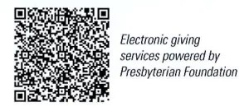
First Presbyterian Church
In the heart of Gardner since 1866 ~ Serving from the heart of God

Sunday, October 13, 2024
8:45 AM
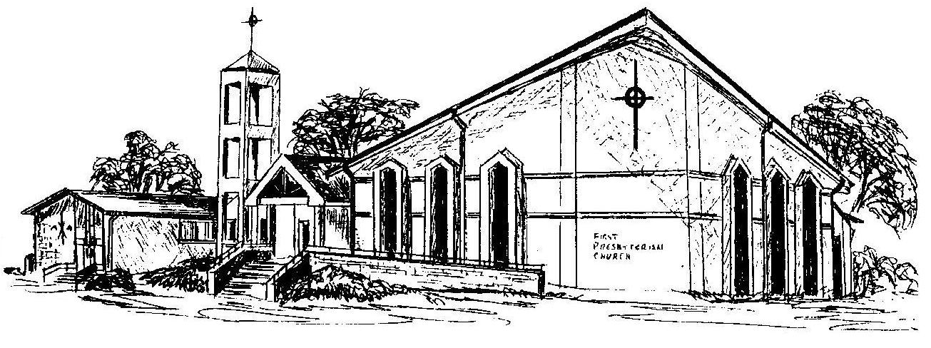

Welcome - Thank you for joining us for worship today. Please fill out a visitor information card found in the pew racks and place those in the offering plate so that we may follow up with you in the future. Your presence with us today has been a blessing to us, we hope that you have felt the presence of God and the welcome of this congregation.

