Welcome
Prelude “Here I Am, Lord”
written by Daniel Schutte, Arr. by Lloyd Larson
Let us prepare our hearts and minds for worship.

Call to Worship (adapted from Christine Sine; Godspace)
Leader: God who is One, calls us to be one.
People: May we be one with all who are made in God’s image.
Leader: God who is Three, calls us to be community.
People: May we find community with all who are called in God’s name.
Leader: God who calls us each by name.
People: May we find our belonging in God’s family of grace.

*Opening Hymn: “The Church’s One Foundation” Red Hymnal, # 277

*Prayer of Confession (Unison) (Unison) (adapted from Ministry Matters)
Loving God, you call us into community, and bless us with abundant life. Yet we turn aside to follow other paths: listening to the world’s call rather than your call to commitment. We let differences divide us. We hold on to resentments. We block your gifts of forgiveness and reconciliation. Forgive us. Draw us into community with each other, that we may grow in faithfulness and work together in peace. Amen.

*Silent Reflection

*Assurance of Pardon

*Gloria Patri (Glory Be to the Father…) Red Hymnal, # 623

Children’s Time

Scripture “Isaiah 58:6-9a” (page 1153)
“Luke 4:14-21” (page 1596)
“1 Corinthians 12:12-13” (page 1785)
Leader: The word of the Lord.
People: Thanks be to God.

Music “Beyond What I Can See”
words & music Larnelle Harris, Mak Kaylor, & Darryl Williams, arr. by Camp Kirkland Sermon: “State of the Union” Rev. Kimby Young

*Profession of Faith The Apostle's Creed Red Hymnal, inside back cover
I Believe in God the Father Almighty, Maker of heaven and earth, and in Jesus Christ his only Son our Lord; who was conceived by the Holy Ghost, born of the Virgin Mary, suffered under Pontius Pilate, was crucified, dead, and buried; he descended into hell; the third day he rose again from the dead; he ascended into heaven, and sitteth on the right hand of God the Father Almighty; from thence he shall come to judge the quick and the dead. I believe in the Holy Ghost; the holy catholic Church; the communion of saints; the forgiveness of sins; the resurrection of the body; and the life everlasting. Amen

*Hymn “Blest Be The Tie That Binds” Red Hymnal, # 286

Pastoral Prayer & Lord’s Prayer

Offertory Meditation: “Nearer, My God, to Thee”
written by Lowell Mason, Arr. by Mark Hayes

*Doxology

*Prayer of Dedication

*Closing Hymn: “Come All Christians Be Committed” Red Hymnal, # 455

*Benediction

*Postlude “Goodness of God”
words and Music by E. Cash, B. Fielding, J. Ingram, B. Johnson, J. Johnson,
arr. by R. Kingsmore
*Those who are comfortably able will please stand.

Rev. Kimby Young, Pastor; Robyn Forkner, Worship Assistant
Chancel Choir; Dean Faulk, Music Ministries
Robyn Forkner, Pianist
Mike McGuire and Brad Cornell, Slide Production; Kim Liu Sound
Childcare is always available in the nursery (off the hall to the west of the sanctuary). Children are welcome to stay in the sanctuary thru the whole service, or to leave at any time. Allison Perry is our primary childcare attendant.

Worship Bags for Children are available outside the north door to the sanctuary. Choose books, crayons, pencils, Legos, stuffed toys and other items to fill your bag to use during worship.

Offering Plates are at the entrance of each aisle for your contributions to the work of the church.

Gardner Multi Service Center collection is ongoing every week and is always in need of any non-perishable food. Bring something every week or once a month.

Fair Trade Products for Sale on Sundays Coffee, tea, chocolate, nuts, olive oil, dried fruit, baking products, and a few other items are for sale each Sunday at church.

Harvesters Food Distribution is always seeking volunteers. Every 3rd Saturday at Trade Net Parking lot and every 4th Wednesday at Divine Mercy Parish. Distribution begins at about 1 p.m.

A "Suggestion Box" is outside the office for ideas, comments, questions, and thoughts. Contents will be reviewed at session meetings on the 2nd Monday of each month.

Joy Closet – Our mission center thrift store provides free clothing to a variety of needs. Extra items are sold at low cost. Volunteers are trained in a variety of jobs and work at different times. Our church provides all volunteers on the fourth Saturday of each month.

The session has called a congregational meeting today, January 26 at 9:45 a.m.

Confirmation Class will start today at 3:00 p.m.

Sunday, February 9, Souper Bowl of caring offering received both services.

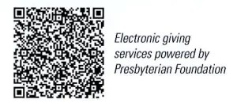

First Presbyterian Church
In the heart of Gardner since 1866 ~ Serving from the heart of God

January 26, 2025
8:45 AM

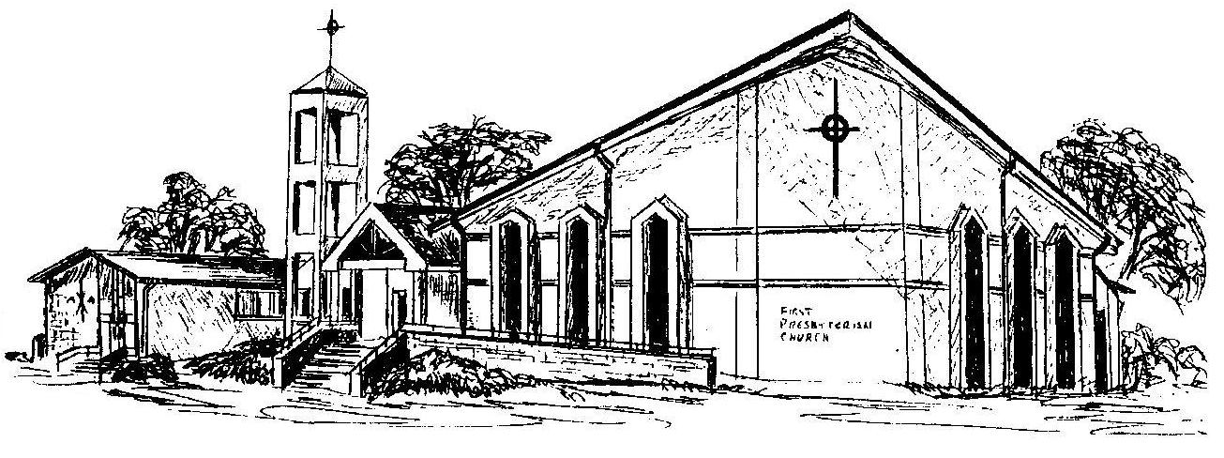
Welcome - Thank you for joining us for worship today. Please fill out a visitor information card found in the pew racks and place those in the offering plate so that we may follow up with you in the future. Your presence with us today has been a blessing to us, we hope that you have felt the presence of God and the welcome of this congregation.

