Welcome
Prelude “
Let us prepare our hearts and minds for worship.

Call to Worship
Leader: This Reformation Sunday, we gather remembering God’s grace for many generations.
People: We remember God’s presence and look forward to the future God has promised.
Leader: We remember that we are one in Christ and it is Christ alone who saves us.
People: We celebrate the Church that was, the Church that is, and the Church that yet will be, to the glory of God.

*Opening Hymn: “A Mighty Fortress Is Our God” Red Hymnal, #26

*Prayer of Confession (Unison)
God of Formation and Reformation, we give thanks for the Church Universal and for this our local church in Gardner. We know that we are not perfect, that we have made mistakes, and that we sometimes have not lived up to your high calling. We pray, forgive us and reshape us again. Help us to make amends for any wrong we have done. Inspire us to be the best that we can be. Open our hearts to your transformation that we may become your grace filled servants, sharing your love and working for your justice, through Jesus Christ our Lord. Amen.

*Silent Reflection

*Assurance of Pardon (from 1 John 1:8-9)
Leader: If we say that we have no sin, we deceive ourselves, and the truth is not in us.
People: If we confess our sins, God, who is faithful and just, will forgive our sins, and cleanse us from all unrighteousness.
Leader: Friends, hear and believe the good news of God’s amazing grace.
People: In Jesus Christ we are forgiven and set free to wholeness and new life.

*Gloria Patri (Glory Be to the Father…) Red Hymnal, #623

Children’s Time

Scripture “Matthew 7:24-29” (page 1506)
“Ephesians 2:13-22” (page 1819)
“1 Corinthians 6:19-20” (page 1778)
Leader: The word of the Lord.
People: Thanks be to God.

Choir “

Sermon: “Dwelling Place for God” Rev. Kimby Young

*Profession of Faith The Apostle's Creed Red Hymnal, inside back cover
I Believe in God the Father Almighty, Maker of heaven and earth, And in Jesus Christ his only Son our Lord; who was conceived by the Holy Ghost, born of the Virgin Mary, suffered under Pontius Pilate, was crucified, dead, and buried; he descended into hell; the third day he rose again from the dead; he ascended into heaven, and sitteth on the right hand of God the Father Almighty; from thence he shall come to judge the quick and the dead. I believe in the Holy Ghost; the holy catholic Church; the communion of saints; the forgiveness of sins; the resurrection of the body; and the life everlasting. Amen

*Hymn “Be Thou My Vision” Red Hymnal, # 382

Pastoral Prayer & Lord’s Prayer

Offertory Meditation “

*Doxology

*Prayer of Dedication

*Closing Hymn: “God of Our Fathers” Red Hymnal, # 573

*Benediction

*Postlude “

*Those who are comfortably able will please stand.

Rev. Kimby Young, Pastor; Amber Hildreth, Worship Assistant
Alice Rollf, Organist; Robyn Forkner, Pianist;
Dean Faulk, Music Ministries
Mike McGuire and Brad Cornell, Slide Production; Kim Liu, Sound

Childcare is always available in the nursery (off the hall to the west of the sanctuary). Children are welcome to stay in the sanctuary thru the whole service, or to leave at any time. Allison Perry is our primary childcare attendant.

Worship Bags for Children are available outside the north door to the sanctuary. Choose books, crayons, pencils, Legos, stuffed toys and other items to fill your bag to use during worship.

Offering Plates are at the entrance of each aisle for your contributions to the work of the church.

A "Suggestion Box" is outside the office for ideas, comments, questions, and thoughts. Contents will be reviewed at session meetings on the 2nd Monday of each month.

Elder On Call Ginger Crist will be in the narthex this Sunday morning between services to answer questions and hear ideas or concerns.

On-line Bible study group continues - "From Beginning to Forever - A Study of the Grand Narrative of Scripture". Meeting on Tuesday evening at 6:00 p.m. Interested in joining should email Jennifer Waites at jwaitemail@hotmail.com.

Women of Faith Book Club The next book club will be held on Thursday, December 5 at 6:30p.m. at the home of Jennifer Waites. The book is "Two from Galilee" by Marjorie Holmes. All are welcome. Please join us.

Mitten Tree Watch for the Mitten Tree in early November. New stocking hats, mittens and gloves will be collected for students in need.

Wednesday Music Rehearsals - Bell Choir is at 6:00 p.m., Christmas Cantata is at 7:00 p.m., Choir is at 8:00 p.m.

Trunk or Treat and Chili Supper! October 27 – Today!! Bring Candy anytime.
5-6:00 p.m. – Truck-or-treat and Games – North Parking Lot
5:45-7 p.m. –Chili Supper – Fellowship Hall

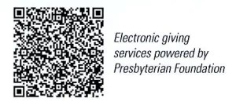

First Presbyterian Church
In the heart of Gardner since 1866 ~ Serving from the heart of God

Sunday, October 27, 2024
8:45 AM
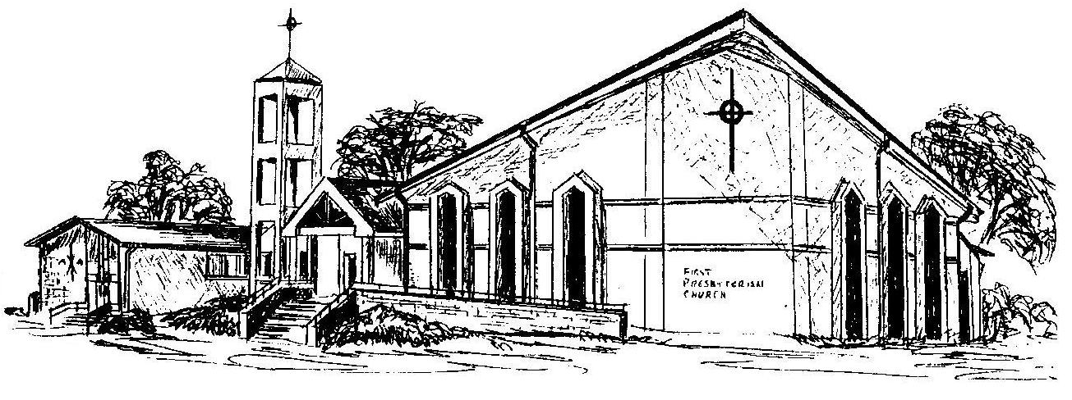

Welcome - Thank you for joining us for worship today. Please fill out a visitor information card found in the pew racks and place those in the offering plate so that we may follow up with you in the future. Your presence with us today has been a blessing to us, we hope that you have felt the presence of God and the welcome of this congregation.

