Welcome
Prelude “I Will Call Upon the Lord” Michael O'Shields
“He is Exalted” Twila Paris
Let us prepare our hearts and minds for worship.

Call to Worship:
Leader: With Christians of many ages, we confess our faith in One Triune God who loves us all.
People: We believe in God the Father Almighty, Creator of heaven and earth.
Leader: We believe in Jesus Christ, God’s only son, our Savior and Lord.
People: We believe in the Holy Spirit moving among us – inspiring, gifting, calling and sending us out in the world to share God’s gracious love.

*Opening Hymn: “The Church’s One Foundation” Red Hymnal, #277

*Prayer of the Confession (Unison)
(from the Pontifical Council for Promoting Christian Unity; based on 1 Corinthians 3: 10-11)
Almighty Lord, no one can lay any foundation other than the one that has been laid by You. That foundation is Jesus Christ. We admit that we have not been able to finish building on this foundation in such a way that we may become the dwelling place of God. We have sometimes even been the cause of its ruin. Even if our work should be lost, save us, Lord, and give us a fresh chance to work for unity. Create in us an ardent longing for the unity of your church and enable us to work towards it. In the name of our Rock and Redeemer, Jesus Christ, we pray. Amen.

*Silent Reflection

*Assurance of Pardon

* Gloria Patri (Glory Be to the Father…) Red Hymnal, #623

Children’s Time

Scripture “Matthew 16:13-19” (page 1524)
“Romans 10: 9-13” (page 1760)
“Acts 1: 8” (page 1691)
Leader: The word of the Lord.
People: Thanks be to God.

Music “They’ll Know We Are Christians By Our Love”
Tune: St. Brendan’s, arr. by Lani Smith

Sermon “What Do I Believe” Rev. Kimby Young

*Profession of Faith The Apostle's Creed Red Hymnal, inside back cover
I Believe in God the Father Almighty, Maker of heaven and earth, And in Jesus Christ his only Son our Lord; who was conceived by the Holy Ghost, born of the Virgin Mary, suffered under Pontius Pilate, was crucified, dead, and buried; he descended into hell; the third day he rose again from the dead; he ascended into heaven, and sitteth on the right hand of God the Father Almighty; from thence he shall come to judge the quick and the dead. I believe in the Holy Ghost; the holy catholic Church; the communion of saints; the forgiveness of sins; the resurrection of the body; and the life everlasting. Amen

*Hymn “Christ is Made the Sure Foundation” Red Hymnal, # 276

Pastoral Prayer & Lord’s Prayer

Offertory Meditation “My Hope is in the Lord”
Norman J. Clayton and Michael James

*Doxology

*Prayer of Dedication

*Closing Hymn: “The Solid Rock” Red Hymnal, #404

*Benediction

Postlude “What a Mighty God We Serve”
arr. by Ken Barker and Tom Fettke
*Those who are comfortably able will please stand

Rev. Kimby Young, Pastor; Karl Allen, Worship Assistant
Robyn Forkner and Vanessa Marriott, Piano and Organ Duet
Dean Faulk, Music Ministries; Alice Rollf, Organist
Mike McGuire and Brad Cornell, Slide Production; Kim Liu, Sound

Childcare is always available in the nursery (off the hall to the west of the sanctuary). Children are welcome to stay in the sanctuary thru the whole service, or to leave at any time. Allison Perry is our primary childcare attendant.

Worship Bags for Children are available outside the north door to the sanctuary. Choose books, crayons, pencils, Legos, stuffed toys and other items to fill your bag to use during worship.

Offering Plates are at the entrance of each aisle for your contributions to the work of the church.

Gardner Multi Service Center collection is ongoing every week and is always in need of any non-perishable food. Bring something every week or once a month.

Fair Trade Products for Sale on Sundays Coffee, tea, chocolate, nuts, olive oil, dried fruit, baking products, and a few other items are for sale each Sunday at church.

Harvesters Food Distribution is always seeking volunteers. Every 3rd Saturday at Trade Net Parking lot and every 4th Wednesday at Divine Mercy Parish. Distribution begins at about 1 p.m.

A "Suggestion Box" is outside the office for ideas, comments, questions, and thoughts. Contents will be reviewed at session meetings on the 2nd Monday of each month.

SAS – Summer Adventures on Sunday - Sunday school for all ages - 10 a.m. To help or lead a week talk to Kimby Young or Marsha Cooper.

Elder On Call Tracy McCabe will be in the narthex this Sunday morning between services to answer questions and hear ideas or concerns.

Women of Faith Book Club - The next Book Club will be held Thursday, August 22, 2024, at 6:30 pm at the home of Linda Jensen, 36400 W. 159th, Gardner, KS. The book of choice is "Mostly What God Does" by Savannah Guthrie. Anyone is welcome to join anytime.

Pack Hygiene Kits for Heart to Heart International September 7 – Travel 9:30 a.m.
Packing time 10:00-noon. Sign up to carpool and attend.

Called Congregational Meeting, Sunday, September 15 at 9:45 a.m. Session has called a congregational meeting for the purpose of electing officers for 2025.

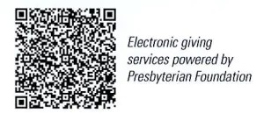
First Presbyterian Church
In the heart of Gardner since 1866 ~ Serving from the heart of God

Sunday, August 18, 2024
8:45 AM

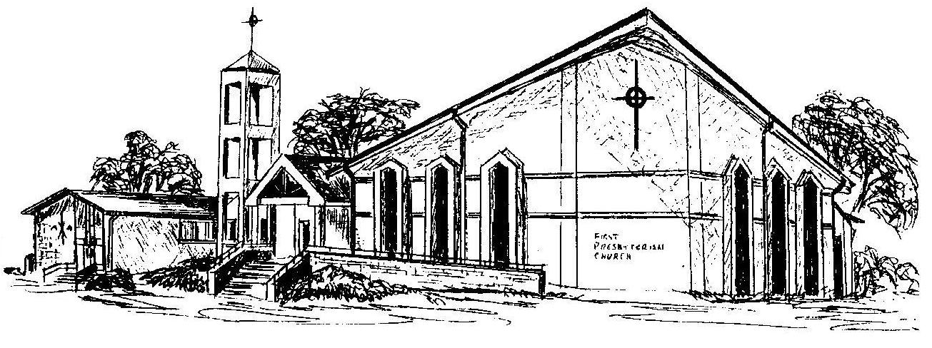

Welcome - Thank you for joining us for worship today. Please fill out a visitor information card found in the pew racks and place those in the offering plate so that we may follow up with you in the future. Your presence with us today has been a blessing to us, we hope that you have felt the presence of God and the welcome of this congregation.

