Welcome
Minute from Mission

Prelude “Enter His Courts with Praise” Adam Mason
Let us prepare our hearts and minds for worship.

Call to Worship: (from Abingdon Worship Annual)
Leader: Come and see the love God has given to us.
People: Come and see what it means to be beloved children of God.
Leader: Come with this hope, that Christ’s presence is real.
People: With joy, we come to see the Lord. With thanksgiving, we worship God.

*Opening Hymn: “How Great Thou Art” Red Hymnal , #4

*Prayer of the Confession (Unison)
(adapted from Carolyn Brown, Worshipping with Children)
Gracious God, you created our hands beautiful and capable, but too often we use them to grab what we want. We ball them into fists. We hide them - pretending there is nothing we could do to help. So, we turn our hands up to you asking for forgiveness. Wash our hands and make them clean. Lead us to use our hands well. Teach us to open our hands to share with others. Show us how to join hands with our neighbors to build your kingdom of love. We pray in Jesus’ name and remembering his loving hands. Amen.

*Silent Reflection

*Assurance of Pardon

* Gloria Patri (Glory Be to the Father…) Red Hymnal, #623

Children’s Time

Scripture “John 13:12-17” (page 1674)
“1 Corinthians 12:4-13” (page 1785)
“James 2:14-17” (page 1882)
Leader: The word of the Lord.
People: Thanks be to God.

Music “He Is Exalted”
words and music by Twila Paris, arr. by Lloyd Larson
Sermon “Priesthood of All Believers: Hands and Feet of Jesus” Rev. Kimby Young

*Profession of Faith The Apostle's Creed Red Hymnal, inside back cover
I Believe in God the Father Almighty, Maker of heaven and earth, And in Jesus Christ his only Son our Lord; who was conceived by the Holy Ghost, born of the Virgin Mary, suffered under Pontius Pilate, was crucified, dead, and buried; he descended into hell; the third day he rose again from the dead; he ascended into heaven, and sitteth on the right hand of God the Father Almighty; from thence he shall come to judge the quick and the dead. I believe in the Holy Ghost; the holy catholic Church; the communion of saints; the forgiveness of sins; the resurrection of the body; and the life everlasting. Amen

*Hymn “Take My Life and Let It Be” Red Hymnal, #379 vs 1, 2, and 6

Pastoral Prayer & Lord’s Prayer

Offertory Meditation “Let Your Heart Be Broken” James Mountain

*Doxology

*Prayer of Dedication

*Closing Hymn: “Come, All Christians, Be Committed” Red Hymnal, #455

*Benediction

Congregational Meeting Purpose of Electing Officers
Elders - Seth Cooper, Mitch McSwane, Dave Sinclair, Eric Gourley and Karl Allen
Deacons - Carl Frahme, Susan Rushing, Julie Sutton, Cathy Cochran, and Teri Winegar
Nominating Committee at large members class of 2025
– Paula Waters, Larry Atwater, Lois Barber, Phil Lenahan, Robin Tropansky

Postlude “We’ve a Story to Tell to the Nations” H. Ernest Nichol
*Those who are comfortably able will please stand.

Rev. Kimby Young, Pastor; Lynn Moldrup, Worship Assistant
Chancel Choir; Dean Faulk, Music Ministries; Alice Rollf, Organist
Mike McGuire and Brad Cornell, Slide Production; Kim Liu, Sound

Childcare is always available in the nursery (off the hall to the west of the sanctuary). Children are welcome to stay in the sanctuary thru the whole service, or to leave at any time. Allison Perry is our primary childcare attendant.

Worship Bags for Children are available outside the north door to the sanctuary. Choose books, crayons, pencils, Legos, stuffed toys and other items to fill your bag to use during worship.

Offering Plates are at the entrance of each aisle for your contributions to the work of the church.

Gardner Multi Service Center collection is ongoing every week and is always in need of any non-perishable food. Bring something every week or once a month.

Fair Trade Products for Sale on Sundays Coffee, tea, chocolate, nuts, olive oil, dried fruit, baking products, and a few other items are for sale each Sunday at church.

Harvesters Food Distribution is always seeking volunteers. Every 3rd Saturday at Trade Net Parking lot and every 4th Wednesday at Divine Mercy Parish. Distribution begins at about 1 p.m.

A "Suggestion Box" is outside the office for ideas, comments, questions, and thoughts. Contents will be reviewed at session meetings on the 2nd Monday of each month.

Elder On Call Lynn Moldrup will be in the narthex this Sunday morning between services to answer questions and hear ideas or concerns.

Womens Fall Book/Bible Study through October 24th at 6:30 p.m. in Fellowship Hall. Study book “The GOD We Can Know” by Rob Fuquay.

Womens Book Club please join us in October and November to discuss the book "Two from Galilee" by Marjorie Holmes. Dates and locations are yet to be determined.

Bell Choir will rehearse at 6:00 p.m. and the Choir will rehearse at 7:00 p.m. If you would like to sing the Christmas Cantata rehearsals will start October 2nd at 8:00 p.m.

Kimby’s Bible Study Thursday’s, 10-11:30 a.m. in Fellowship Hall studying “Acts”.

Sunday Morning Groups for Adults 10a.m. each Sunday All are welcome.
Seekers and Servants – led by Alice Rollf and Paula Waters - in the library. Studies a book.
Parenting Group - led by Cindy Rollf in PYF room downstairs - video based short term series.
Men's Devotional Discussion – led by Phil Lenahan - Calvin room off the office. Shares devotion.
Bible Reflection - led by Mary Wykes - in Westminster room off of fellowship hall. Lectio Divina - read and reflect on a Biblical passage - sharing faith together.

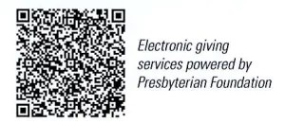
First Presbyterian Church
In the heart of Gardner since 1866 ~ Serving from the heart of God

Sunday, September 15, 2024
8:45 AM
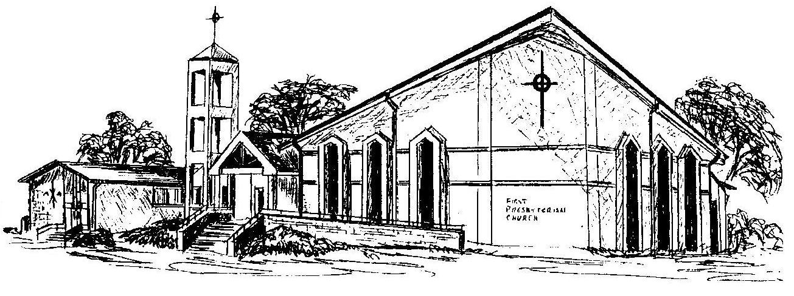

Welcome - Thank you for joining us for worship today. Please fill out a visitor information card found in the pew racks and place those in the offering plate so that we may follow up with you in the future. Your presence with us today has been a blessing to us, we hope that you have felt the presence of God and the welcome of this congregation.

