Welcome

Prelude
Let us prepare our hearts and minds for worship.

Call to Worship
Leader: In the beginning, God’s Spirit moved over the waters.
People: Even today, the Spirit of God moves through water to remind us of God’s grace.
Leader: In baptism, we are touched by God’s Spirit, enfolded in a community of grace, and empowered to go forth sharing God’s love in the world.
People: Let us celebrate God’s grace, remembering our baptisms and accepting our call to serve God in Jesus Christ our Lord.

*Opening Hymn: “Amazing Grace” Red Hymnal, # 202

*Prayer of Confession (Unison) (adapted from Stephen Fearing, Wild and Precious Life.)
God of our baptismal waters, You sent John the Baptist to point to Your Son, and You sent Your Son who pointed always to You. But too often, we point only to ourselves or our own concerns. Forgive us, Lord, for pointing in all the wrong directions. Hold our gaze on your baptismal promise sealed in the life, death, and resurrection of your Son. Through the power of your Spirit, give us the courage to speak what we have seen and point to the One who takes away the sins of the world. In the name of your son, Jesus Christ, we pray. Amen.

*Silent Reflection

*Assurance of Pardon (from 1 John 3:1 and baptism liturgy)
Leader: God hears our prayers and responds with everlasting grace.
People: We remember God’s love and accept God’s forgiveness in Jesus Christ.
Leader: See what love God has for us that we should be called children of God.
People: We are God’s beloved and we have received new life in Christ. Thanks be to God!

*Gloria Patri (Glory Be to the Father…) Red Hymnal, # 623

Children’s Time

Scripture “Matthew 3:13-17” (page 1499)
“John 1:29-42” (page 1647)
Leader: The word of the Lord.
People: Thanks be to God.

Music “The First Christmas” Doug Stone
Sermon: “Revealing God” Rev. Kimby Young

*Profession of Faith The Apostle's Creed Red Hymnal, inside back cover
I Believe in God the Father Almighty, Maker of heaven and earth, and in Jesus Christ his only Son our Lord; who was conceived by the Holy Ghost, born of the Virgin Mary, suffered under Pontius Pilate, was crucified, dead, and buried; he descended into hell; the third day he rose again from the dead; he ascended into heaven, and sitteth on the right hand of God the Father Almighty; from thence he shall come to judge the quick and the dead. I believe in the Holy Ghost; the holy catholic Church; the communion of saints; the forgiveness of sins; the resurrection of the body; and the life everlasting. Amen

*Hymn “Take My Life and Let It Be” Red Hymnal, # 379 verses 1, 5, 6

Reaffirmation of Baptism Covenant:
Trusting in the gracious promises of God, do you renounce sin and the power of evil in your life and in the world?
Do you turn again to Jesus Christ and accept Jesus as your Lord and Savior?
Do you intend to be Christ's faithful disciple, obeying God’s Word, showing God’s love and sharing God’s grace in the world?

Pastoral Prayer & Lord’s Prayer

Offertory Meditation:

*Doxology

Prayer of Dedication

*Closing Hymn: “Have Thine Own Way Lord” Red Hymnal, # 371

*Benediction

*Postlude
*Those who are comfortably able will please stand.

Rev. Kimby Young, Pastor; Susan Rushing, Worship Assistant
Chesley Jones, Soloist;; Dean Faulk, Music Ministries
Robyn Forkner, Pianist
Mike McGuire and Brad Cornell, Slide Production; Kim Liu. Sound
Childcare is always available in the nursery (off the hall to the west of the sanctuary). Children are welcome to stay in the sanctuary thru the whole service, or to leave at any time. Allison Perry is our primary childcare attendant.

Worship Bags for Children are available outside the north door to the sanctuary. Choose books, crayons, pencils, Legos, stuffed toys and other items to fill your bag to use during worship.

Offering Plates are at the entrance of each aisle for your contributions to the work of the church.

Gardner Multi Service Center collection is ongoing every week and is always in need of any non-perishable food. Bring something every week or once a month.

Fair Trade Products for Sale on Sundays Coffee, tea, chocolate, nuts, olive oil, dried fruit, baking products, and a few other items are for sale each Sunday at church.

Harvesters Food Distribution is always seeking volunteers. Every 3rd Saturday at Trade Net Parking lot and every 4th Wednesday at Divine Mercy Parish. Distribution begins at about 1 p.m.

A "Suggestion Box" is outside the office for ideas, comments, questions, and thoughts. Contents will be reviewed at session meetings on the 2nd Monday of each month.

Joy Closet – Our mission center thrift store provides free clothing to a variety of needs. Extra items are sold at low cost. Volunteers are trained in a variety of jobs and work at different times. We have a job that fits every ability. Our church provides all volunteers on the fourth Saturday of each month.

Men’s Breakfast on Tuesday, January 14 7:00 a.m. at Perkins.

The session has called a congregational meeting for Sunday, January 26 at 9:45 a.m. The purpose of the meeting is to receive our annual reports from staff, committees, groups and pillars, and to approve the terms of call for pastor Kimby Young.

Confirmation Class will start on Sunday, January 26 at 3:00 p.m.

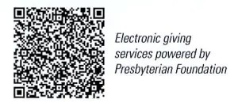
First Presbyterian Church
In the heart of Gardner since 1866 ~ Serving from the heart of God

January 12, 2025
Baptism of the Lord Sunday
8:45 AM

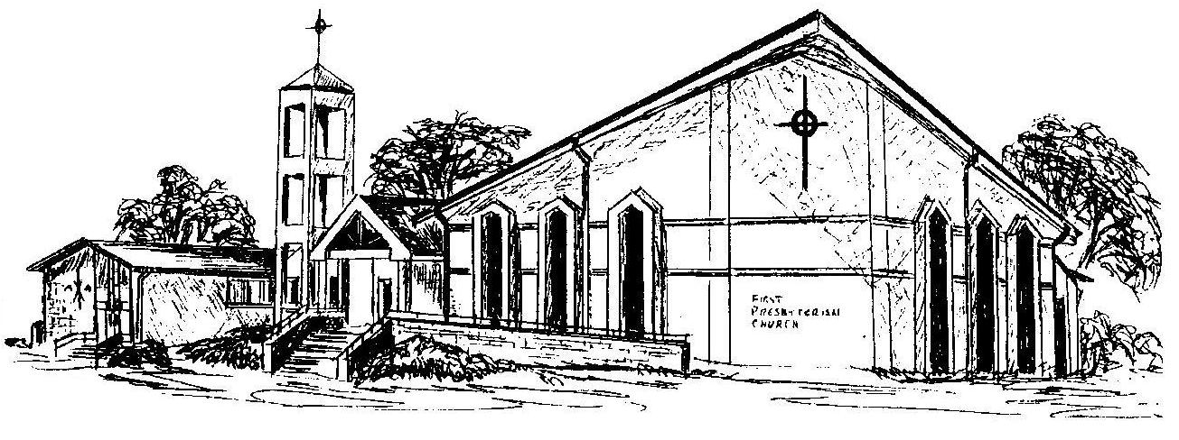
Welcome - Thank you for joining us for worship today. Please fill out a visitor information card found in the pew racks and place those in the offering plate so that we may follow up with you in the future. Your presence with us today has been a blessing to us, we hope that you have felt the presence of God and the welcome of this congregation.

