Welcome
Minute from Finance & Operations

Prelude “Song of Praise”
J.S. Bach /arr. by Ellen Jane Lorenz
Let us prepare our hearts and minds for worship.

Call to Worship:
Leader: You who are created in the image of God, let us worship this God of all creation.
People: We worship God by caring for the people and the world around us.
Leader: You who are called to follow Jesus Christ, let us serve God as we gather together.
People: We celebrate God’s gifts of amazing grace. We respond with joy to God’s abundant love.

*Opening Hymn: “Morning Has Broken” Red Hymnal , #60

*Prayer of the Confession (Unison)
Creator God, we know that you have blessed us with everything we could possibly need. We know that you are with us at all times and that you love us without limits. However, fear sometimes captures our hearts and confuses our thinking. We worry about what might happen and we are reluctant to take chances. Help us to hear your call to care. Empower us to reach out in love. Inspire us to share the gifts you have given with generosity, confidence and joy. In Jesus name we pray. Amen.

*Silent Reflection

*Assurance of Pardon

* Gloria Patri (Glory Be to the Father…) Red Hymnal, #623

Children’s Time

Scripture “Genesis 1:26-28” (page 3)
“Genesis 12:1-3” (page 17)
“Luke 4:16-21” (page 1596)
“Luke 6:38” (page 1601)
“Luke 12:48b” (page 1619)
“John 15:7-12” (page 1677)
Leader: The word of the Lord.
People: Thanks be to God.
Music “This Little Light of Mine”
words and music by Joel Raney, arr. by Joel Raney

Sermon “Stewardship: Response Ability” Rev. Kimby Young

*Profession of Faith The Apostle's Creed Red Hymnal, inside back cover
I Believe in God the Father Almighty, Maker of heaven and earth, And in Jesus Christ his only Son our Lord; who was conceived by the Holy Ghost, born of the Virgin Mary, suffered under Pontius Pilate, was crucified, dead, and buried; he descended into hell; the third day he rose again from the dead; he ascended into heaven, and sitteth on the right hand of God the Father Almighty; from thence he shall come to judge the quick and the dead. I believe in the Holy Ghost; the holy catholic Church; the communion of saints; the forgiveness of sins; the resurrection of the body; and the life everlasting. Amen

*Hymn “There Shall Be Showers of Blessing” Red Hymnal, #289

Pastoral Prayer & Lord’s Prayer

Offertory Meditation “Give of Your Best to the Master” Charlotte A. Barnard

*Doxology

*Prayer of Dedication

*Closing Hymn: “Blessed Assurance” Red Hymnal, #345

*Benediction

Postlude “Great is Thy Faithfulness” William M. Runyan
*Those who are comfortably able will please stand.

Rev. Kimby Young, Pastor; Teri Winegar, Worship Assistant
Chancel Choir; Dean Faulk, Music Ministries
Alice Rollf, Organist; Robyn Forkner, Pianist
Mike McGuire and Brad Cornell, Slide Production; Kim Liu, Sound

Childcare is always available in the nursery (off the hall to the west of the sanctuary). Children are welcome to stay in the sanctuary thru the whole service, or to leave at any time. Allison Perry is our primary childcare attendant.

Worship Bags for Children are available outside the north door to the sanctuary. Choose books, crayons, pencils, Legos, stuffed toys and other items to fill your bag to use during worship.

Offering Plates are at the entrance of each aisle for your contributions to the work of the church.

Gardner Multi Service Center collection is ongoing every week and is always in need of any non-perishable food. Bring something every week or once a month.

Fair Trade Products for Sale on Sundays Coffee, tea, chocolate, nuts, olive oil, dried fruit, baking products, and a few other items are for sale each Sunday at church.

Harvesters Food Distribution is always seeking volunteers. Every 3rd Saturday at Trade Net Parking lot and every 4th Wednesday at Divine Mercy Parish. Distribution begins at about 1 p.m.

A "Suggestion Box" is outside the office for ideas, comments, questions, and thoughts. Contents will be reviewed at session meetings on the 2nd Monday of each month.

Elder On Call Seth Cooper will be in the narthex this Sunday morning between services to answer questions and hear ideas or concerns.

Womens Fall Book/Bible through October 24th at 6:30 p.m. in Fellowship Hall. Study book "The GOD We Can Know" by Rob Fuquay.

Womens Book Club please join us in October and November to discuss the book "Two from Galilee" by Marjorie Holmes. Dates and locations are yet to be determined.

Bell Choir will rehearse at 6:00 p.m. and the Choir will rehearse at 7:00 p.m. If you would like to sing the Christmas Cantata rehearsals will start October 2nd at 8:00 p.m.

Kimby’s Bible Study Thursday, Sept. 25th 10-11:30 a.m. in Fellowship Hall studying “Acts”.

Kimby will take a week of vacation from September 23rd – September 30th. Guest preacher for Sunday, September 29 will be Amgad Megally at 10:00 a.m. service. Potluck to follow the service.

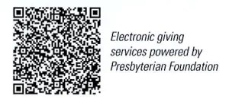
First Presbyterian Church
In the heart of Gardner since 1866 ~ Serving from the heart of God

Sunday, September 22, 2024
8:45 AM
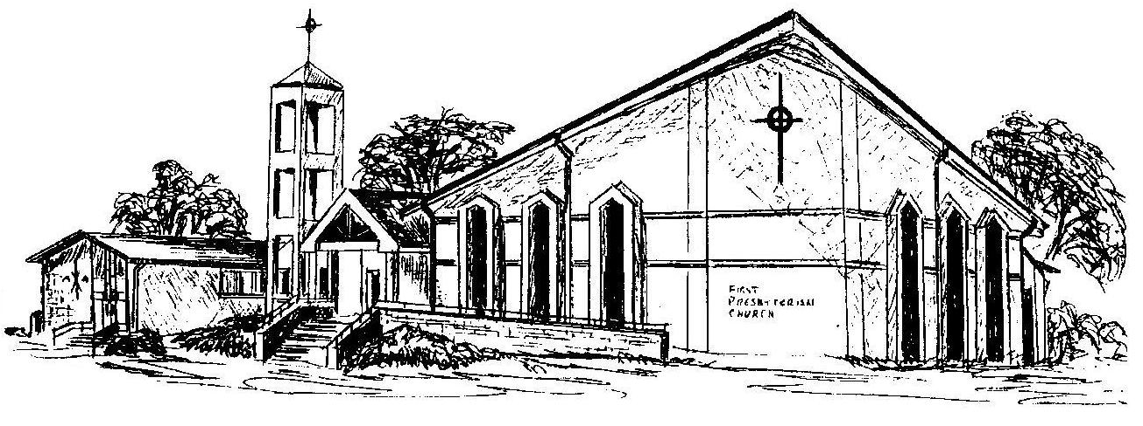

Welcome - Thank you for joining us for worship today. Please fill out a visitor information card found in the pew racks and place those in the offering plate so that we may follow up with you in the future. Your presence with us today has been a blessing to us, we hope that you have felt the presence of God and the welcome of this congregation.

