Welcome
Prelude “Praise Medley”
Let us prepare our hearts and minds for worship.

Call to Worship
Leader: Jesus has called you by name.
People: We hear the voice of our Savior and we come to worship with great joy.
Leader: God knows you and loves you. You belong to God.
People: We will follow Jesus in the way of love.

*Opening Hymn: “Joyful, Joyful, We Adore Thee Red Hymnal, #1

*Prayer of Confession (Unison)
Shepherd God of Love, you call each of us by name. We hear your voice. We want to come to you. But fear binds us. Worry distracts us. Busy-ness exhausts us. We wander where we are not meant to go. Call us again. Help us to hear. Remind us that we belong to you. We know you love us and you lead us by the grace of Jesus Christ our Lord.

*Silent Reflection

*Assurance of Pardon

* Gloria Patri (Glory Be to the Father…) Red Hymnal, #623

Bell Choir

Children’s Time

Scripture John 11:17-44” (page 1668)
Leader: The word of the Lord.
People: Thanks be to God.

Anthem “You Are My All in All”
Words and music by Dennis Jernigan / arr. Larry Shackley

Sermon “Unbound Resurrection” Rev. Kimby Young

*Profession of Faith The Apostle's Creed Red Hymnal, inside back cover
I Believe in God the Father Almighty, Maker of heaven and earth, And in Jesus Christ his only Son our Lord; who was conceived by the Holy Ghost, born of the Virgin Mary, suffered under Pontius Pilate, was crucified, dead, and buried; he descended into hell; the third day he rose again from the dead; he ascended into heaven, and sitteth on the right hand of God the Father Almighty; from thence he shall come to judge the quick and the dead. I believe in the Holy Ghost; the holy catholic Church; the communion of saints; the forgiveness of sins; the resurrection of the body; and the life everlasting. Amen

*Hymn “O Master Let Me Walk With Thee” Red Hymnal, #451

Pastoral Prayer & Lord’s Prayer

Offertory Meditation “Jesus of Nazareth”
Hugh W. Dougall / arr. by Brent Jorgensen

*Doxology

*Prayer of Dedication

*Closing Hymn: “Be Still My Soul” Red Hymnal, #347

*Benediction

Postlude “Go Now in Peace” Don Besig
*Those who are comfortably able will please stand.

Rev. Kimby Young, Pastor; Wayne Rollf, Worship Assistant
Dean Faulk, Music Ministries; Chancel Choir
Alice Rollf, Organist
Mike McGuire and Brad Cornell, Slide Production
Theo Borge, Tech, and Videographer; Kim Liu, Soun

Childcare is always available in the nursery (off the hall to the west of the sanctuary). Children are welcome to stay in the sanctuary thru the whole service, or to leave at any time. Allison Perry is our primary childcare attendant.

Offering Plates are at the entrance of each aisle for your contributions to the work of the church.

Gardner Multi Service Center collection is ongoing every week and is always in need of any non-perishable food. Bring something every week or once a month.

Fair Trade Products for Sale on Sundays Coffee, tea, chocolate, nuts, olive oil, dried fruit, baking products, and a few other items are for sale each Sunday at church.

Harvesters Food Distribution is always seeking volunteers. Every 3rd Saturday at Trade Net Parking lot and every 4th Wednesday at Divine Mercy Parish. Distribution begins at about 1 p.m.

Session has established a "Suggestion Box" just outside the office for ideas, comments, questions, and thoughts. Contents will be reviewed at session meetings on the 2nd Monday of each month. Names are helpful if we need to follow up, but you may remain anonymous.

Card Shower for Juanita Murrow 90th Birthday on May 1. Cards may be dropped in the basket in the Narthex or mailed to be received by Monday, 4/29. Juanita Murrow c/o Robyn McGuire, 20260 S. Gardner, Rd., Gardner, KS 66030.

Women’s Fellowship Group meets on Wednesday, May 1, at 10:00 a.m. in the Fellowship Hall.
Please join us for a morning of fellowship, including devotions by Tina Fraser and refreshments by Jan Richardson.

John Forkner is asking members to sign up for Ushers during the summer months. Please let him know if you can help.

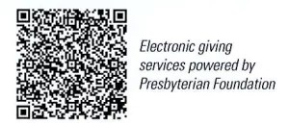
First Presbyterian Church
In the heart of Gardner since 1866 ~ Serving from the heart of God

Sunday, April 28, 2024
8:45 AM
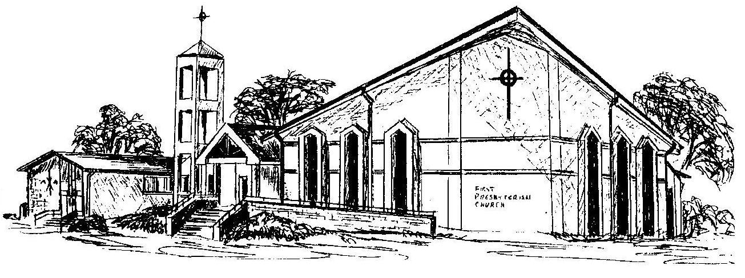

Welcome - Thank you for joining us for worship today. Please fill out a visitor information card found in the pew racks and place those in the offering plate so that we may follow up with you in the future. Your presence with us today has been a blessing to us, we hope that you have felt the presence of God and the welcome of this congregation.

