Welcome
Prelude
Let us prepare our hearts and minds for worship.

Call to Worship (translated and adapted from Teresa of Avila - 16th century).
Leader: Christ has no body now on earth but yours;
People: No hands but yours; No feet but yours;
Leader: Yours are the eyes through which is to look out Christ’s compassion to the world;
People: Yours are the feet with which Jesus is to go about doing good;
Leader: Yours are the hands with which he is to bless now.
People: Let us worship God with all of ourselves.

*Opening Hymn: “Great Is Thy Faithfulness” Red Hymnal, #43

*Prayer of Confession (Unison)
(adapted from Rev. MaryAnn R. Rennie, Church of Scotland)
Redeeming God, out of the flames of your creation, your voice calls, marking us as your own. Yet there are times when we choose to ignore your voice, and listen instead to our own needs and desires. Forgive us for those times; when we have ignored the needs of others; when we have failed to place our feet upon your path; when we allow the earthly voice to distract us from your call. Loving Lord, in hearing your voice may we find our place within your creation. AMEN.

*Silent Reflection

*Assurance of Pardon

*Gloria Patri (Glory Be to the Father…) Red Hymnal, #623

Children’s Time

Scripture “ Isaiah 52:7” (page 1144)
“ Exodus 3:1-6” (page 90)
“John 13:1-5, 12-17” (page 1673)
“ 1 Corinthians 12:12-14” (page 1785)
Leader: The word of the Lord.
People: Thanks be to God.

Anthem “The Name of Jesus”
arr. by Dennis Allen

Sermon “Beautiful Feet” Rev. Kimby Young

*Profession of Faith The Apostle's Creed Red Hymnal, inside back cover
I Believe in God the Father Almighty, Maker of heaven and earth, And in Jesus Christ his only Son our Lord; who was conceived by the Holy Ghost, born of the Virgin Mary, suffered under Pontius Pilate, was crucified, dead, and buried; he descended into hell; the third day he rose again from the dead; he ascended into heaven, and sitteth on the right hand of God the Father Almighty; from thence he shall come to judge the quick and the dead. I believe in the Holy Ghost; the holy catholic Church; the communion of saints; the forgiveness of sins; the resurrection of the body; and the life everlasting. Amen

*Hymn “Take My Life and Let It Be” Red Hymnal, #379 vs 1,2,3,6

Pastoral Prayer & Lord’s Prayer

Offertory Meditation:

*Doxology

*Prayer of Dedication

*Closing Hymn: “In the Garden” Red Hymnal, #425

*Benediction

Postlude
*Those who are comfortably able will please stand.

Rev. Kimby Young, Pastor; Karen Elliott, Worship Assistant
Dean Faulk, Music Ministries; Chancel Choir
Harlan Plunkett, Organist; Robyn Forkner, Pianist
Mike McGuire and Brad Cornell, Slide Production; Kim Liu, Sound

Childcare is always available in the nursery (off the hall to the west of the sanctuary). Children are welcome to stay in the sanctuary thru the whole service, or to leave at any time. Allison Perry is our primary childcare attendant.

Worship Bags for Children are available outside the north door to the sanctuary. Choose books,
crayons, pencils, Legos, stuffed toys and other items to fill your bag to use during worship.

Offering Plates are at the entrance of each aisle for your contributions to the work of the church.

Gardner Multi Service Center collection is ongoing every week and is always in need of any non-perishable food. Bring something every week or once a month.

Fair Trade Products for Sale on Sundays Coffee, tea, chocolate, nuts, olive oil, dried fruit, baking products, and a few other items are for sale each Sunday at church.

Harvesters Food Distribution is always seeking volunteers. Every 3rd Saturday at Trade Net Parking lot and every 2nd Thursday at Divine Mercy Parish. Distribution begins at 1 p.m.

Joy Closet – Our mission center thrift store provides free clothing to a variety of needs. Our church provides all volunteers on the fourth Saturday of each month.

A "Suggestion Box" is outside the office for ideas, comments, questions and thoughts. Contents will be reviewed at session meetings on the 2nd Monday of each month.

Mission Pillar Hygiene Kits - raising funds now $5 per kit - goal of over 200 kits. Assemble kits on Saturday July 12 (time TBD) at Heart to Heart International warehouse. Please mark your donations to "FPC" for "Mission Kits."

Kimby will take vacation from May 19-25. Guest Preacher on Sunday, May 25 is Susan Cox.

Worship Service on Sunday, May 25 at 10:00 a.m. Memorial Day Weekend.

Sunday, June 1 Ice cream social between services.

Sunday, June 8, remember to wear red in celebration of Pentecost.

Ladies Community Luncheon at Divine Mercy Parish on Saturday, June 14, 2025, 11:30 a.m., 555 W Main Street. Come for fun and fellowship.
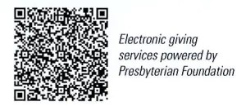
First Presbyterian Church
In the heart of Gardner since 1866 ~ Serving from the heart of God

Sunday, May 18, 2025
8:45 AM

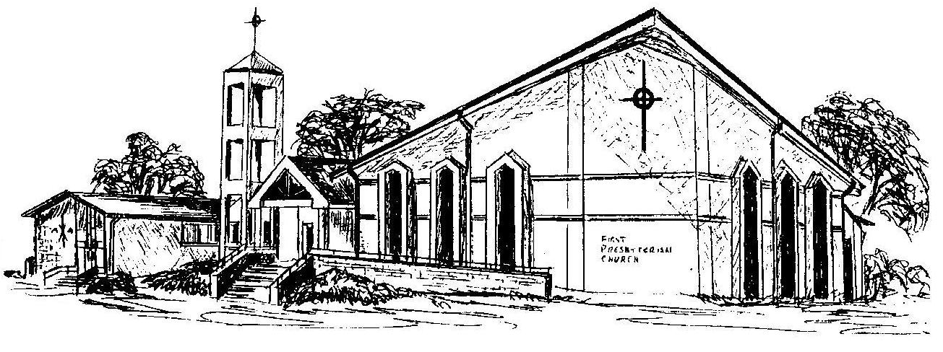

Welcome - Thank you for joining us for worship today. Please fill out a visitor information card found in the pew racks and place those in the offering plate so that we may follow up with you in the future. Your presence with us today has been a blessing to us, we hope that you have felt the presence of God and the welcome of this congregation.

