Welcome
Prelude “America, Our Heritage” Helen Steele
Let us prepare our hearts and minds for worship.

Call to Worship:
Leader: In this great nation we celebrate freedom of worship.
People: We praise God with hearts and hands and voices.
Leader: We celebrate the diversity of God’s creation and God’s people.
People: We are grateful for God’s gifts and pledge to share God’s love.

*Opening Hymn: “My Country Tis of Thee” Red Hymnal ,#571

*Prayer of the Confession (Unison)
Great God of freedom and justice for all. Oddly enough in this land of liberty, we sometimes forget the freedom You have won for all. We confess that sometimes we think everyone should think and act the way we do. Sometimes we read your scripture the way we want to read, rather than seeking your inspiration and guidance. Open our eyes. Open our ears. Open our hearts to Your voice of truth and love. In the name of Jesus we pray. Amen.

*Silent Reflection

*Assurance of Pardon

* Gloria Patri (Glory Be to the Father…) Red Hymnal, #623

Children’s Time

Scripture “Psalm 119:97-105” (page 961)
“Luke 24:27-32” (page 1643)
“Hebrews 1:1-4” (page 1862)
Leader: The word of the Lord.
People: Thanks be to God.

Duet: Pat Revey and Rhonda Atwater

Sermon “How We Read Scripture” Rev. Kimby Young

*Profession of Faith The Apostle's Creed Red Hymnal, inside back cover
I Believe in God the Father Almighty, Maker of heaven and earth, And in Jesus Christ his only Son our Lord; who was conceived by the Holy Ghost, born of the Virgin Mary, suffered under Pontius Pilate, was crucified, dead, and buried; he descended into hell; the third day he rose again from the dead; he ascended into heaven, and sitteth on the right hand of God the Father Almighty; from thence he shall come to judge the quick and the dead. I believe in the Holy Ghost; the holy catholic Church; the communion of saints; the forgiveness of sins; the resurrection of the body; and the life everlasting. Amen

*Hymn “Break Thou the Bread of Life” Red Hymnal, #274

Offertory Meditation “Thy Word” Michael W. Smith

*Doxology

The Sacrament of Holy Communion
(All bread is gluten free. Prepacked elements are available in the back.)
Invitation
Great Prayer and The Lord’s Prayer
Words of Institution – Breaking of Bread
Communion of the People
Prayer of Thanksgiving

*Closing Hymn: “America the Beautiful” Red Hymnal, #572

*Benediction

Postlude “Battle Hymn of the Republic” American Melody
*Those who are comfortably able will please stand.

Rev. Kimby Young, Pastor; Dean Faulk, Music Ministries
Larry Schick, Worship Assistant; Alice Rollf, Organist
Mike McGuire and Brad Cornell, Slide Production; Kim Liu, Sound

Childcare is always available in the nursery (off the hall to the west of the sanctuary). Children are welcome to stay in the sanctuary thru the whole service, or to leave at any time. Allison Perry is our primary childcare attendant.

Offering Plates are at the entrance of each aisle for your contributions to the work of the church.

Gardner Multi Service Center collection is ongoing every week and is always in need of any non-perishable food. Bring something every week or once a month.

Fair Trade Products for Sale on Sundays Coffee, tea, chocolate, nuts, olive oil, dried fruit, baking products, and a few other items are for sale each Sunday at church.

Harvesters Food Distribution is always seeking volunteers. Every 3rd Saturday at Trade Net Parking lot and every 4th Wednesday at Divine Mercy Parish. Distribution begins at about 1 p.m.

A "Suggestion Box" is outside the office for ideas, comments, questions, and thoughts. Contents will be reviewed at session meetings on the 2nd Monday of each month.

Elder On Call will be in the narthex each Sunday morning between services to answer questions and hear ideas or concerns.

SAS – Summer Adventures on Sunday - Sunday school for all ages. Starts June 2 - 10 a.m. To help or lead a week talk to Kimby Young or Marsha Cooper.

Ice Cream Social – today between services in fellowship hall. Sponsored by deacons.

Office will be closed July 8-14. Connie is taking a vacation with Ron to go to Pennsylvania to see his family. If you need Kimby, please call her at 913-481-7076.

Men’s Breakfast on Tuesday, July 9 at Perkins starting at 7:00 a.m.

Holy Smokes BBQ and Music Festival Community Event - Saturday, August 17 – 5-8 p.m.

Scripture for Upcoming Worship – series on Why Presbyterians Do What We Do
July 14 – Studying Scripture - Genesis 1 and 2:1-4a
July 21 – Women are Called to Preach - Gal.3:23-29; 1 Cor 14:34-36; 1 Tim 1:8-15
July 28 – Inclusion and Sexuality – Only God Can Judge – Luke 6:36-45; Mark 12:28-31.

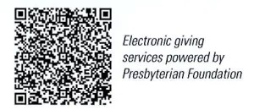
First Presbyterian Church
In the heart of Gardner since 1866 ~ Serving from the heart of God

Sunday, July 7, 2024
8:45 AM
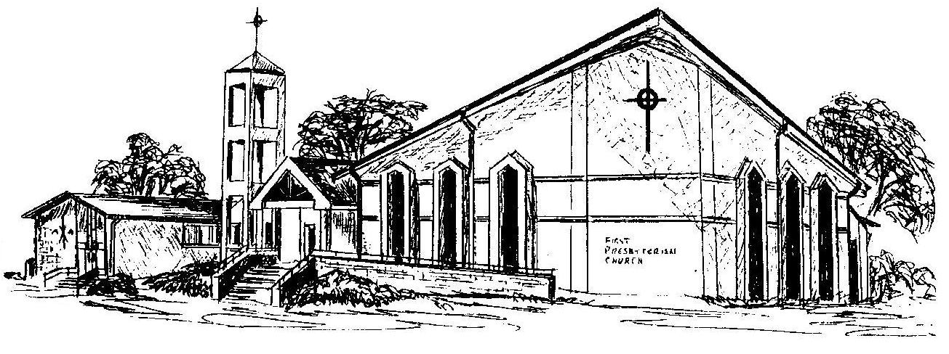

Welcome - Thank you for joining us for worship today. Please fill out a visitor information card found in the pew racks and place those in the offering plate so that we may follow up with you in the future. Your presence with us today has been a blessing to us, we hope that you have felt the presence of God and the welcome of this congregation.

