Welcome

Prelude “Come, O Jesus, Savior Mine” Luigi Cherubini
Let us prepare our hearts and minds for worship.

Call to Worship
Leader: Come to the table which Christ has prepared.
People: We come to share the feast of Jesus Christ.
Leader: How joyful it is, to celebrate the good news of God’s love!
People: We are called to be Easter people!

*Opening Hymn: “God of Grace and God of Glory” Red Hymnal, #292

* Prayer of Confession (Unison) (adapted from Rev. Mindi on Rev-o-lution blog)
Wondrous God, we confess that at times our doubts and fears override our hope and faith. Forgive us when we lose sight of the joy of Your love and instead fall into gloom. Lift up our spirits, Lord, and help us to remember the promise of new life here and now through Jesus the Christ in whose name we pray. Amen.

*Silent Reflection

*Assurance of Pardon

*Gloria Patri (Glory Be to the Father…) Red Hymnal, #623

Bell Choir “When We All Get to Heaven”
Music by Emily D. Wilson, arr. By Tammy Waldrop

Children’s Time

Scripture “Luke 24:36-49” (page 1644)
Leader: The word of the Lord.
People: Thanks be to God.

Anthem “The Broken Who Break the Bread”
words and music by Bev Herrema, Don Koch, and Alli LaPointe, arr. by Camp Kirkland

Sermon “Proof in the Eating” Rev. Kimby Young
*Profession of Faith The Apostle's Creed Red Hymnal, inside back cover
I Believe in God the Father Almighty, Maker of heaven and earth, And in Jesus Christ his only Son our Lord; who was conceived by the Holy Ghost, born of the Virgin Mary, suffered under Pontius Pilate, was crucified, dead, and buried; he descended into hell; the third day he rose again from the dead; he ascended into heaven, and sitteth on the right hand of God the Father Almighty; from thence he shall come to judge the quick and the dead. I believe in the Holy Ghost; the holy catholic Church; the communion of saints; the forgiveness of sins; the resurrection of the body; and the life everlasting. Amen

*Hymn “Break Thou the Bread of Life” Red Hymnal, #274

Offertory Meditation: “Meditation” Louis Gottschalk

*Doxology

The Sacrament of Holy Communion
Invitation
Great Prayer and The Lord’s Prayer
Words of Institution – Breaking of Bread
Communion of the People
Prayer of Thanksgiving

*Closing Hymn: “Let Us Break Bread Together” Red Hymnal, #323

*Benediction

Postlude “My Heart Shall Rejoice-“ Chester Nordman
*Those who are comfortably able will please stand.

Rev. Kimby Young, Pastor; Teri Winegar, Worship Assistant
Dean Faulk, Music Ministries; Chancel Choir, Bell Choir
Alice Rollf, Organist; Becky Kunard, Pianist
Mike McGuire and Brad Cornell, Slide Production
Davis Tropansky, Tech and Videographer; Kim Liu, Sound

Childcare is always available in the nursery (off the hall to the west of the sanctuary). Children are welcome to stay in the sanctuary thru the whole service, or to leave at any time. Allison Perry is our primary childcare attendant.

Offering Plates are at the entrance of each aisle for your contributions to the work of the church.

Gardner Multi Service Center collection is ongoing every week and is always in need of any non-perishable food. Bring something every week or once a month.

Fair Trade Products for Sale on Sundays Coffee, tea, chocolate, nuts, olive oil, dried fruit, baking products, and a few other items are for sale each Sunday at church.

Harvesters Food Distribution is always seeking volunteers. Every 3rd Saturday at Trade Net Parking lot and every 4th Wednesday at Divine Mercy Parish. Distribution begins at about 1 p.m.

Fair Trade Chocolate Tasting - Sunday, May 7, 9:45-11 a.m. - A sweet day of chocolate tasting to explain why to buy Fair Trade chocolate and to sample the products

Men’s Breakfast on Tuesday, May 9 at 7:00 a.m. at Perkins.

Nalleli Rollf and family invite you to a graduation party on May 20 from 1:30 - 4 pm.in Fellowship Hall.

Michael Judah graduation party, on May 20 from 4:30 – 6:30 pm in Fellowship Hall given Doug & Bea Judah. All welcome!

Rachel Cornell invites you to join us Sunday May 21st 3 -6 pm in Fellowship Hall to celebrate her graduation from GEHS. All are welcome!

Traveling Day Camp – June 19 to June 23, 2023. At the current time we have 46 out of 48 campers sign up. Go to: heartlandcamps.org/Parkville-day-camps and then click on “register here.

Scripture for Upcoming Worship
May 14 – Mother’s Day – Isaiah 46:3-5; Hosea 11:1-4; Luke 13:34.
May 21 – Ascension Sunday – Acts 1:1-11; Luke 24:44-53.
May 28 – Pentecost – Acts 2:1-21; Genesis 2:4-8.
June 4 – Trinity Sunday – Matthew 28:16-20; 2 Corinthians 13:11-13; Romans 5:1-5.

Pentecost is Sunday May 28 (Memorial Day weekend)
Wear red (or red, white, and blue) in celebration.

Monday, May 29th Memorial Day office closed.

First Presbyterian Church
In the heart of Gardner since 1866 ~ Serving from the heart of God

Sunday, May 7, 2023
8:45 AM
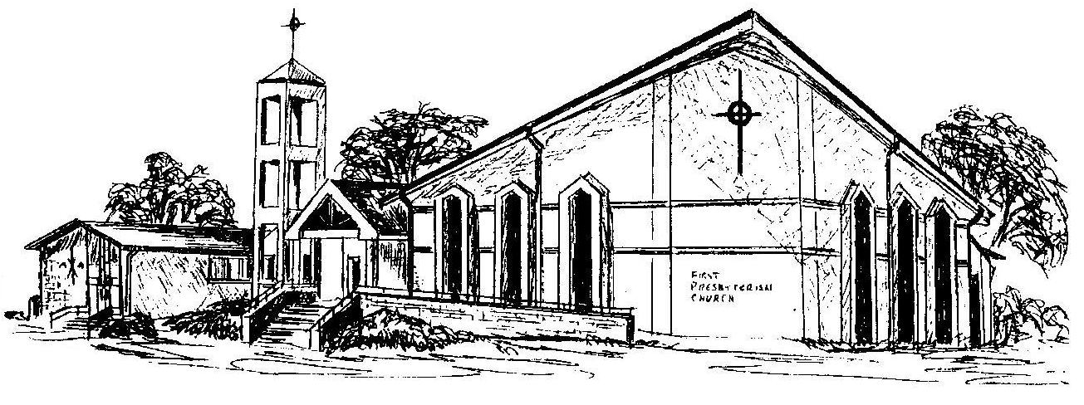

Welcome - Thank you for joining us for worship today. Please fill out a visitor information card found in the pew racks and place those the offering plate so that we may follow up with you in the future. Your presence with us today has been a blessing to us, we hope that you have felt the presence of God and the welcome of this congregation.

