Welcome

Prelude “God's House” Lynda Parker Loucks / arr. by Lee Ellis
Let us prepare our hearts and minds for worship.

Call to Worship (adapted from Nancy Townley, Worship Connection, Ministry Matters)
Leader: The time for harvest is near. What have you done with the gifts God has given you?
People: We have brought our gifts to the house of the Lord.
Leader: Praise God for gifts and for opportunities for service that they represent.
People: We praise God for all the ways in which our lives have been blessed.

*Opening Hymn: “We Praise Thee O God Our Redeemer” Red Hymnal, #16

*Prayer of Confession (Unison) (Presbyterian Church USA website).
Almighty God, you poured your Spirit upon gathered disciples creating bold tongues, open ears, and a new community of faith. We confess that we hold back the force of your Spirit among us. We do not listen for your word of grace, speak the good news of your love, or live as a people made one in Christ. Have mercy on us, O God. Transform our timid lives by the power of your Spirit, and fill us with a flaming desire to be your faithful people, doing your will for the sake of Jesus Christ our Lord. Amen.

*Silent Reflection

*Assurance of Pardon

*Gloria Patri (Glory Be to the Father…) Red Hymnal, #623

Children’s Time

Reception of New Members Maureen D. Allinder, Holly Applegarth, Robert McVey, Sandra McVey, Felistas Kavuu Nthasa, Tony Newson Waites, Virginia Jennifer Waites.

Scripture “Numbers 11:16-17” (page 225)
“Numbers 11:24-29” (page 225)
“Acts 2:1-4” (page 1692)
Leader: The word of the Lord.
People: Thanks be to God.

Music “Hymn of Heaven” by Phil Wickham

Sermon: “Growing Pains” Rev. Kimby Young

*Profession of Faith The Apostle's Creed Red Hymnal, inside back cover
I Believe in God the Father Almighty, Maker of heaven and earth, And in Jesus Christ his only Son our Lord; who was conceived by the Holy Ghost, born of the Virgin Mary, suffered under Pontius Pilate, was crucified, dead, and buried; he descended into hell; the third day he rose again from the dead; he ascended into heaven, and sitteth on the right hand of God the Father Almighty; from thence he shall come to judge the quick and the dead. I believe in the Holy Ghost; the holy catholic Church; the communion of saints; the forgiveness of sins; the resurrection of the body; and the life everlasting. Amen

*Hymn “Spirit of God Descend Upon My Heart” Red Hymnal, #249

Pastoral Prayer & Lord’s Prayer

Offertory Meditation “Spirit Song” John Wimber

*Doxology

*Prayer of Dedication

*Closing Hymn: “Trust and Obey” Red Hymnal, #349

*Benediction

*Postlude “Short Postlude” Edouard Batiste / arr. by Lee Ellis

*Those who are comfortably able will please stand.

Rev. Kimby Young, Pastor; Shana Devlin, Worship Assistant
Alice Rollf, Organist; Robyn Forkner, Pianist;
Dean Faulk, Music Ministries
Mike McGuire and Brad Cornell, Slide Production; Kim Liu, Sound

Childcare is always available in the nursery (off the hall to the west of the sanctuary). Children are welcome to stay in the sanctuary thru the whole service, or to leave at any time. Allison Perry is our primary childcare attendant.

Worship Bags for Children are available outside the north door to the sanctuary. Choose books, crayons, pencils, Legos, stuffed toys and other items to fill your bag to use during worship.

Offering Plates are at the entrance of each aisle for your contributions to the work of the church.

A "Suggestion Box" is outside the office for ideas, comments, questions, and thoughts. Contents will be reviewed at session meetings on the 2nd Monday of each month.

Elder On Call Linda Wolf will be in the narthex this Sunday morning between services to answer questions and hear ideas or concerns.

Womens Fall Book/Bible Study through October 24th at 6:30 p.m. in Fellowship Hall. Study book “The GOD We Can Know” by Rob Fuquay.

On-line Bible study group will start a new study, "From Beginning to Forever - A Study of the Grand Narrative of Scripture", on Oct. 8th. Meeting on Tuesday evening at 6:00 p.m. Interested in joining should email Jennifer Waites at jwaitemail@hotmail.com.

Women of Faith Book Club The next book club will be held on Thursday, December 5 at 6:30p.m. at the home of Jennifer Waites. The book is "Two from Galilee" by Marjorie Holmes. All are welcome. Please join us.

Mitten Tree Watch for the Mitten Tree in early November. New stocking hats, mittens and gloves will be collected for students in need.

Bell Choir will rehearse at 6:00 p.m., Christmas Cantata will rehearse 7:00 p.m., Choir will rehearse 8:00 p.m.

Trunk or Treat and Chili Supper October 27
Bring candy any time.
5-6:00 p.m. – Truck-or-treat and Games – North Parking Lot
5:45-7 p.m. –Chili Supper – Fellowship Hall
Sign up to help, bring food, or to provide a trunk.

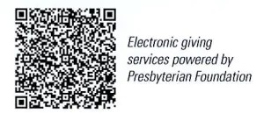
First Presbyterian Church
In the heart of Gardner since 1866 ~ Serving from the heart of God

Sunday, October 20, 2024
8:45 AM
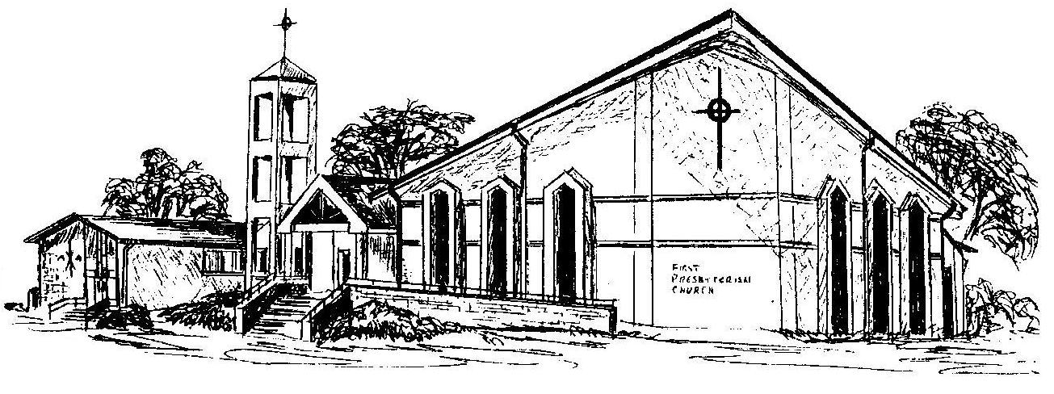

Welcome - Thank you for joining us for worship today. Please fill out a visitor information card found in the pew racks and place those in the offering plate so that we may follow up with you in the future. Your presence with us today has been a blessing to us, we hope that you have felt the presence of God and the welcome of this congregation.

