Welcome
Prelude “Holy, Holy, Holy, Lord God Almighty”
John B. Dykes / arr. Hugh S. Livingston Jr.
Let us prepare our hearts and minds for worship.

Call to Worship:
Leader: We gather to worship our Triune God – Father, Son, and Holy Spirit.
People: We praise the God who is and was and always will be.
Leader: We know God by many names and yet we cannot ever fully understand God.
People: Creator, Christ, and Comforter; Speaker, Word, and Breath; Giver, Gift and Giving; Source, Savior, and Spirit.
Leader: Our God is infinite transcendent mystery, as well as intimate ever-present companion.
People: We praise this God of grace and glory revealed in luminous love.

*Opening Hymn: “Holy Holy, Holy” Red Hymnal, #262

* Prayer for Confession (Unison) (adapted from Words for Worship)
O God, even as we celebrate your unity, we know that sometimes we forget the beauty of your three persons. Holy Trinity, if we are tempted to think that we know all that there is to know, closing ourselves off from ideas which others offer and neglecting to search for even deeper truths: Forgive us, Jesus Christ. Guide and guard us, Holy Spirit. Continue creating within us, Creator God. This we pray in your Triune name. Amen.

*Silent Reflection

*Assurance of Pardon

* Gloria Patri (Glory Be to the Father…) Red Hymnal, #623

Children’s Time

Scripture “Isaiah 6:1-8” (page 1068)
“John 3:1-17” (page 1649)
Leader: The word of the Lord.
People: Thanks be to God.

Special Music “Day Star” by Steve Richardson

Sermon “Trinity Calls” Rev. Kimby Young

*Profession of Faith The Apostle's Creed Red Hymnal, inside back cover
I Believe in God the Father Almighty, Maker of heaven and earth, And in Jesus Christ his only Son our Lord; who was conceived by the Holy Ghost, born of the Virgin Mary, suffered under Pontius Pilate, was crucified, dead, and buried; he descended into hell; the third day he rose again from the dead; he ascended into heaven, and sitteth on the right hand of God the Father Almighty; from thence he shall come to judge the quick and the dead. I believe in the Holy Ghost; the holy catholic Church; the communion of saints; the forgiveness of sins; the resurrection of the body; and the life everlasting. Amen

*Hymn “Here I Am Lord” Insert

Pastoral Prayer & Lord’s Prayer

Offertory Meditation “Holy, Holy” Jimmy Owens

*Doxology

*Prayer of Dedication

*Closing Hymn: “Eternal Father Strong to Save” Red Hymnal, #575

*Benediction

Postlude “Homage” John E. Boalt

Rev. Kimby Young, Pastor; Dean Faulk, Music Ministries
Paula Waters, Worship Assistant
Alice Rollf, Organist; Chesley Jones, Solo
Mike McGuire and Brad Cornell, Slide Production
Theo Borge, Tech, and Videographer; Kim Liu, Sound

Childcare is always available in the nursery (off the hall to the west of the sanctuary). Children are welcome to stay in the sanctuary thru the whole service, or to leave at any time. Allison Perry is our primary childcare attendant.

Offering Plates are at the entrance of each aisle for your contributions to the work of the church.

Gardner Multi Service Center collection is ongoing every week and is always in need of any non-perishable food. Bring something every week or once a month.

Fair Trade Products for Sale on Sundays Coffee, tea, chocolate, nuts, olive oil, dried fruit, baking products, and a few other items are for sale each Sunday at church.

Harvesters Food Distribution is always seeking volunteers. Every 3rd Saturday at Trade Net Parking lot and every 4th Wednesday at Divine Mercy Parish. Distribution begins at about 1 p.m.

A "Suggestion Box" is outside the office for ideas, comments, questions, and thoughts. Contents will be reviewed at session meetings on the 2nd Monday of each month.

Traveling Day Camp - June 17-21 - Sign up in the narthex for breakfasts and dinners for staff. Snacks for campers. Other helpers talk to Kim and Karen Liu, Robin Tropansky or Marsha Cooper to volunteer.

Monday, May 27, Office Closed to observe Memorial Day.

Elder On Call - Beginning June 2, an elder of the church will be in the narthex each Sunday morning to answer questions and hear ideas or concerns. This is an effort to increase communication as we make decisions for the future of the church.

SAS – Summer Adventures on Sunday - Sunday school for all ages. Starts June 2 - 10 a.m. To help or lead a week talk to Kimby Young or Marsha Cooper.

Women Fellowship Group will meet on Wednesday, June 5 at 10:00 a.m. in Fellowship Hall. Everyone bring 3 bags/boxes of cookies to the meeting for Traveling Day Camp.

Church Family and Friends - End of TDC Picnic – Everyone Welcome!
Friday, June 21, 4:15-6 p.m.

Coffee Machine regular coffee is working.
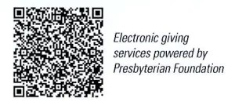
First Presbyterian Church
In the heart of Gardner since 1866 ~ Serving from the heart of God

Sunday, May 26, 2024
Trinity Sunday
Memorial Day Weekend
8:45 AM
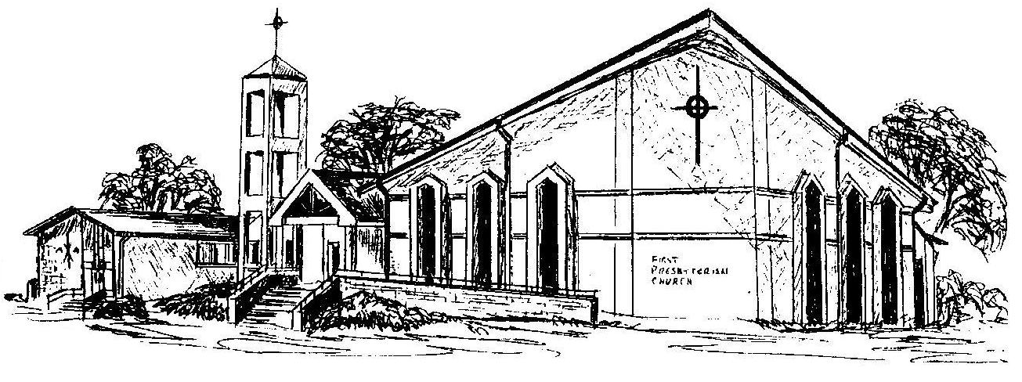

Welcome - Thank you for joining us for worship today. Please fill out a visitor information card found in the pew racks and place those in the offering plate so that we may follow up with you in the future. Your presence with us today has been a blessing to us, we hope that you have felt the presence of God and the welcome of this congregation.

