Welcome

Prelude
Let us prepare our hearts and minds for worship.

Call to Worship (inspired by Amos 5:24, Micah 6:8)
Leader: God’s prophet says, “Let justice roll down like mighty waters, and righteousness like an ever-flowing stream.”
People: We seek to do God’s will, to follow God’s way, to love God’s people.
Leader: God’s Word says, “Seek justice, love mercy, walk humbly with your God.
People: We strive to walk with God and to do what is right for all people.
Leader: Sometimes the way is clear. Sometimes we need more understanding.
People: As we worship God, we ask for God’s guidance and inspiration.

*Opening Hymn: “Great Is Thy Faithfulness” Red Hymnal, # 43

*Prayer of Confession (Unison)
God of grace, Your call to us is clear and true – justice and mercy lived in lives of faithfulness. We hear Your challenge to serve the least among us, to care for the poor and needy, to comfort those who have lost much, to restore lives of those who have been beaten down. We try to respond, and yet sometimes we fail to give our hearts to Your mission. Empower us to share Your light in the world and to transform lives by Your love. Inspire us to serve now, knowing that we have been called for such a time as this. Amen.

*Silent Reflection

*Assurance of Pardon

*Gloria Patri (Glory Be to the Father…) Red Hymnal, # 623

Children’s Time

Scripture “Esther 4:13-14” (page 780)
“John 2:1-11” (page 1648)
“1 John 4:7-21” (page 1902)
Leader: The word of the Lord.
People: Thanks be to God.

Music “God’s Greatness Medley” arr. by Dennis Allen
Sermon: “Such A Time As This” Rev. Kimby Young

*Profession of Faith The Apostle's Creed Red Hymnal, inside back cover
I Believe in God the Father Almighty, Maker of heaven and earth, and in Jesus Christ his only Son our Lord; who was conceived by the Holy Ghost, born of the Virgin Mary, suffered under Pontius Pilate, was crucified, dead, and buried; he descended into hell; the third day he rose again from the dead; he ascended into heaven, and sitteth on the right hand of God the Father Almighty; from thence he shall come to judge the quick and the dead. I believe in the Holy Ghost; the holy catholic Church; the communion of saints; the forgiveness of sins; the resurrection of the body; and the life everlasting. Amen

*Hymn “They’ll Know We Are Christians By Our Love” Red Hymnal, # 284

Pastoral Prayer & Lord’s Prayer

Offertory Meditation:

*Doxology

*Prayer of Dedication

*Closing Hymn: “Lord Speak to Me” Red Hymnal, # 450

*Benediction

*Postlude
*Those who are comfortably able will please stand.

Rev. Kimby Young, Pastor; Judy Mason, Worship Assistant
Chancel Choir; Dean Faulk, Music Ministries
Robyn Forkner, Pianist
Mike McGuire and Brad Cornell, Slide Production; Kim Liu. Sound

Childcare is always available in the nursery (off the hall to the west of the sanctuary). Children are welcome to stay in the sanctuary thru the whole service, or to leave at any time. Allison Perry is our primary childcare attendant.

Worship Bags for Children are available outside the north door to the sanctuary. Choose books, crayons, pencils, Legos, stuffed toys and other items to fill your bag to use during worship.

Offering Plates are at the entrance of each aisle for your contributions to the work of the church.

Gardner Multi Service Center collection is ongoing every week and is always in need of any non-perishable food. Bring something every week or once a month.

Fair Trade Products for Sale on Sundays Coffee, tea, chocolate, nuts, olive oil, dried fruit, baking products, and a few other items are for sale each Sunday at church.

Harvesters Food Distribution is always seeking volunteers. Every 3rd Saturday at Trade Net Parking lot and every 4th Wednesday at Divine Mercy Parish. Distribution begins at about 1 p.m.

A "Suggestion Box" is outside the office for ideas, comments, questions, and thoughts. Contents will be reviewed at session meetings on the 2nd Monday of each month.

Joy Closet – Our mission center thrift store provides free clothing to a variety of needs. Extra items are sold at low cost. Volunteers are trained in a variety of jobs and work at different times. We have a job that fits every ability. Our church provides all volunteers on the fourth Saturday of each month.

The session has called a congregational meeting for Sunday, January 26 at 9:45 a.m. The purpose of the meeting is to receive our annual reports from staff, committees, groups and pillars, and to approve the terms of call for pastor Kimby Young.

Confirmation Class will start on Sunday, January 26 at 3:00 p.m.

Sunday, February 9, Souper Bowl of Caring offering received both services.

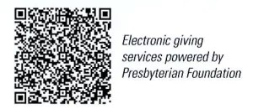
First Presbyterian Church
In the heart of Gardner since 1866 ~ Serving from the heart of God

January 19, 2025
Martin Luther King, Jr. Day
8:45 AM

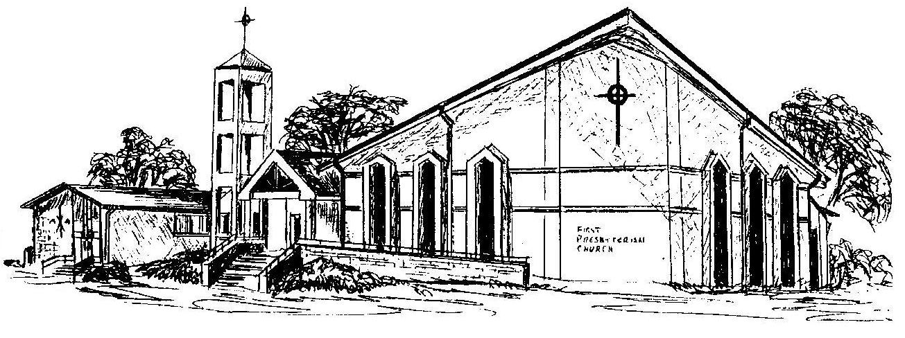
Welcome - Thank you for joining us for worship today. Please fill out a visitor information card found in the pew racks and place those in the offering plate so that we may follow up with you in the future. Your presence with us today has been a blessing to us, we hope that you have felt the presence of God and the welcome of this congregation.

