Welcome
Prelude "Spirit of God, Descend Upon My Heart"
by F. Atkinson, Arr. by L. Larson
Let us prepare our hearts and minds for worship.

Call to Worship:
Leader: The Spirit descends like a dove, bringing peace to unite the world.
People: The Spirit comes like a breath, bringing life to renew the people of God.
Leader: The Spirit spreads like fire, bringing energy for witnessing to the love of God.
People: Spirit of the living God, come to us and transform our lives by your power

*Opening Hymn: “Spirit of God, Descend Upon My Heart” Red Hymnal, #249

* Prayer for Confession ( Unison) (adapted from John van de Laar.)
God of amazing love and unexpected grace, Open our eyes that we may see You especially in those times when we feel abandoned and alone; Forgive us that we so easily allow circumstance to blind us to Your Presence. Touch our lives that we may know You especially in those times when we feel unable to cope; Forgive us that we too frequently mistrust Your power. Fill our hearts that we may become like You; Forgive us that we forget who we are: children of God with Your Spirit in us. In the name of Jesus, we pray. Amen.

*Silent Reflection

*Assurance of Pardon

* Gloria Patri (Glory Be to the Father…) Red Hymnal, #623

Children’s Time

Scripture “Acts 2:1-8, 14-21” (page 1692)
“1 Corinthians 12:4-14” (page 1785)
“Galatians 5:22-23a” (page 1816)
Leader: The word of the Lord.
People: Thanks be to God.

Anthem “He Never Failed Me Yet”
Words and music by Robert Ray
Sermon “Gifts of the Spirit” Rev. Kimby Young

*Profession of Faith The Apostle's Creed Red Hymnal, inside back cover
I Believe in God the Father Almighty, Maker of heaven and earth, And in Jesus Christ his only Son our Lord; who was conceived by the Holy Ghost, born of the Virgin Mary, suffered under Pontius Pilate, was crucified, dead, and buried; he descended into hell; the third day he rose again from the dead; he ascended into heaven, and sitteth on the right hand of God the Father Almighty; from thence he shall come to judge the quick and the dead. I believe in the Holy Ghost; the holy catholic Church; the communion of saints; the forgiveness of sins; the resurrection of the body; and the life everlasting. Amen

*Hymn “Breathe on Me, Breath of God” Red Hymnal, #259

Pastoral Prayer & Lord’s Prayer

Offertory Meditation "Surely the Presence of the Lord Is In This Place"
by L. Wolfe

*Doxology

*Prayer of Dedication

*Closing Hymn: “Take Time To Be Holy” Red Hymnal, #441

*Benediction

Postlude "Great Is The Lord"
by M. Smith and D. Smith
*Those who are comfortably able will please stand.

Rev. Kimby Young, Pastor; Dean Faulk, Music Ministries
Tina Fraser, Worship Assistant; Chancel Choir; Vanessa Marriott, Pianist
Alice Rollf, Organist; Robyn Miller Forkner, Pianist
Mike McGuire and Brad Cornell, Slide Production
Theo Borge, Tech, and Videographer; Kim Liu, Sound

Childcare is always available in the nursery (off the hall to the west of the sanctuary). Children are welcome to stay in the sanctuary thru the whole service, or to leave at any time. Allison Perry is our primary childcare attendant.

Offering Plates are at the entrance of each aisle for your contributions to the work of the church.

Gardner Multi Service Center collection is ongoing every week and is always in need of any non-perishable food. Bring something every week or once a month.

Fair Trade Products for Sale on Sundays Coffee, tea, chocolate, nuts, olive oil, dried fruit, baking products, and a few other items are for sale each Sunday at church.

Harvesters Food Distribution is always seeking volunteers. Every 3rd Saturday at Trade Net Parking lot and every 4th Wednesday at Divine Mercy Parish. Distribution begins at about 1 p.m.

A "Suggestion Box" is outside the office for ideas, comments, questions, and thoughts. Contents will be reviewed at session meetings on the 2nd Monday of each month.

Traveling Day Camp - June 17-21 - Sign up in the narthex for breakfasts and dinners for staff. Snacks for campers. Other helpers talk to Kim and Karen Liu, Robin Tropansky or Marsha Cooper to volunteer.

Ice Cream Social Sunday, May 26, Memorial Day and Trinity Sunday 9:45 a.m. – 11:00 a.m.

Monday, May 27, Office Closed to observe Memorial Day.

No Sunday School for kids May 19 or 26.

Elder On Call - Beginning June 2, an elder of the church will be in the narthex each Sunday morning to answer questions and hear ideas or concerns. This is an effort to increase communication as we make decisions for the future of the church.

SAS – Summer Adventures on Sunday - Sunday school for all ages. Starts June 2 – 10 a.m. To help or lead a week talk to Kimby Young or Marsha Cooper.

Church Family and Friends - End of TDC Picnic – Everyone Welcome!
Friday, June 21, 5:30-7:00 p.m.

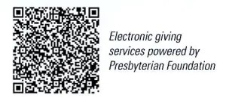
First Presbyterian Church
In the heart of Gardner since 1866 ~ Serving from the heart of God

Sunday, May 19, 2024
Pentecost Sunday
8:45 AM
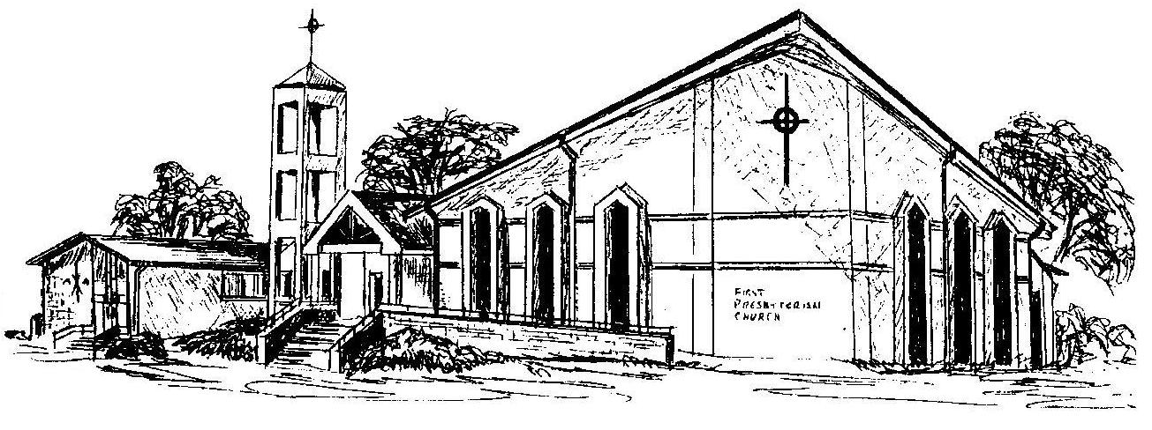

Welcome - Thank you for joining us for worship today. Please fill out a visitor information card found in the pew racks and place those in the offering plate so that we may follow up with you in the future. Your presence with us today has been a blessing to us, we hope that you have felt the presence of God and the welcome of this congregation.

