Welcome
Minute from Discipleship

Prelude “10,000 Reasons” (Bless the Lord)
Let us prepare our hearts and minds for worship.

Call to Worship:
Leader: Jesus says, "Come to me! Follow me! Be my people!"
People: In the name of Christ, we accept the invitation to discipleship.
Leader: We gather to worship together and to share the love of God.
People: We receive God’s gifts and are blessed in God’s amazing grace.

*Opening Hymn: “Jesus Calls Us” Red Hymnal , #375

*Prayer of the Confession (Unison) (from re-worship. blogspot)
Merciful God, You call us to follow; to turn away from our own selfish interests, and to take up our cross and follow after You, even if the path is difficult to see, or is heading in a direction we would never have chosen for ourselves. Forgive us for being so quick to question and so hesitant to follow. Help us to see with the eyes of faith, rather than from our own human point of view. Teach us to follow without fear, knowing that You are always with us, leading the way. Amen.

*Silent Reflection

*Assurance of Pardon

* Gloria Patri (Glory Be to the Father…) Red Hymnal, #623

Children’s Time

Scripture “Mark 1:16-20” (page 1552)
“1 Peter 2:9-10” (page 1888)
“Romans 8:28-30” (page 1757)
“Romans 8:37-39” (page 1758)
Leader: The word of the Lord.
People: Thanks be to God.

Music “On My Way” written by Diana Mummert
Sermon “Chosen to Follow” Rev. Kimby Young

*Profession of Faith The Apostle's Creed Red Hymnal, inside back cover
I Believe in God the Father Almighty, Maker of heaven and earth, And in Jesus Christ his only Son our Lord; who was conceived by the Holy Ghost, born of the Virgin Mary, suffered under Pontius Pilate, was crucified, dead, and buried; he descended into hell; the third day he rose again from the dead; he ascended into heaven, and sitteth on the right hand of God the Father Almighty; from thence he shall come to judge the quick and the dead. I believe in the Holy Ghost; the holy catholic Church; the communion of saints; the forgiveness of sins; the resurrection of the body; and the life everlasting. Amen

*Hymn “Rise Up O Church of God” Red Hymnal, #293

Pastoral Prayer & Lord’s Prayer

Offertory Meditation “The Summons” Scottish Traditional

*Doxology

*Prayer of Dedication

*Closing Hymn: “Onward Christian Soldiers” Red Hymnal, #479

*Benediction

Postlude “Here I Am, Lord” Daniel Schutte
*Those who are comfortably able will please stand.

Rev. Kimby Young, Pastor; Mitch McSwane, Worship Assistant
Chesley and Brenda Jones, Duet
Dean Faulk, Music Ministries; Alice Rollf, Organist
Mike McGuire and Brad Cornell, Slide Production; Kim Liu, Sound

Childcare is always available in the nursery (off the hall to the west of the sanctuary). Children are welcome to stay in the sanctuary thru the whole service, or to leave at any time. Allison Perry is our primary childcare attendant.

Worship Bags for Children are available outside the north door to the sanctuary. Choose books, crayons, pencils, Legos, stuffed toys and other items to fill your bag to use during worship.

Offering Plates are at the entrance of each aisle for your contributions to the work of the church.

Gardner Multi Service Center collection is ongoing every week and is always in need of any non-perishable food. Bring something every week or once a month.

Fair Trade Products for Sale on Sundays Coffee, tea, chocolate, nuts, olive oil, dried fruit, baking products, and a few other items are for sale each Sunday at church.

Harvesters Food Distribution is always seeking volunteers. Every 3rd Saturday at Trade Net Parking lot and every 4th Wednesday at Divine Mercy Parish. Distribution begins at about 1 p.m.

A "Suggestion Box" is outside the office for ideas, comments, questions, and thoughts. Contents will be reviewed at session meetings on the 2nd Monday of each month.

Elder On Call Larry Schick will be in the narthex this Sunday morning between services to answer questions and hear ideas or concerns.

Men’s Breakfast on Tuesday, September 10, 7 a.m. at Perkins.

Kimby’s Bible Study starts Thursday, September 12 10-11:30 a.m. in Fellowship Hall studying “The Acts of the Apostles of Jesus”.

Womens Fall Book/Bible Study is scheduled to begin on Thursday, September 12th through October 24th at 6:30 p.m. in Fellowship Hall. Please see Paula Waters to purchase the book entitled "The GOD We Can Know" by Rob Fuquay. Book cost is $10.

Called Congregational Meeting, Sunday, September 15 at 9:45 a.m. Session has called a congregational meeting for the purpose of electing officers for 2025.

Bell Choir will rehearse at 6:00 p.m. and the Choir will rehearse at 7:00 p.m. If you would like to sing the Christmas Cantata rehearsals will start October 2nd at 8:00 p.m.

Womens Book Club please join us in October and November to discuss the book "Two from Galilee" by Marjorie Holmes. Dates and locations are yet to be determined.

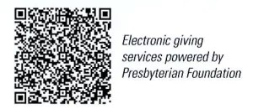
. First Presbyterian Church
In the heart of Gardner since 1866 ~ Serving from the heart of God

Sunday, September 8, 2024
8:45 AM
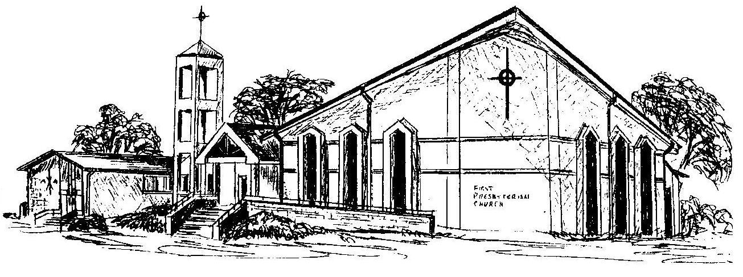

Welcome - Thank you for joining us for worship today. Please fill out a visitor information card found in the pew racks and place those in the offering plate so that we may follow up with you in the future. Your presence with us today has been a blessing to us, we hope that you have felt the presence of God and the welcome of this congregation.

