Welcome

Prelude “Hymn tune Filmore” arr. by Steve Martin
Let us prepare our hearts and minds for worship.

Call to Worship (adapted from Worship Ways Archive, United Church of Christ.)
Leader: We have come to worship God,
People: The Living God, who calls prophets and teachers to bear witness.
Leader: We have come to praise God,
People: Almighty God, who answers the forces of hatred and hurt with the power of grace.
Leader: We have come to thank God,
People: All-gracious God, who chooses us, to receive and carry the Word of life and hope.

*Opening Hymn: “Joyful, Joyful, We Adore Thee” Red Hymnal, # 1

*Prayer of Confession (Unison)
God of Grace, we have received your mercy. We know your grace. We are grateful. You have called us to share what we believe and to tell the good news of great joy which is for all people. Still we are reluctant to talk about our faith. Give us courage to witness in the world to the love we have received in Jesus Christ our Savior. Amen.

*Silent Reflection

*Assurance of Pardon

*Gloria Patri (Glory Be to the Father…) Red Hymnal, # 623

Children’s Time

Scripture “Acts 3:1-10” (page 1694)
“Acts 4:13-22” (page 1696)
Leader: The word of the Lord.
People: Thanks be to God.

Music

Sermon: “Show and Tell” Rev. Kimby Young

*Profession of Faith The Apostle's Creed Red Hymnal, inside back cover
I Believe in God the Father Almighty, Maker of heaven and earth, and in Jesus Christ his only Son our Lord; who was conceived by the Holy Ghost, born of the Virgin Mary, suffered under Pontius Pilate, was crucified, dead, and buried; he descended into hell; the third day he rose again from the dead; he ascended into heaven, and sitteth on the right hand of God the Father Almighty; from thence he shall come to judge the quick and the dead. I believe in the Holy Ghost; the holy catholic Church; the communion of saints; the forgiveness of sins; the resurrection of the body; and the life everlasting. Amen

*Hymn “I Love to Tell the Story” Red Hymnal, # 297

Pastoral Prayer & Lord’s Prayer

Offertory Meditation: “Jesus Loves Me Medley” arr. Jason Payne

*Doxology

*Prayer of Dedication

*Closing Hymn: “Stand Up, Stand Up for Jesus” Red Hymnal, # 481

*Benediction

*Postlude “Prelude in Classic Style” by Gordon Young
*Those who are comfortably able will please stand.

Rev. Kimby Young, Pastor; Carl Frahme, Worship Assistant
Chancel Choir; Dean Faulk, Music Ministries
Harlan Plunkett, Organist; Robyn Forkner, Pianist
Mike McGuire and Brad Cornell, Slide Production; Kim Liu. Sound

Childcare is always available in the nursery (off the hall to the west of the sanctuary). Children are welcome to stay in the sanctuary thru the whole service, or to leave at any time. Allison Perry is our primary childcare attendant.

Worship Bags for Children are available outside the north door to the sanctuary. Choose books, crayons, pencils, Legos, stuffed toys and other items to fill your bag to use during worship.
Offering Plates are at the entrance of each aisle for your contributions to the work of the church.

Gardner Multi Service Center collection is ongoing every week and is always in need of any non-perishable food. Bring something every week or once a month.

Fair Trade Products for Sale on Sundays Coffee, tea, chocolate, nuts, olive oil, dried fruit, baking products, and a few other items are for sale each Sunday at church.

Harvesters Food Distribution is always seeking volunteers. Every 3rd Saturday at Trade Net Parking lot and every 4th Wednesday at Divine Mercy Parish. Distribution begins at about 1 p.m.

A "Suggestion Box" is outside the office for ideas, comments, questions, and thoughts. Contents will be reviewed at session meetings on the 2nd Monday of each month.

Joy Closet – Our mission center thrift store provides free clothing to a variety of needs. Extra items are sold at low cost. Volunteers are trained in a variety of jobs and work at different times. Our church provides all volunteers on the fourth Saturday of each month.

Welcome New Organist Harlan Plunkett
Harlan was raised in rural Southwest Kansas on a farm. He attended MidAmerica Nazarene University (MNU) in Olathe KS in the 1980’s graduating with a BA in business. He has worked for MNU full-time since 1990 in the Financial Aid Office. He currently is the Associate Director of Operations. He also delivers flowers for HyVee part-time for fun.
He began music lessons with his mother when he was three years old learning to read music before reading or writing. Harlan studied Piano throughout the K-12 years with a local Piano teacher. In college he began private organ lessons with a concert organist in Kansas City, MO who became a dear friend and long-time mentor.
At age 8 he played in a small local church for the first time and soon began to play regularly for the church services because there was no one else to play. With few interruptions he has served as an organist for various churches since.
Harlan has two daughters, Audrey, a junior at UMKC double majoring in Physics and Math, and Devan who is a Senior at Olathe North High School. Harlan loves being a Dad.
His hobbies include traveling, photography, and cooking.

Men’s Breakfast Men’s Breakfast on Tuesday, February 11 at 7:00 a.m. at Perkins. It is an opportunity to get to know one another and build a stronger community of Faith.

Presbyterian Women’s Bible Study will begin Thursday, Feb 27th - April 10th, each Thursday for 7 sessions. They will be meeting at 6:30 pm in the Fellowship Hall. The study is “Twelve Extraordinary Women.” How God Shaped Women of the Bible and What He Wants to Do With You by John MacArthur. See Paula Waters or Alice Rollf about a book. Signup sheets in narthex. All Ladies are welcome!

Traveling Day Camp Registration is open.

First Presbyterian Church
In the heart of Gardner since 1866 ~ Serving from the heart of God

February 9, 2025
8:45 AM

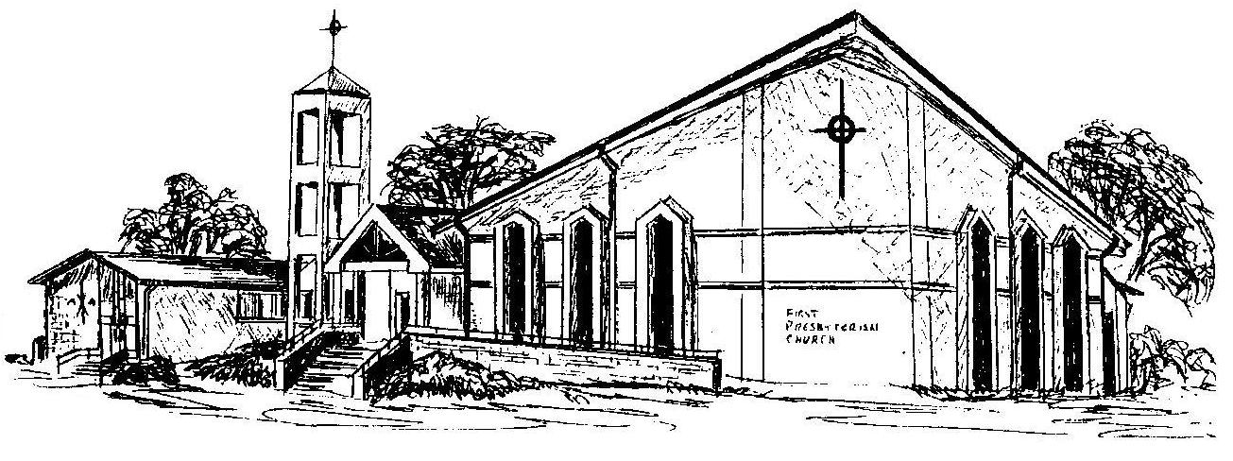
Welcome - Thank you for joining us for worship today. Please fill out a visitor information card found in the pew racks and place those in the offering plate so that we may follow up with you in the future. Your presence with us today has been a blessing to us, we hope that you have felt the presence of God and the welcome of this congregation.

