Welcome
Prelude
Let us prepare our hearts and minds for worship.

Call to Worship: (inspired by Luke 4)
Leader: Jesus said, “God has anointed me to bring good news to the poor.”
People: To proclaim release to the captives and recovery of sight to the blind, to let the oppressed go free, to proclaim the year of the Lord’s favor.
Leader: Today we join Jesus in that work of justice and renewal.
People: We promise to love God and to love others as Jesus loved.

*Opening Hymn: “Called As Partners In Christ’s Service” Insert

*Prayer of the Confession (from Rev. Mindi - Rev-o-lution)
God who Delivers and Redeems, we have failed to live into the promise of new life. We have been afraid to enter troubled waters to help the poor and downtrodden. We have been afraid to walk with those burned by the system of sin and oppression. We have sought ease and comfort. Forgive us when we have not lived for others. Call us into new life, that is lived in the promise of Your love for the whole world. In Jesus’ name. Amen.

*Silent Reflection

*Assurance of Pardon

* Gloria Patri (Glory Be to the Father…) Red Hymnal, #623

Children’s Time

Scripture “Amos 5:24” (page 1426)
“Micah 6:8” (page 1447)
“Matthew 5:43-48” (page 1503)
“Matthew 25:31-40” (page 1542)
Leader: The word of the Lord.
People: Thanks be to God.

Music “Be Still, My Soul”

Sermon “Working for Justice” Rev. Kimby Young

*Profession of Faith The Apostle's Creed Red Hymnal, inside back cover
I Believe in God the Father Almighty, Maker of heaven and earth, And in Jesus Christ his only Son our Lord; who was conceived by the Holy Ghost, born of the Virgin Mary, suffered under Pontius Pilate, was crucified, dead, and buried; he descended into hell; the third day he rose again from the dead; he ascended into heaven, and sitteth on the right hand of God the Father Almighty; from thence he shall come to judge the quick and the dead. I believe in the Holy Ghost; the holy catholic Church; the communion of saints; the forgiveness of sins; the resurrection of the body; and the life everlasting. Amen

*Hymn “O Master Let Me Walk With Thee” Red Hymnal, #451

Offertory Meditation

*Doxology

The Sacrament of Holy Communion
(All bread is gluten free. Prepacked elements are available in the back.)
Invitation
Great Prayer and The Lord’s Prayer
Words of Institution – Breaking of Bread
Communion of the People
Prayer of Thanksgiving

*Closing Hymn: “Take My Life and Let It Be” Red Hymnal, #379

*Benediction

Postlude
*Those who are comfortably able will please stand.

Rev. Kimby Young, Pastor; Kim Allen, Worship Assistant
Chesley Jones, Solo; Dean Faulk, Music Ministries; Alice Rollf, Organist
Mike McGuire and Brad Cornell, Slide Production; Kim Liu, Sound

Childcare is always available in the nursery (off the hall to the west of the sanctuary). Children are welcome to stay in the sanctuary thru the whole service, or to leave at any time. Allison Perry is our primary childcare attendant.

Worship Bags for Children are available outside the north door to the sanctuary. Choose books, crayons, pencils, Legos, stuffed toys and other items to fill your bag to use during worship.

Offering Plates are at the entrance of each aisle for your contributions to the work of the church.

Gardner Multi Service Center collection is ongoing every week and is always in need of any non-perishable food. Bring something every week or once a month.

Fair Trade Products for Sale on Sundays Coffee, tea, chocolate, nuts, olive oil, dried fruit, baking products, and a few other items are for sale each Sunday at church.

Harvesters Food Distribution is always seeking volunteers. Every 3rd Saturday at Trade Net Parking lot and every 4th Wednesday at Divine Mercy Parish. Distribution begins at about 1 p.m.

A "Suggestion Box" is outside the office for ideas, comments, questions, and thoughts. Contents will be reviewed at session meetings on the 2nd Monday of each month.

SAS – Summer Adventures on Sunday - Sunday school for all ages - 10 a.m. To help or lead a week talk to Kimby Young or Marsha Cooper.

Elder On Call will be in the narthex each Sunday morning between services to answer questions and hear ideas or concerns.

Women Fellowship Group will meet on Wednesday, August 7 at 10:00 am. in Fellowship Hall. We will enjoy a morning of fellowship, devotions by Paula Waters, refreshments by Tina Fraser.

Blessing of the Backpacks Sunday, August 11, both services.

Men’s Breakfast Tuesday, August 13, at Perkins 7:00 a.m.

Holy Smokes BBQ and Music Festival Community Event - Saturday, August 17 – 5-7 p.m.

Noisy Offering on Sunday, August 18, bring your loose change. Make a Joyful Noise to the Lord.

Women of Faith Book Club - The next Book Club will be held Thursday, August 22, 2024, at 6:30 pm at the home of Linda Jensen,36400 W. 159th, Gardner, KS. The book of choice is "Mostly What God Does" by Savannah Guthrie. Anyone is welcome to join anytime.

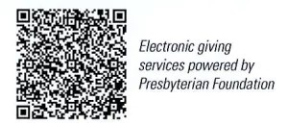
First Presbyterian Church
In the heart of Gardner since 1866 ~ Serving from the heart of God

Sunday, August 4, 2024
8:45 AM
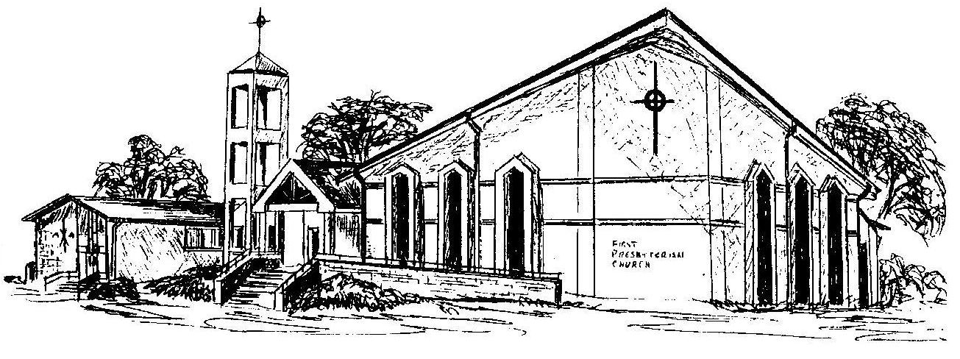

Welcome - Thank you for joining us for worship today. Please fill out a visitor information card found in the pew racks and place those in the offering plate so that we may follow up with you in the future. Your presence with us today has been a blessing to us, we hope that you have felt the presence of God and the welcome of this congregation.

