Welcome
Prelude “Worship the Lord in the Beauty of Holiness” Tom Fettke
“No Other Name” Robert Gay
Let us prepare our hearts and minds for worship.

Call to Worship
Leader: In the beginning God created the heavens and the earth.
People: And God saw that it was good. Creation was very good.
Leader: In the beginning the Word became flesh and came to dwell among us.
People: Jesus Christ reveals God’s love for us and for all creation.
Leader: We praise God for life and for every day miracles.
People: We praise God with all that we have and all that we are.

*Opening Hymn: For the Beauty of the Earth” Red Hymnal, # 560

*Prayer of Confession (Unison)
God of all creation, we sometimes fail to see your order amid the chaos of our lives. We hear the wind and storm, and do not see YOU standing right before us, coming to be with us. We fear the darkness, rather than turning toward your light. Forgive us. Help us to remember that you can walk on water and calm every storm. Inspire us to step out in faith and to trust in you through Jesus Christ our Savior. Amen.

*Silent Reflection

*Assurance of Pardon

* Gloria Patri (Glory Be to the Father…) Red Hymnal, #623

Children’s Time

Scripture “John 6:16-22” (page 1656)
“Matthew 17:1-8” (page 1524)
Leader: The word of the Lord.
People: Thanks be to God.

Anthem “When We All Get to Heaven”
By Emily D. Wilson, arr. Cliff Durent

Sermon “Lord of All Creation” Rev. Kimby Young

*Profession of Faith The Apostle's Creed Red Hymnal, inside back cover
I Believe in God the Father Almighty, Maker of heaven and earth, And in Jesus Christ his only Son our Lord; who was conceived by the Holy Ghost, born of the Virgin Mary, suffered under Pontius Pilate, was crucified, dead, and buried; he descended into hell; the third day he rose again from the dead; he ascended into heaven, and sitteth on the right hand of God the Father Almighty; from thence he shall come to judge the quick and the dead. I believe in the Holy Ghost; the holy catholic Church; the communion of saints; the forgiveness of sins; the resurrection of the body; and the life everlasting. Amen

*Hymn “Fairest Lord Jesus” Red Hymnal, #88

Pastoral Prayer & Lord’s Prayer

Offertory Meditation: “Hear Thou Our Prayer” Louise E. Stairs

*Doxology

*Prayer of Dedication

*Closing Hymn: “He’s Got the Whole World in His Hands” Red Hymnal, #344

*Benediction

Postlude “ I Sing the Mighty Power of God” Benton Price
*Those who are comfortably able will please stand.

Rev. Kimby Young, Pastor; Karl Allen, Worship Assistant
Dean Faulk, Music Ministries; Alice Rollf, Organist; Chancel Choir
Mike McGuire and Brad Cornell, Slide Production
Theo Borge, Tech and Videographer; Kim Liu, Sound

Childcare is always available in the nursery (off the hall to the west of the sanctuary). Children are welcome to stay in the sanctuary thru the whole service, or to leave at any time. Allison Perry is our primary childcare attendant.

Offering Plates are at the entrance of each aisle for your contributions to the work of the church.

Gardner Multi Service Center collection is ongoing every week and is always in need of any non-perishable food. Bring something every week or once a month.

Fair Trade Products for Sale on Sundays Coffee, tea, chocolate, nuts, olive oil, dried fruit, baking products, and a few other items are for sale each Sunday at church.

Harvesters Food Distribution is always seeking volunteers. Every 3rd Saturday at Trade Net Parking lot and every 4th Wednesday at Divine Mercy Parish. Distribution begins at about 1 p.m.

2024 Per Capita is $43.29 General Assembly $7.73, Synod $2.80, Presbytery $32.76

Noisy Offering on Sunday, February 11 is going to Souper Bowl Sunday.

Men’s Breakfast on Tuesday, February 13, Perkins at 7:00 a.m.

Ash Wednesday, February 14 Worship Service is 7:00 p.m. Drive through– 5:30-6:30 p.m.

Presbyterian Women Bible Study has begun on Thursdays, at 7:00 p.m.in Fellowship Hall lesson is “Worth More Than Rubies” by Christina Patterson.

Monday Night Bible Study group is starting a new study: Angels: 8 Studies for Individuals or Groups, on Feb. 12. This group meets every other Monday evening at 5:30pm via Zoom. If interested, please contact Jennifer Waites (jwaitemail@hotmail.com).

Lenten Devotion Books in narthex, adult “Take Up Your Cross.” The children and family book is “Walking in His Ways.”

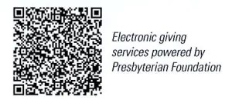
First Presbyterian Church
In the heart of Gardner since 1866 ~ Serving from the heart of God

Sunday, February 11, 2024
Transfiguration Sunday
Souper Bowl Sunday
8:45 AM
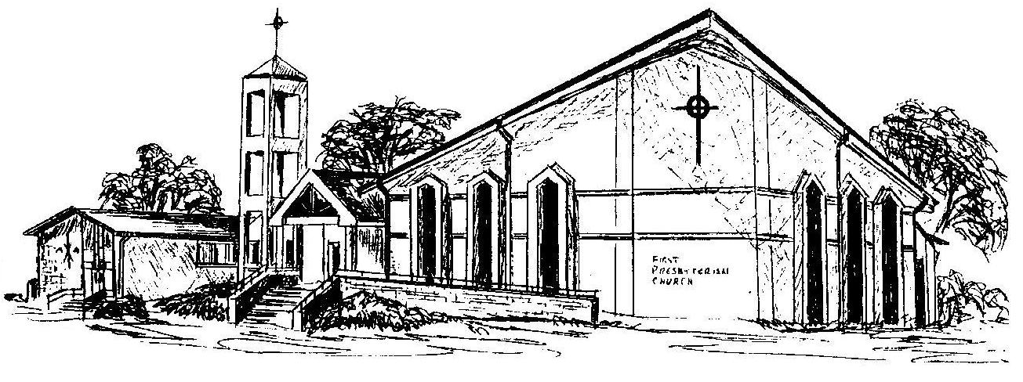

Welcome - Thank you for joining us for worship today. Please fill out a visitor information card found in the pew racks and place those in the offering plate so that we may follow up with you in the future. Your presence with us today has been a blessing to us, we hope that you have felt the presence of God and the welcome of this congregation.

