Welcome

Prelude “O Little Town of Bethlehem” Lewis H. Redner
Let us prepare our hearts and minds for worship.

Call to Worship and Lighting of the Advent Wreath – Ron and Connie Crabbs
Leader: Jesus said, “I am the Light of the World, whoever follows me will not walk in darkness, but will have the light of life.”
People: As we light the first candle again in our Advent wreath, we remember the prophet’s hope based on God’s promise: To send a Messiah who would bring peace and love to the world.
Leader: As we light the second candle, we remember the peace of Christ that calms our fears and inspires us to reach out to others,
People: The light reminds us that Christ has come to set our hearts on fire. Get up and make ready, for Jesus Christ comes.
Leader: Let us prepare for the coming of the Lord.
People: Let us praise Jesus Christ, Light of the World!

*Opening Hymn: “O Come, O Come Emmanuel” Red Hymnal, #123

*Prayer of Confession (Unison)
Prince of Peace, Light in our darkness, help us to hear your message and answer your call. We know your promises come in many ways, yet we look for the familiar, the material, the comforting and the certain. Inspire us to listen and to look beyond the obvious, that we might see your glory and receive your grace, through Jesus Christ who loves us beyond our understanding. Amen.

*Silent Reflection

*Assurance of Pardon

*Gloria Patri (Glory Be to the Father…) Red Hymnal, #623

Children’s Time

Scripture “Isaiah 9:2-7” (page 1072)
“Luke 1:46-55” (page 1589)
“Luke 2:1-7” (page 1590)
Leader: The word of the Lord.
People: Thanks be to God.
Music

Sermon: “From a Manger to Feed the World” Rev. Kimby Young

*Profession of Faith The Apostle's Creed Red Hymnal, inside back cover
I Believe in God the Father Almighty, Maker of heaven and earth, And in Jesus Christ his only Son our Lord; who was conceived by the Holy Ghost, born of the Virgin Mary, suffered under Pontius Pilate, was crucified, dead, and buried; he descended into hell; the third day he rose again from the dead; he ascended into heaven, and sitteth on the right hand of God the Father Almighty; from thence he shall come to judge the quick and the dead. I believe in the Holy Ghost; the holy catholic Church; the communion of saints; the forgiveness of sins; the resurrection of the body; and the life everlasting. Amen

*Hymn “Away in a Manger” Red Hymnal, #157

Pastoral Prayer & Lord’s Prayer

Offertory Meditation: “Away in a Manger”
William J. Kirkpatrick; James R. Murray

*Doxology

*Prayer of Dedication

*Closing Hymn: “It Came Upon the Midnight Clear” Red Hymnal, #128

*Benediction

*Postlude “How Great Our Joy” German Melody arr. by Hugo Jungst
“Joy to the World“ G.F. Handel arr. by Lowell Mason

*Those who are comfortably able will please stand.

Rev. Kimby Young, Pastor; Maureen Allinder, Worship Assistant
Chancel Choir; Dean Faulk, Music Ministries
Alice Rollf, Organist; Robyn Forkner, Pianist
Mike McGuire and Brad Cornell, Slide Production; Kim Liu. Sound

Childcare is always available in the nursery (off the hall to the west of the sanctuary). Children are welcome to stay in the sanctuary thru the whole service, or to leave at any time. Allison Perry is our primary childcare attendant.

Worship Bags for Children are available outside the north door to the sanctuary. Choose books, crayons, pencils, Legos, stuffed toys and other items to fill your bag to use during worship.

Offering Plates are at the entrance of each aisle for your contributions to the work of the church.

A "Suggestion Box" is outside the office for ideas, comments, questions, and thoughts. Contents will be reviewed at session meetings on the 2nd Monday of each month.

Presbyterian Women Mitten Tree. Please bring scarves, gloves, mittens, winter items. They will be delivered to different Gardner schools.

Wednesday Music Rehearsals - Bell Choir is at 6:00 p.m., Christmas Cantata is at 7:00 p.m., Choir is at 8:00 p.m.

Session has called a Congregational Meeting for Sunday, December 8 at 9:45 a.m. at the end of the first service for the purpose of electing an Associate Pastor Nominating Committee.
The slate of nominees for the associate pastor search committee is:
Karl Allen, Holly Applegarth, Ella Falkner, Laura Gourley, Devon Mason, Sandy Rieger, Dave Rollf, Rachel Schramm, Heather Shutt, Dave Sinclair, Tony Waites, Paula Waters.

Men’s Breakfast on Tuesday, December 10 at 7:00 p.m.

Sunday Potluck Brunch, December 15, 11:00 a.m. or at the end of the Cantata and Worship. Bring
A main dish, side dish, salad or dessert to share. Bring a friend or family members.

Christmas Caroling – Sunday, December 4-6 p.m. with hot chocolate after in fellowship hall.

Sunday, December 15, December 22 and December 29 – One Worship Service at 10:00 a.m.

Christmas Eve Service, Tuesday, December 24, 4:30 p.m. – Communion and Candlelight Worship

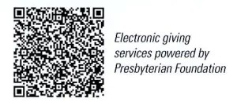
First Presbyterian Church
In the heart of Gardner since 1866 ~ Serving from the heart of God
Sunday, December 8, 2024
Second Sunday of Advent
8:45 AM

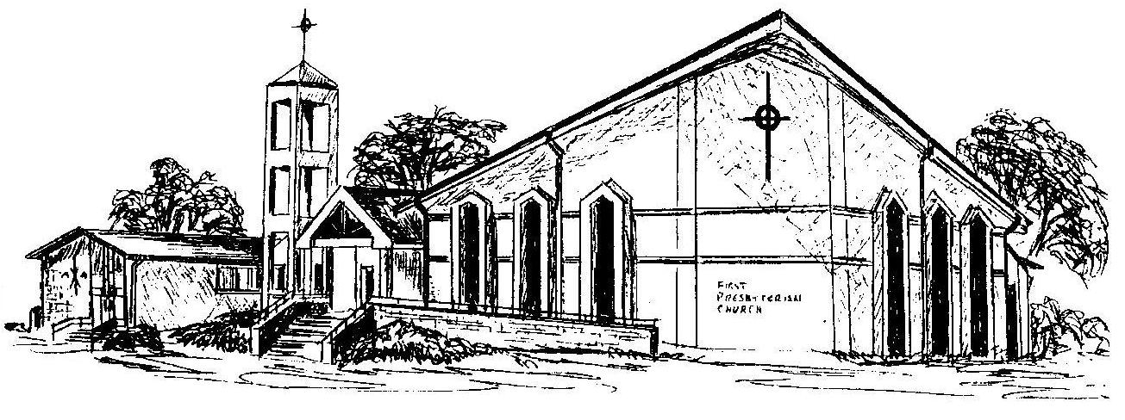

Welcome - Thank you for joining us for worship today. Please fill out a visitor information card found in the pew racks and place those in the offering plate so that we may follow up with you in the future. Your presence with us today has been a blessing to us, we hope that you have felt the presence of God and the welcome of this congregation.

