Welcome
Prelude
Let us prepare our hearts and minds for worship.

Call to Worship
Leader: Come to the table all who seek Jesus Christ!
People: We walk in the presence of God all of our days.
Leader: Open your eyes to the grace of God surrounding you.
People: Our hearts burn within us as we recognize Jesus here among us.

*Opening Hymn: “Thine Is the Glory” Red Hymnal, #227

*Prayer of Confession (Unison)
God of mercy, how often do we walk the roads of life confused and complaining? How often do we not even notice that you are right beside us, comforting and guiding us? Open our eyes to your presence. Open our hearts to your wisdom. Open our lives to your healing. Open our hands to your service. We pray in the name of our Risen Lord, Jesus Christ. Amen.

* Silent Reflection

* Assurance of Pardon

* Gloria Patri (Glory Be to the Father…) Red Hymnal, #623

Children’s Time

Recognition of High School Seniors Robert Falkner, Jon Rollf, Hayleigh Schramm

Scripture “Jeremiah 29:11” (page 1221)
“Luke 24:13-35” (page 1642)
Leader: The word of the Lord.
People: Thanks be to God.

Anthem “Face the Cross” Ella Falkner Flute Solo
Lyrics Frombach; music by David Lantz III

Sermon “Walking With Jesus” Rev. Kimby Young

*Profession of Faith The Apostle's Creed Red Hymnal, inside back cover
I Believe in God the Father Almighty, Maker of heaven and earth, And in Jesus Christ his only Son our Lord; who was conceived by the Holy Ghost, born of the Virgin Mary, suffered under Pontius Pilate, was crucified, dead, and buried; he descended into hell; the third day he rose again from the dead; he ascended into heaven, and sitteth on the right hand of God the Father Almighty; from thence he shall come to judge the quick and the dead. I believe in the Holy Ghost; the holy catholic Church; the communion of saints; the forgiveness of sins; the resurrection of the body; and the life everlasting. Amen

*Hymn “Just A Closer Walk With Thee” Red Hymnal, #380

Offertory Meditation

*Doxology

The Sacrament of Holy Communion
(All bread is gluten free. Prepacked elements are available in the back.)
Invitation
Great Prayer and The Lord’s Prayer
Words of Institution – Breaking of Bread
Communion of the People
Prayer of Thanksgiving

*Closing Hymn: “Let Us Break Bread Together” Red Hymnal, #323

*Benediction

Postlude
*Those who are comfortably able will please stand.

Rev. Kimby Young, Pastor; Rhonda Atwater, Worship Assistant
Dean Faulk, Music Ministries; Chancel Choir
Ella Falkner, Flute Solo
Harlan Plunkett, Organist; Robyn Forkner, Pianist
Mike McGuire and Brad Cornell, Slide Production; Kim Liu, Sound

Childcare is always available in the nursery (off the hall to the west of the sanctuary). Children are welcome to stay in the sanctuary thru the whole service, or to leave at any time. Allison Perry is our primary childcare attendant.

Worship Bags for Children are available outside the north door to the sanctuary. Choose books,
crayons, pencils, Legos, stuffed toys and other items to fill your bag to use during worship.

Offering Plates are at the entrance of each aisle for your contributions to the work of the church.

Gardner Multi Service Center collection is ongoing every week and is always in need of any non-perishable food. Bring something every week or once a month.

Fair Trade Products for Sale on Sundays Coffee, tea, chocolate, nuts, olive oil, dried fruit, baking products, and a few other items are for sale each Sunday at church.

Harvesters Food Distribution is always seeking volunteers. Every 3rd Saturday at Trade Net Parking lot and every 2nd Thursday at Divine Mercy Parish. Distribution begins at 1 p.m.

Joy Closet – Our mission center thrift store provides free clothing to a variety of needs. Our church provides all volunteers on the fourth Saturday of each month.

A "Suggestion Box" is outside the office for ideas, comments, questions and thoughts. Contents will be reviewed at session meetings on the 2nd Monday of each month.

Mission Pillar Hygiene Kits - raising funds now $5 per kit - goal of over 200 kits. Assemble kits on Saturday July 12 (time TBD) at Heart to Heart International warehouse. Please mark your donations to "FPC" for "Mission Kits."

Teachers and Leaders needed - for Summer combined Sunday School at 10 a.m. Teach one lesson or more. Volunteer to Marsha Cooper or Pastor Kimby. We can help you with ideas.

Women Fellowship Group will meet on Wednesday, May 7 at 10:00 a.m. in Fellowship Hall.

Kimby will take a vacation from May 19-25. Guest Preacher on Sunday, May 25 will be Susan Cox. Worship Service at 10:00 a.m. Memorial Day Weekend.

Sunday, June 1 Ice cream social between services.

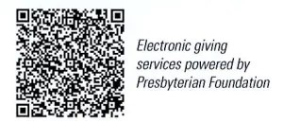
First Presbyterian Church
In the heart of Gardner since 1866 ~ Serving from the heart of God

Sunday, May 4, 2025
8:45 AM

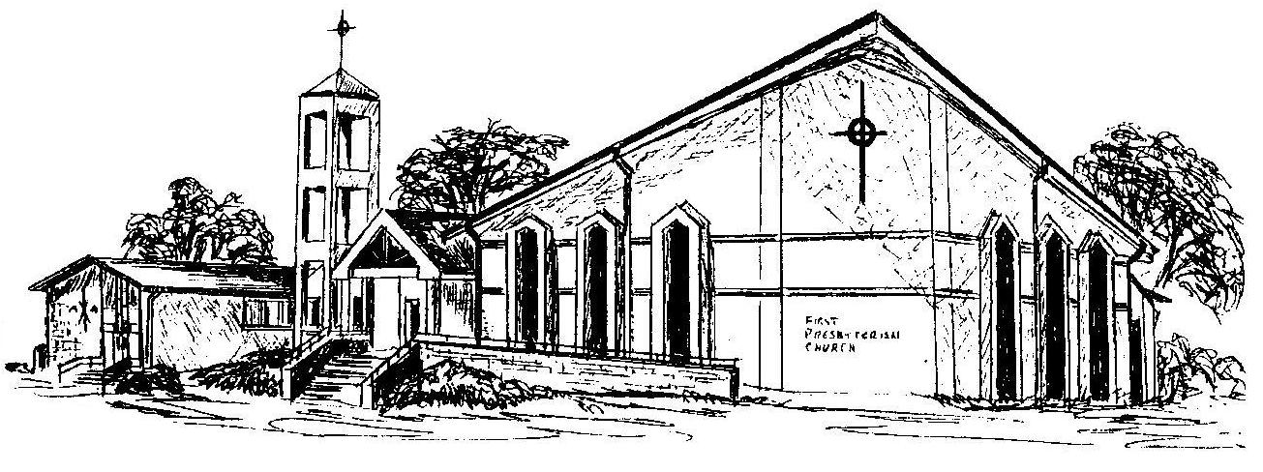

Welcome - Thank you for joining us for worship today. Please fill out a visitor information card found in the pew racks and place those in the offering plate so that we may follow up with you in the future. Your presence with us today has been a blessing to us, we hope that you have felt the presence of God and the welcome of this congregation.

