Welcome
Prelude “Tuba Tune” Paul Fey
Let us prepare our hearts and minds for worship.

Leader: Alleluia! Christ is risen!
People: Christ is risen indeed! Alleluia!
Leader: Be glad and rejoice! Hear the Good News!
People: And the celebration continues!
Leader: We greet the Risen Christ who is here among us.
People: We praise the Risen Christ and worship with great joy.

*Opening Hymn: “Worship Christ the Risen King” Red Hymnal, #225

*Prayer of the Day (Unison)
On the first day of creation, Holy God, You held out Your hands, filled with all the grace we would ever need; and You began to surround us with all that is good and pleasant. On the first day of Easter, Defeater of Death, You walked through the closed doors of our doubts and fears; You held tight until the warmth of your grace softened our hardened hearts. On the first day of following You, Breath of Peace, You opened our eyes to the bright color of hope; You teach us the glad songs of grace. God of wonders, we bring You our Easter season worship and praise. Amen.

* Gloria Patri (Glory Be to the Father…) Red Hymnal, #623

Children’s Time

Scripture “Jeremiah 6:14” (page 1181)
“John 20:19-29” (page 1686)
“Philippians 4:4-9” (page 1830)
Leader: The word of the Lord.
People: Thanks be to God.

Bell Choir “Faith of Our Fathers”
Henri F. Hemy: Arr. by Daniel Longhin

Sermon “Life Goes On” Rev. Kimby Young

*Profession of Faith The Apostle's Creed Red Hymnal, inside back cover
I Believe in God the Father Almighty, Maker of heaven and earth, And in Jesus Christ his only Son our Lord; who was conceived by the Holy Ghost, born of the Virgin Mary, suffered under Pontius Pilate, was crucified, dead, and buried; he descended into hell; the third day he rose again from the dead; he ascended into heaven, and sitteth on the right hand of God the Father Almighty; from thence he shall come to judge the quick and the dead. I believe in the Holy Ghost; the holy catholic Church; the communion of saints; the forgiveness of sins; the resurrection of the body; and the life everlasting. Amen

*Hymn “Because He Lives” Red Hymnal, #213

Offertory Meditation “I Will Sing of the Mercies” Arr. Steve Martin

*Doxology

*Prayer of Dedication

*Closing Hymn: “Christ Arose” Red Hymnal, #216

*Benediction

Postlude “To God Be the Glory” Arr. Harlan Plunkett
*Those who are comfortably able will please stand.

Rev. Kimby Young, Pastor; Larry Schick, Worship Assistant
Dean Faulk, Music Ministries; Bell Choir
Harlan Plunkett, Organist; Robyn Forkner, Pianist
Mike McGuire and Brad Cornell, Slide Production; Kim Liu, Sound

Childcare is always available in the nursery (off the hall to the west of the sanctuary). Children are welcome to stay in the sanctuary thru the whole service, or to leave at any time. Allison Perry is our primary childcare attendant.

Worship Bags for Children are available outside the north door to the sanctuary. Choose books,
crayons, pencils, Legos, stuffed toys and other items to fill your bag to use during worship.

Offering Plates are at the entrance of each aisle for your contributions to the work of the church.

Gardner Multi Service Center collection is ongoing every week and is always in need of any non-perishable food. Bring something every week or once a month.

Fair Trade Products for Sale on Sundays Coffee, tea, chocolate, nuts, olive oil, dried fruit, baking products, and a few other items are for sale each Sunday at church.

Harvesters Food Distribution is always seeking volunteers. Every 3rd Saturday at Trade Net Parking lot and every 2nd Thursday at Divine Mercy Parish. Distribution begins at 1 p.m.

Joy Closet – Our mission center thrift store provides free clothing to a variety of needs. Our church provides all volunteers on the fourth Saturday of each month.

A "Suggestion Box" is outside the office for ideas, comments, questions and thoughts. Contents will be reviewed at session meetings on the 2nd Monday of each month.

Presbyterian Youth Fellowship Chicken & Noodle dinner April 27 food served 11:30–1:00 p.m.

Mission Pillar Hygiene Kits - raising funds now $5 per kit - goal of over 200 kits. Assemble kits on Saturday July 12 (time TBD) at Heart to Heart International warehouse. Please mark your donations to "FPC" for "Mission Kits."

Joy Closet Volunteers Needed - any time in the next few weeks and on Garage Sale Saturday afternoon – May 3.

Teachers and Leaders needed - for Summer combined Sunday School at 10 a.m. Teach one lesson or more. Volunteer to Marsha Cooper or Pastor Kimby. We can help you with ideas.

May 25 - one service at 10 a.m. with a guest preacher - Memorial Day weekend

June 1 - ice cream social between services 9:45 – 11:00 a.m.

Statements of Faith from the Confirmation Commissioning Class of 2025 are in the narthex.

Women Fellowship Group will meet on Wednesday, May 7 at 10:00 a.m. in Fellowship Hall.
First Presbyterian Church
In the heart of Gardner since 1866 ~ Serving from the heart of God

Sunday, April 27, 2025
Second Sunday of Easter
8:45 AM
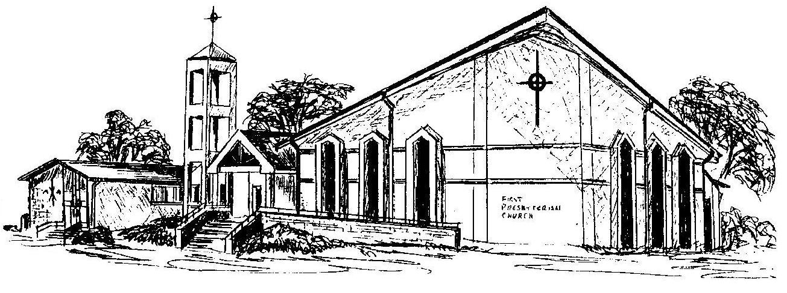

Welcome - Thank you for joining us for worship today. Please fill out a visitor information card found in the pew racks and place those in the offering plate so that we may follow up with you in the future. Your presence with us today has been a blessing to us, we hope that you have felt the presence of God and the welcome of this congregation.

