Welcome
Prelude “Grand Choeur”
Cesar Franck / arr. by Ellen Jane Lorenz
Let us prepare our hearts and minds for worship.

Call to Worship: (adapted from Katherine Hawker, Liturgy Outside the Box)
Leader: The spirit of God calls us from many places; some of us come from busy homes with many people; some of us live alone.
People: We all belong together in God’s family.
Leader: This week has been different for each of us; some of us have had happy news we want to celebrate; some of us have faced grief and need to cry.
People: We are all members of God’s family and we belong together.
Leader: We all come to this same place; all of us seeking God’s presence in our lives.
People: Together we become God’s family of love and belonging. Let us worship God.

*Opening Hymn: “Joyful, Joyful, We Adore Thee” Red Hymnal , #1

*Prayer of the Confession (Unison)
(from Come, Let Us Build by Mary Nelson Abbott, UCC)
We confess to you, Renewing Spirit, that we confuse unity with uniformity, and diversity with divisiveness. We speak and behave as if being a part of your family means assimilating others to our way of living. We deny and destroy the beauty you created in each person. We long to change these patterns, Creator, but we do not know how. Teach us to value challenge. Help us to see strength in difference. And empower us to build your kingdom in creativity and love. Amen.

*Silent Reflection

*Assurance of Pardon

* Gloria Patri (Glory Be to the Father…) Red Hymnal, #623

Children’s Time

Scripture “Psalm 133:1” (page 970)
“Matthew 5:9” (page 1501)
“Galatians 3:26-29” (page 1813)
“Ephesians 2:13-22” (page 1819)
Leader: The word of the Lord.
People: Thanks be to God.
Music “Then Shall the Righteous Shine Forth” Felix Mendelssohn
(Dann warden die Gerechten leuchten) from Elijah

Sermon “The Big Tent: Why Can’t We All Just Get Along?” Rev. Kimby Young

*Profession of Faith The Apostle's Creed Red Hymnal, inside back cover
I Believe in God the Father Almighty, Maker of heaven and earth, And in Jesus Christ his only Son our Lord; who was conceived by the Holy Ghost, born of the Virgin Mary, suffered under Pontius Pilate, was crucified, dead, and buried; he descended into hell; the third day he rose again from the dead; he ascended into heaven, and sitteth on the right hand of God the Father Almighty; from thence he shall come to judge the quick and the dead. I believe in the Holy Ghost; the holy catholic Church; the communion of saints; the forgiveness of sins; the resurrection of the body; and the life everlasting. Amen

*Hymn “Blest Be the Tie That Binds” Red Hymnal, #286

Pastoral Prayer & Lord’s Prayer

Offertory Meditation “Bind Us Together” Bob Gillman

*Doxology

*Prayer of Dedication

*Closing Hymn: “We Are God’s People” Red Hymnal, #283

*Benediction

Postlude “Let There Be Peace on Earth” Sy Miller and Jill Jackson
*Those who are comfortably able will please stand.

Rev. Kimby Young, Pastor; Wayne Rollf, Worship Assistant
Scott Allison, Solo; Vanessa Marriott, Piano Accompanist
Dean Faulk, Music Ministries Alice Rollf, Organist
Mike McGuire and Brad Cornell, Slide Production; Kim Liu, Sound

Childcare is always available in the nursery (off the hall to the west of the sanctuary). Children are welcome to stay in the sanctuary thru the whole service, or to leave at any time. Allison Perry is our primary childcare attendant.

Worship Bags for Children are available outside the north door to the sanctuary. Choose books, crayons, pencils, Legos, stuffed toys and other items to fill your bag to use during worship.

Offering Plates are at the entrance of each aisle for your contributions to the work of the church.

Gardner Multi Service Center collection is ongoing every week and is always in need of any non-perishable food. Bring something every week or once a month.

Fair Trade Products for Sale on Sundays Coffee, tea, chocolate, nuts, olive oil, dried fruit, baking products, and a few other items are for sale each Sunday at church.

Harvesters Food Distribution is always seeking volunteers. Every 3rd Saturday at Trade Net Parking lot and every 4th Wednesday at Divine Mercy Parish. Distribution begins at about 1 p.m.

A "Suggestion Box" is outside the office for ideas, comments, questions, and thoughts. Contents will be reviewed at session meetings on the 2nd Monday of each month.

SAS – Summer Adventures on Sunday - Sunday school for all ages - 10 a.m. To help or lead a week talk to Kimby Young or Marsha Cooper.

Elder On Call will be in the narthex each Sunday morning between services to answer questions and hear ideas or concerns.

Holy Smokes BBQ and Music Festival Community Event – Saturday, August 17, 2024, 5 – 7 p.m.

Noisy Offering on Sunday, August 18, bring loose change. Make a Joyful Nosie to the Lord.

Women of Faith Book Club - The next Book Club will be held Thursday, August 22, 2024, at 6:30 pm at the home of Linda Jensen, 36400 W. 159th, Gardner, KS. The book of choice is "Mostly What God Does" by Savannah Guthrie. Anyone is welcome to join anytime.

Pack Hygiene Kits for Heart to Heart International September 7 – Travel 9:30 a.m.
Packing time 10:00-noon. Sign up to carpool and attend.

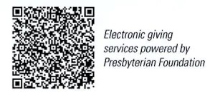
First Presbyterian Church
In the heart of Gardner since 1866 ~ Serving from the heart of God

Sunday, August 11, 2024
8:45 AM

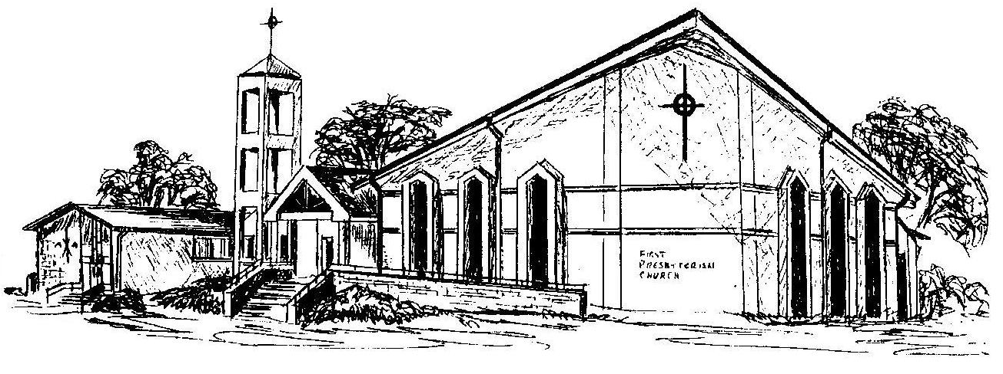

Welcome - Thank you for joining us for worship today. Please fill out a visitor information card found in the pew racks and place those in the offering plate so that we may follow up with you in the future. Your presence with us today has been a blessing to us, we hope that you have felt the presence of God and the welcome of this congregation.

