Welcome

Prelude
Let us prepare our hearts and minds for worship.

Call to Worship (Psalm 24 adapted)
Leader: All that we are is a gift from God.
People: The earth is the Lord’s and all that is in it,
Leader: All that we have is a gift from God.
People: The world, and those who dwell therein;
Leader: There are no words to describe the wonders of God’s creation.
People: For God has founded it on the seas; God has established it upon the rivers.
Leader: Who shall stand in God’s holy place? Who shall approach God with confidence?
People: All shall receive blessing from the Lord, and righteousness from the God of our salvation.

*Opening Hymn: “Now Thank We All Our God” Red Hymnal, #556

*Prayer of Confession (Unison) (adapted from by Sarah E. Weaver, Preaching in Pumps)
God of amazing grace, you have asked us to give of ourselves, wholly and completely. We have heard your call and have responded with great affirmation and joy. Yet there are times when we fall short. Times when we forget. Times when we focus on the wrong things. Help us to have faith, O God. Help us to give and serve through that faith. Help us to be blessed by that faith. Help us to renew that faith. Help us to share that faith with others. We pray in Jesus name. Amen.

*Silent Reflection

*Assurance of Pardon

*Gloria Patri (Glory Be to the Father…) Red Hymnal, #623

Children’s Time

Scripture “Exodus 16:11-21” (page 112)
“Philippians 4:4-13” (page 1830)
“Matthew 6:25-34” (page 1505)
“Luke 6:38” (page 1601)
Leader: The word of the Lord.
People: Thanks be to God.
Music “Hear Me Now, O Lord” Jay Althohuse

Sermon: “More Than Enough” Rev. Kimby Young

*Stewardship Pledge Dedication Litany of Gratitude Insert

*Hymn “Take My Life and Let It Be” Red Hymnal, #379 vs. 1, 2, and 6

Pastoral Prayer & Lord’s Prayer

Offertory Meditation:

*Doxology

*Prayer of Dedication with PW Thank Offering and Mitten Tree Dedication
– adapted from PW Resources (Unison)
Gracious God, we give you thanks for providing for our every need: food, shelter, wisdom, skill, friendship, affection. We remember that these gifts come from you and are meant to be shared. Creator, Giver, for all of this, we thank you. Bless these Thank Offering gifts and our Mitten Tree Warm items as they touch the lives of others. Bless the children who will benefit. Bless the women who will have greater access to resources. In the name of the One who responded with unbounded love and generosity, Jesus Christ our Savior. Amen.

*Closing Hymn: “Here I Am, Lord” Insert

*Benediction

*Postlude
*Those who are comfortably able will please stand.

Rev. Kimby Young, Pastor; Carl Frahme, Worship Assistant
Chancel Choir; Dean Faulk, Music Ministries;
Alice Rollf, Organist; Robyn Forkner, Pianist
Mike McGuire and Brad Cornell, Slide Production; Kim Liu. Sound

Childcare is always available in the nursery (off the hall to the west of the sanctuary). Children are welcome to stay in the sanctuary thru the whole service, or to leave at any time. Allison Perry is our primary childcare attendant.

Worship Bags for Children are available outside the north door to the sanctuary. Choose books, crayons, pencils, Legos, stuffed toys and other items to fill your bag to use during worship.

Offering Plates are at the entrance of each aisle for your contributions to the work of the church.

A "Suggestion Box" is outside the office for ideas, comments, questions, and thoughts. Contents will be reviewed at session meetings on the 2nd Monday of each month.

Elder On Call Seth Cooper will be in the narthex this Sunday morning between services to answer questions and hear ideas or concerns.

On-line Bible study group continues - "From Beginning to Forever - A Study of the Grand Narrative of Scripture". Meeting on Tuesday evening at 6:00 p.m. Interested in joining should email Jennifer Waites at jwaitemail@hotmail.com.

Women of Faith Book Club The next book club will be held on Thursday, December 5 at 6:30p.m. at the home of Jennifer Waites. The book is "Two from Galilee" by Marjorie Holmes. All are welcome. Please join us.

Ladies Christmas Luncheon: Saturday, December 7th at 12:00 noon. Mark your calendars!

Presbyterian Women Mitten Tree. Please bring scarves, gloves, mittens, winter items. They will be delivered to different Gardner schools.

Operation Christmas Child Packing Party – November 17 – 10:00a.m. You are all invited to a packing party for Operation Christmas Child.

Wednesday Music Rehearsals - Bell Choir is at 6:00 p.m., Christmas Cantata is at 7:00 p.m., Choir is at 8:00 p.m.

PYF Annual Brunch on Sunday, November 24. Food will be served 9:30 –11:00 a.m. Biscuits and gravy, pancakes, sausage, bacon and eggs. Donations accepted for 2025 mission trip.

A square Fiesta Plum in color dish, was taken from the Chili Supper the night of Trunk or Treat. If taken by mistake, please return to the church office please. Thanks Judy Lenehan.

Christmas Poinsettias for Sanctuary cost $13.00 in memory of or in honor of someone special due by Monday, December 2.

First PresbyterianChurch
In the heart of Gardner since 1866 ~ Serving from the heart of God
Sunday, November 17, 2024
8:45 AM

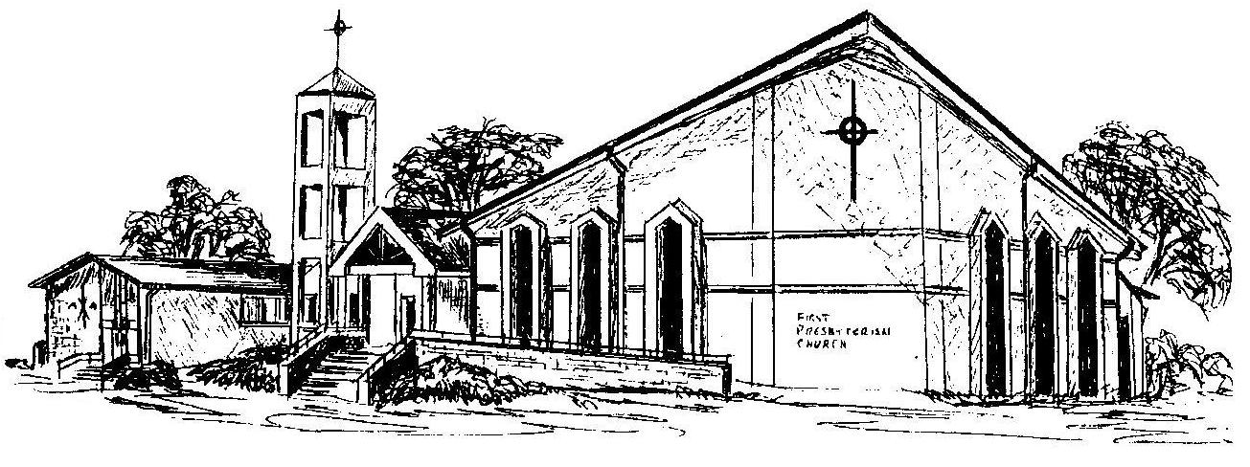

Welcome - Thank you for joining us for worship today. Please fill out a visitor information card found in the pew racks and place those in the offering plate so that we may follow up with you in the future. Your presence with us today has been a blessing to us, we hope that you have felt the presence of God and the welcome of this congregation.

