Welcome

Prelude

*Let us prepare our hearts and minds for worship.*

Call to Worship

Leader: For all the saints who have gone before us,

who have spoken to our hearts and touched our lives,

**People: We praise you, God of the past!**

Leader: For all the saints who live beside us,

whose weaknesses and strengths are woven with our own,

**People: We praise you, God of the present!**

Leader: For all the saints who live beyond us,

who challenge us to change the world with them,

**People: We praise you, God of the future!**

*Opening Hymn: *“For All The Saints”* Red Hymnal, #546

Remembrance of the Saints and Lighting of the Candles

*Thomas (Mike) Fraser, Glenn Bonar, Janet Bonar*

Unison Prayer

**Gracious God, we praise you for the glorious company of the saints who now rest with you. We thank you today for those who have departed from this life over the past year, and remember them in gratitude. We pray your blessing on their loved ones and on all of us who remember. Grant us your peace and confidence in you. We pray in witness to the resurrection of Jesus Christ and in the hope of that eternal union you have promised for all who believe in you. Amen.**

*Gloria Patri *(Glory Be to the Father…)* Red Hymnal, #623

Children’s Time

Scripture “Isaiah 58:8-10” (page 1153)

“Ephesians 1:3-23” (page 1817)

“Revelation 22:1-5” (page 1938)

Leader: The Word of the Lord.

**People: Thanks be to God.**

Music

Sermon*: “Inheritance in Light”* Rev. Kimby Young

*Profession of Faith The Apostle's Creed Red Hymnal, inside back cover

**I Believe in God the Father Almighty, Maker of heaven and earth, and in Jesus Christ his only Son our Lord; who was conceived by the Holy Ghost, born of the Virgin Mary, suffered under Pontius Pilate, was crucified, dead, and buried; he descended into hell; the third day he rose again from the dead; he ascended into heaven, and sitteth on the right hand of God the Father Almighty; from thence he shall come to judge the quick and the dead. I believe in the Holy Ghost; the holy catholic Church; the communion of saints; the forgiveness of sins; the resurrection of the body; and the life everlasting. Amen**

*Hymn *“The Day of Resurrection”* Red Hymnal, #226

Offertory Meditation:

*Doxology

The Sacrament of Holy Communion and Remembrance of Saints

*(All bread is gluten free. Prepacked elements are available in the back)*

Invitation

Great Prayer and The Lord’s Prayer

Words of Institution – Breaking of Bread

Communion of the People

Prayer of Thanksgiving

*Closing Hymn: *“In Remembrance”* Red Hymnal, #322

*Benediction

Postlude

*Those who are comfortably able will please stand.

Rev. Kimby Young, Pastor; Robyn Forkner, Worship Assistant

Alice Rollf, Organist; Robyn Forkner, Pianist;

Dean Faulk, Music Ministries

Mike McGuire and Brad Cornell, Slide Production; Kim Liu, Sound

**Childcare is always available in the nursery** (off the hall to the west of the sanctuary). Children are welcome to stay in the sanctuary thru the whole service, or to leave at any time. Allison Perry is our primary childcare attendant.

**Worship Bags for Children** are available outside the north door to the sanctuary.  Choose books, crayons, pencils, Legos, stuffed toys and other items to fill your bag to use during worship.

**Offering Plates** are at the entrance of each aisle for your contributions to the work of the church.

**A "Suggestion Box" is** outside the office for ideas, comments, questions, and thoughts. Contents will be reviewed at session meetings on the 2nd Monday of each month.

**Elder On Call** (Dave Sinclair and Randy Rieger)will be in the narthex this Sunday morning between services to answer questions and hear ideas or concerns.

**On-line Bible study group continues -** "From Beginning to Forever - A Study of the Grand Narrative of Scripture". Meeting on Tuesday evening at 6:00 p.m. Interested in joining should email Jennifer Waites at [jwaitemail@hotmail.com](mailto:jwaitemail@hotmail.com).

**Women of Faith Book Club** The next book club will be held on Thursday, December 5 at 6:30p.m. at the home of Jennifer Waites. The book is "Two from Galilee" by Marjorie Holmes. All are welcome. Please join us.

**Ladies Night:** Bring any type of salad to share for a salad supper and dessert will be provided on **Thursday, November 7th** at 6:30 pm in Fellowship Hall. Please call the office by November 4th if childcare is needed in the Nursery. There is a sign-up sheet in the Narthex.

**Ladies Christmas Luncheon:** Saturday December 7th at 12:00 noon. Mark your calendars!

**Mitten Tree**- early November. New stocking hats, mittens and gloves for students in need.

**Operation Christmas Child Packing Party – November 17 – 10:00a.m.**

YOU ARE ALL INVITED TO A PACKING PARTY for Operation Christmas Child.

**Wednesday Music Rehearsals -** Bell Choir is at 6:00 p.m.,Christmas Cantata is at 7:00 p.m., Choir is at 8:00 p.m.

**PYF Annual Brunch on Sunday, November 24.** Food will be served 9:30 –11:00 a.m. Biscuits and gravy, pancakes, sausage, bacon and eggs. Donations accepted for 2025 mission trip.

First Presbyterian Church

*In the heart of Gardner since 1866 ~ Serving from the heart of God*

*Sunday,* *November 3, 2024*

*All Saint’s Sunday*

*8:45 AM*

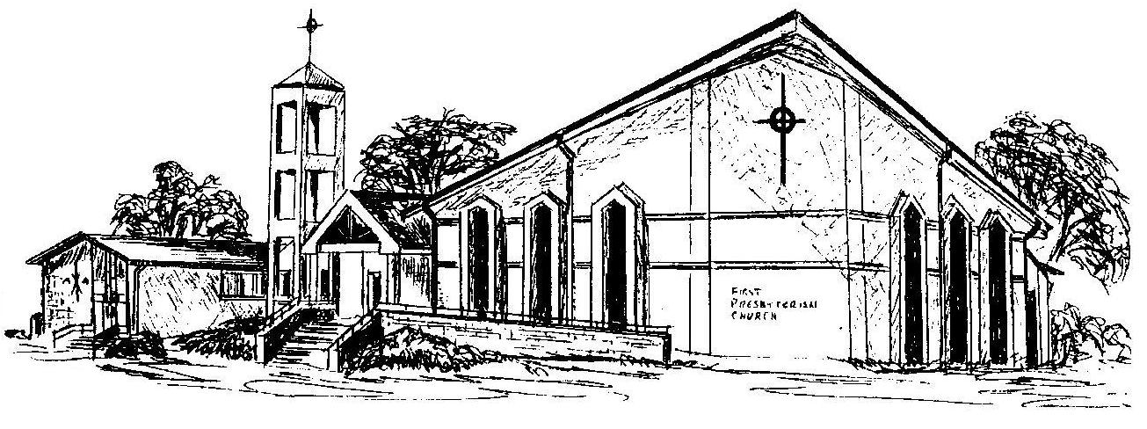

**Welcome -** Thank you for joining us for worship today.  Please fill out a visitor information card found in the pew racks and place those in the offering plate so that we may follow up with you in the future.  Your presence with us today has been a blessing to us, we hope that you have felt the presence of God and the welcome of this congregation.