Welcome

Prelude: *“Majesty”*

Jack W. Hayford / arr. by Eugene Thomas

*Let us prepare our hearts and minds**for worship.*

Call to Worship

Leader: Have you heard the glorious news?

**People: Jesus Christ is born! Emmanuel, God is with us!**

Leader: Indeed, wonder of wonders, the Word became flesh and has come to dwell among us.

**People: And we have seen Christ’s glory, full of grace and truth!**

Leader: Glory to God in the highest,

**People: And on Earth peace among all whom God favors!**

*Opening Hymn: *“Good Christian Men Rejoice”* Red Hymnal, #151

* Prayer for the day (Unison) (from Bread for the Journey by Ruth Duck)

**Amazing God, you have confounded the wisdom of the world by coming to us in the form of a human baby, frail and vulnerable. Help us to comprehend the great love with which you open yourself to our world, that we in turn may risk to open ourselves in love toward all your children, and that we may find the source of our lives in Jesus Christ and the folly of the cross. Amen.**

*Gloria Patri (Glory Be to the Father…) Red Hymnal, #623

Children’s Time

Recognition of Alice Rollf

Scripture *“Matthew 1:18-25”* (page 1497)

Scripture *“Matthew 28:18-20”* (page 1550)

Leader: The word of the Lord.

**People: Thanks be to God.**

Easton Pacey (trumpet) “*Have Yourself a Merry Little Christmas”*

*“A Holly Jolly Christmas”*

Sermon: *“Five Golden Rings”* Rev. Kimby Young

*Hymn: *“What Child is This”* Red Hymnal, #137

Pastoral Prayer, Prayer of Dedication & Lord’s Prayer

Pray your prayers aloud when invited.

Close your prayer with “Lord, in your mercy.”

The Congregation will respond to each: **“Hear Our Prayers.”**

Offertory Meditation: *“Great is Thy Faithfulness”* William M. Runyan

*Doxology

*Prayer of Dedication

*Closing Hymn: *“Go Tell It On the Mountain”* Red Hymnal, #138

*Benediction

*Postlude *“To God Be the Glory”*

William H. Doane / arr. by Doug Holck

*Those who are comfortably able will please stand.

*Rev. Kimby Young, Pastor; Dean Faulk, Music Ministries*

*Alice Rollf, Organist; Robyn Forkner, Pianist*

*Mike McGuire and Brad Cornell, Slide Production; Kim Liu Sound*

**Childcare is always available in the nursery** (off the hall to the west of the sanctuary). Children are welcome to stay in the sanctuary thru the whole service, or to leave at any time. Allison Perry is our primary childcare attendant.

**Worship Bags for Children** are available outside the north door to the sanctuary.  Choose books, crayons, pencils, Legos, stuffed toys and other items to fill your bag to use during worship.

**Offering Plates** are at the entrance of each aisle for your contributions to the work of the church.

**Gardner Multi Service Center** collection is ongoing every week and is always in need of any non-perishable food. Bring something every week or once a month.

**Fair Trade Products for Sale** on Sundays Coffee, tea, chocolate, nuts, olive oil, dried fruit, baking products, and a few other items are for sale each Sunday at church.

**Harvesters Food Distribution** is always seeking volunteers. Every 3rd Saturday at Trade Net Parking lot and every 4th Wednesday at Divine Mercy Parish. Distribution begins at about 1 p.m.

**Joy Closet –** Our mission center thrift store provides free clothing to a variety of needs. Extra items are sold at low cost. Volunteers are trained in a variety of jobs and work at different times. We have a job that fits every ability. Our church provides all volunteers on the fourth Saturday of each month.

**A "Suggestion Box" is** outside the office for ideas, comments, questions, and thoughts. Contents will be reviewed at session meetings on the 2nd Monday of each month.

**If you want to make a donation** that is recorded for 2024, it must be in by December 29.

**Church Office hours:**

December 31 Office Closed

January 1 Office Closed

**Emergency** - If you need Pastor Kimby when the church office is closed, call on her cell phone 913-481-7076.  Leave a message for call back.

First Presbyterian Church

*In the heart of Gardner since 1866 ~ Serving from the heart of God*

*Sunday,* *December 29,**2024*

*10:00 AM*

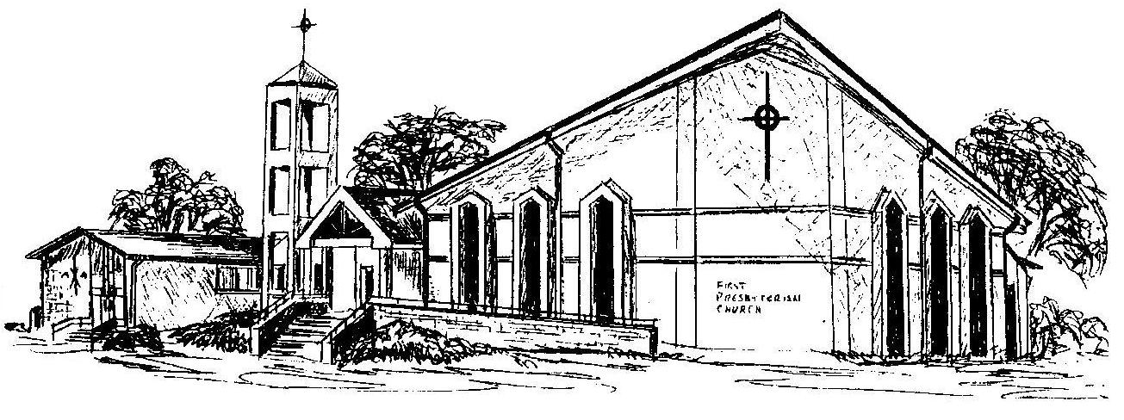

***Welcome -*** *Thank you for joining us for worship today.  Please fill out a visitor information card found in the pew racks and place those in the offering plate so that we may follow up with you in the future.  Your presence with us today has been a blessing to us, we hope that you have felt the presence of God and the welcome of this congregation.*