Welcome
Prelude “Precious Lord, Take My Hand”
George N. Allen / arr. Thomas A. Dorsey
“Just a Closer Walk With Thee” Anonymous
Let us prepare our hearts and minds for worship.

Call to Worship
Leader: Throughout these forty days of Lent we are called to awareness.
People: We come to worship God, seeking to follow our Lord Jesus Christ.
Leader: Jesus leads us to prayer and service. Jesus calls us to share our gifts.
People: We lift our hearts to the Lord in gratitude for God’s grace.

*Opening Hymn ”Here, I Am Lord” Insert

*Prayer of Confession (Unison)
God of the journey, often you lead us where we fear to go. You call us, but we are reluctant to follow. We promise to serve and then we fall short. Give us the courage to go where you send us, the strength to stay where you need us, and the wisdom to respond as you inspire us. Help us to love your people as you love, through Jesus Christ our Lord. Amen.

*Silent Reflection

*Assurance of Pardon

* Gloria Patri (Glory Be to the Father…) Red Hymnal, #623

Children’s Time

Scripture “Matthew 4:18-22” (page 1500)
“Matthew 9:9” (page 1509)
“Luke 9:57-62” (page 1611)
Leader: The word of the Lord.
People: Thanks be to God.

Anthem “Living Hope”
Words & music by Phil Wickham and Brian Johnson, arr. by David Wise

Sermon “Follow Jesus” Rev. Kimby Young

*Profession of Faith The Apostle's Creed Red Hymnal, inside back cover
I Believe in God the Father Almighty, Maker of heaven and earth, And in Jesus Christ his only Son our Lord; who was conceived by the Holy Ghost, born of the Virgin Mary, suffered under Pontius Pilate, was crucified, dead, and buried; he descended into hell; the third day he rose again from the dead; he ascended into heaven, and sitteth on the right hand of God the Father Almighty; from thence he shall come to judge the quick and the dead. I believe in the Holy Ghost; the holy catholic Church; the communion of saints; the forgiveness of sins; the resurrection of the body; and the life everlasting. Amen

*Hymn “Dear Lord and Father of Mankind” Red Hymnal, #427

Pastoral Prayer & Lord’s Prayer

Offertory Meditation “Following Thee” Bertha R. Frick

*Doxology

*Prayer of Dedication

*Closing Hymn: “I Have Decided to Follow Jesus” Red Hymnal, #376

*Benediction

Postlude “Living for Jesus” C. Harold Lowden
*Those who are comfortably able will please stand.

Rev. Kimby Young, Pastor; Larry Schick, Worship Assistant
Dean Faulk, Music Ministries; Alice Rollf, Organist; Chancel Choir
Mike McGuire and Brad Cornell, Slide Production
Theo Borge, Tech, and Videographer; Kim Liu, Sound

Childcare is always available in the nursery (off the hall to the west of the sanctuary). Children are welcome to stay in the sanctuary thru the whole service, or to leave at any time. Allison Perry is our primary childcare attendant.

Offering Plates are at the entrance of each aisle for your contributions to the work of the church.

Gardner Multi Service Center collection is ongoing every week and is always in need of any non-perishable food. Bring something every week or once a month.

Fair Trade Products for Sale on Sundays Coffee, tea, chocolate, nuts, olive oil, dried fruit, baking products, and a few other items are for sale each Sunday at church.

Harvesters Food Distribution is always seeking volunteers. Every 3rd Saturday at Trade Net Parking lot and every 4th Wednesday at Divine Mercy Parish. Distribution begins at about 1 p.m.

2024 Per Capita is $43.29 General Assembly $7.73, Synod $2.80, Presbytery $32.76.

Presbyterian Women Bible Study has begun on Thursdays, at 7:00 p.m.in Fellowship Hall lesson is “Worth More Than Rubies” by Christina Patterson.

Monday Night Bible Study group has started a new study: Angels: 8 Studies for Individuals or Groups, on Feb. 12. This group meets every other Monday evening at 5:30pm via Zoom. If interested, please contact Jennifer Waites (jwaitemail@hotmail.com).

Lenten Devotion Books are available in the narthex.

OGHS collection is collected on March 31, you can ear mark check OGHS.

Mission fundraiser for hygiene kits $5.00, woman/girls health kits $25.00.

Women’s’ Fellowship Group meets on Wednesday, March 6, 10:00 a.m. Fellowship Hall.

PW Bible Study Brunch and Meeting on Saturday, March 9, 9:30 a.m. Fellowship Hall.

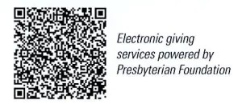
First Presbyterian Church
In the heart of Gardner since 1866 ~ Serving from the heart of God

Sunday, February 18, 2024
1st Sunday of Lent
8:45 AM
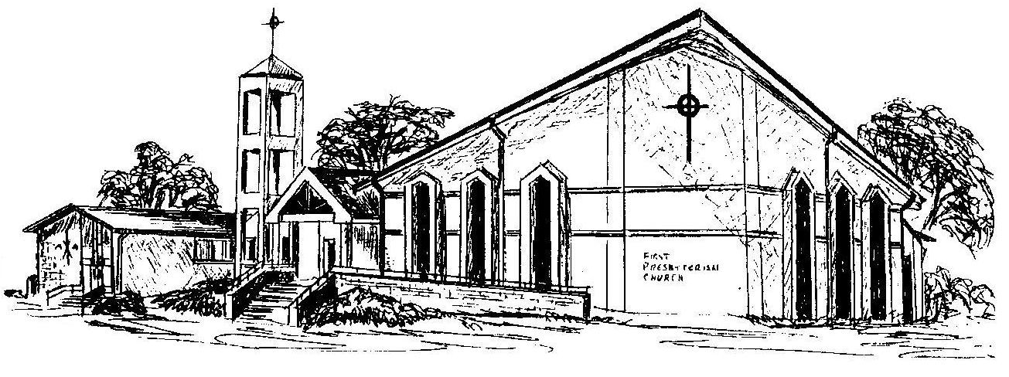

Welcome - Thank you for joining us for worship today. Please fill out a visitor information card found in the pew racks and place those in the offering plate so that we may follow up with you in the future. Your presence with us today has been a blessing to us, we hope that you have felt the presence of God and the welcome of this congregation.

