Welcome

Prelude “He” Jack Richards
Let us prepare our hearts and minds for worship.

Call to Worship
Leader: We’ve come to worship God,
People: who loved us before we were yet born,
Leader: who knows us even better than we know ourselves,
People: whose presence never leaves us,
Leader: and whose love for us never ceases.
People: This is our God. Let us worship together!

*Opening Hymn: “Great Is Thy Faithfulness” Red Hymnal, # 43

*Prayer of Confession (Unison) ) (from intergenerational worship)
God, You know everything about us. Every word we speak, every thought we think, every deed we do— You know them all, even before we do. So take a good look at us now. Look deep into our hearts and souls. Point out the things that displease You, the thoughts and actions we need to change. Show us how to live as You would want us to live. Amen.

*Silent Reflection

*Assurance of Pardon

*Gloria Patri (Glory Be to the Father…) Red Hymnal, #623

Children’s Time

Scripture “Psalm 139” (page 974)
Leader: The Word of the Lord.
People: Thanks be to God.

Anthem In This Very Room”
Words & Music by Ron & Carol Harris

Sermon: “Searched and Known” Rev. Kimby Young

*Profession of Faith The Apostle's Creed Red Hymnal, inside back cover
I Believe in God the Father Almighty, Maker of heaven and earth,
And in Jesus Christ his only Son our Lord; who was conceived by the Holy Ghost, born of the Virgin Mary, suffered under Pontius Pilate, was crucified, dead, and buried; he descended into hell; the third day he rose again from the dead; he ascended into heaven, and sitteth on the right hand of God the Father Almighty; from thence he shall come to judge the quick and the dead.
I believe in the Holy Ghost; the holy catholic Church; the communion of saints; the forgiveness of sins; the resurrection of the body; and the life everlasting. Amen

*Hymn “Seek Ye First” Red Hymnal, #42

Pastoral Prayer & Lord’s Prayer

Offertory Meditation: “You Are Before Me, Lord” Alfred Morton Smith

*Doxology

*Prayer of Dedication

*Closing Hymn: “Jesus, Thou Joy of Loving Hearts” Red Hymnal, #501

*Benediction

Postlude “I Am Thine, O Lord”
William H. Doane / arr. by Joseph Prentiss
*Those who are comfortably able will please stand.

Rev. Kimby Young, Pastor; Poppy Zurcher, Worship Assistant
Dean Faulk, Music Ministries, Chancel Choir
Alice Rollf, Organist
Mike McGuire and Brad Cornell, Slide Production
Davis Tropansky & Theo Borge, Tech and Videographer; Kim Liu, Sound

Childcare is available in the nursery (off hall west of the sanctuary). Children are welcome to stay in the sanctuary, or to leave at any time. Allison Perry is our primary childcare attendant.

Offering Plates are at the entrance of each aisle for your contributions to the work of the church.

Gardner Multi Service Center collection is ongoing every week and is always in need of any non-perishable food. Bring something every week or once a month.

Fair Trade Products for Sale on Sundays Coffee, tea, chocolate, nuts, olive oil, dried fruit, baking products, and a few other items are for sale each Sunday at church.

Harvesters Food Distribution is always seeking volunteers. Every 3rd Saturday at Trade Net Parking lot and every 4th Wednesday at Divine Mercy Parish. Distribution begins at about 1 p.m.

Our church is serving at the Joy Closet on the 4th Saturday of every month. Just show up anytime between 10:00 – 2:00 p.m.

Women’s Bible Study meets every Thursday, at 6:30 pm in Westminster Room. We are studying the book Desperate for HOPE by Vaneetha Risner.

Choirs meet on Wednesday’s Bell Choir at 6:00 p.m. in Chapel, Chancel Choir at 7:00 p.m. in Sanctuary, Christmas Cantata at 8:00 p.m.

Sunday School for all ages. 10:00 a.m. Children & Youth classes meet downstairs.

Book Club 6:30 p.m. at Perkins on Friday, October 27 “An Undivided Heart” Book 3.

The Message in the Hymnal on Sunday, October 15 at 6:30 p.m. in Fellowship Hall. Learn the history behind the songs, Christmas Carols. Coffee & Cookies.

Men’s Breakfast meets on October 10 at Perkins at 7:00 a.m.

Trunk or Treat – Sunday, October 29 5:00 -7:00 p.m. Sign up in the narthex to help.

Monday online Bible Study 6 p.m. starts on Oct. 16, contact Jennifer Waites for login information. jwaitemail@hotmail.com.

Pastor Kimby will be on vacation from Tuesday, October 10 thru Monday, October 16. Contact Connie, if you need anything during that time.

Guest Preacher October 15 - Sarah Evans, returns to lead worship.

First Presbyterian Church
In the heart of Gardner since 1866 ~ Serving from the heart of God

Sunday, October 8, 2023
8:45 AM

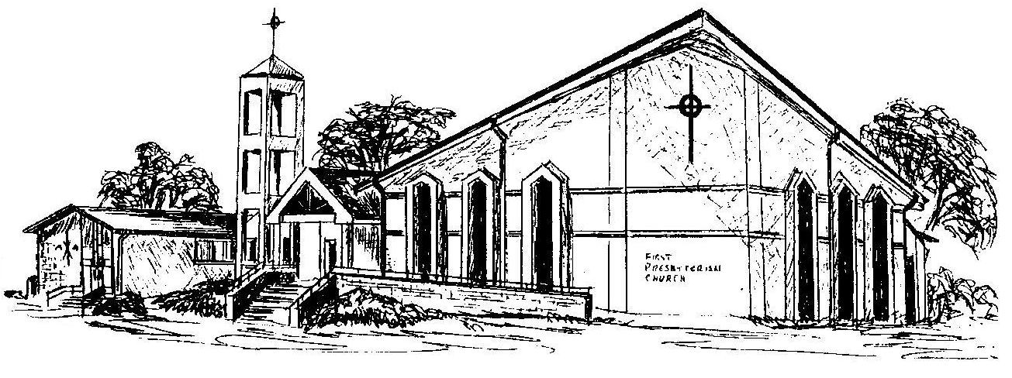

Welcome - Thank you for joining us for worship today. Please fill out a visitor information card found in the pew racks and place those in the offering plate so that we may follow up with you in the future. Your presence with us today has been a blessing to us, we hope that you have felt the presence of God and the welcome of this congregation.

