Welcome

Prelude “The Birthday of the King” W.H. Neidlinger
“ Ring the Bells” Harry Bollback
Let us prepare our hearts and minds for worship.

Call to Worship
Leader: Have you heard the glorious news?
People: Jesus Christ is born! Emmanuel, God is with us!
Leader: Indeed, wonder of wonders,
the Word became flesh and has come to dwell among us.
People: And we have seen Christ’s glory, full of grace and truth!
Leader: Glory to God in the highest,
People: And on Earth peace among all whom God favors!

*Opening Hymn: “Angels We Have Heard on High” Red Hymnal, #132

* Prayer for the day (Unison) (from Bread for the Journey by Ruth Duck)
Amazing God, you have confounded the wisdom of the world by coming to us in the form of a human baby, frail and vulnerable. Help us to comprehend the great love with which you open yourself to our world, that we in turn may risk to open ourselves in love toward all your children, and that we may find the source of our lives in Jesus Christ and the folly of the cross. Amen.

*Gloria Patri (Glory Br to the Father…) Red Hymnal, #623

Children Time

Scripture “Luke 2:21-40” (page 1591)
Leader: The word of the Lord.
People: Thanks be to God.

Bell Choir “Away in a Manager”
James R. Murray, arr. By Cynthia Dobrinski

Sermon: “Count Down” Rev. Kimby Young

*Profession of Faith The Apostle's Creed Red Hymnal, inside back cover
I Believe in God the Father Almighty, Maker of heaven and earth,
And in Jesus Christ his only Son our Lord; who was conceived by the Holy Ghost, born of the Virgin Mary, suffered under Pontius Pilate, was crucified, dead, and buried; he descended into hell; the third day he rose again from the dead; he ascended into heaven, and sitteth on the right hand of God the Father Almighty; from thence he shall come to judge the quick and the dead.
I believe in the Holy Ghost; the holy catholic Church; the communion of saints; the forgiveness of sins; the resurrection of the body; and the life everlasting. Ame

*Hymn “What Child is This” Red Hymnal, #137

Pastoral Prayer & Lord’s Prayer

Offertory Meditation “That First Christmas” Thomas C. Wallace

*Doxology Red Hymnal, #625

*Prayer of Dedication

*Closing Hymn “Good Christian Men Rejoice” Red Hymnal, #151

Benediction

Postlude: “Ring, Christmas Bells” Joe E. Parks
*Those who are comfortably able will please stand

Kimby Young, Pastor; Eric Gourley, Worship Assistant
Alice Rollf, Organist; Bell Choir
Dean Faulk, Music Ministries
Mike McGuire and Brad Cornell, Slide Production
Davis Tropansky & Theo Borge, Tech and Videographer; Kim Liu, Sound

Childcare is available in the nursery (off hall west of the sanctuary). Children are welcome to stay in the sanctuary, or to leave at any time. Allison Perry is our primary childcare attendant.

Offering Plates are at the entrance of each aisle for your contributions to the work of the church.

Gardner Multi Service Center collection is ongoing every week and is always in need of any non-perishable food. Bring something every week or once a month.

Fair Trade Products for Sale on Sundays Coffee, tea, chocolate, nuts, olive oil, dried fruit, baking products, and a few other items are for sale each Sunday at church.

Harvesters Food Distribution is always seeking volunteers. Every 3rd Saturday at Trade Net Parking lot and every 4th Wednesday at Divine Mercy Parish. Distribution begins at about 1 p.m.

The Church Office will be closed on Monday, January 1.

Emergency – If you need Pastor Kimby when the church office is closed, call her on cell phone
913-481-7076. Leave a message to call back.

2024 Per Capita is $43.29 The allocation breakdown is as follows General Assembly $7.73, Synod $2.80, Presbytery $32.76

Sunday January 28 at 9:45 a.m. Annual Congregational Meeting The session has called a congregational meeting for Sunday, January 28 at 9:45 a.m. The purpose of the meeting is to receive our annual reports from staff, committees, groups and pillars, and to approve the terms of call for pastor Kimby Young.

Good Time to start. New Year. Pastor Kimby's Bible Study – Gospel of John each Thursday, 10-11:30 a.m. resumes January 11.

Ladies! Please join us for rolls and coffee on Saturday, January 13, 2024, at 10:00 a.m. in Fellowship Hall for an overview of upcoming winter Bible study.

Weather Cancellation Policy Usually, we try to worship if possible. We may modify worship or cancel Sunday school. Even if we don’t cancel. Be smart. Be cautious. Don't take any chances. Even if a church event is not cancelled, if you do not feel comfortable getting out, you are excused. If you have a duty, we will find someone to cover for you.

First Presbyterian Church
In the heart of Gardner since 1866 ~ Serving from the heart of God

Sunday, December 31, 2023
10:00 AM

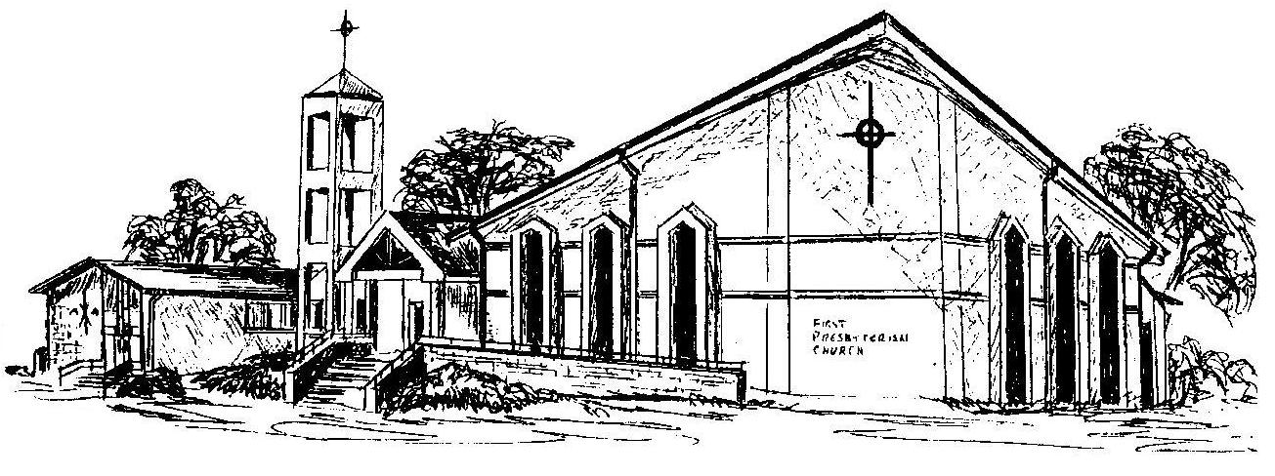

Welcome - Thank you for joining us for worship today. Please fill out a visitor information card found in the pew racks and place those in the offering plate so that we may follow up with you in the future. Your presence with us today has been a blessing to us, we hope that you have felt the presence of God and the welcome of this congregation.

