Welcome

Prelude “Praise the Lord, Ye Nations May F. Lawrence
Let us prepare our hearts and minds for worship.

Call to Worship (Psalm 24 adapted)
Leader: All that we are is a gift from God.
People: The earth is the Lord’s and all that is in it,
Leader: All that we have is a gift from God.
People: The world, and those who dwell therein;
Leader: There are no words to describe the wonders of God’s creation.
People: For God has founded it on the seas; God has established it upon the rivers.
Leader: Who shall stand in God’s holy place? Who shall approach God with confidence?
People: All shall receive blessing from the Lord, and righteousness from the God of our salvation.

*Opening Hymn “Now Thank We All Our God” Red Hymnal, #556

*Prayer of Confession (Unison) adapted from by Sarah E. Weaver, Preaching in Pumps
God of amazing grace, you have asked us to give of ourselves, wholly and completely. We have heard your call and have responded with great affirmation and joy. Yet there are times when we fall short. Times when we forget. Times when we focus on the wrong things. Help us to have faith, O God. Help us to give and serve through that faith. Help us to be blessed by that faith. Help us to renew that faith. Help us to share that faith with others. We pray in Jesus name. Amen.

*Silent Reflection

*Assurance of Pardon

*Gloria Patri (Glory Be to the Father…) Red Hymnal, #62

Children’s Time

Scripture “Joshua 24:14-18 ” (page 369)
“Psalm 136:1-9” (page 972)
Leader: The Word of the Lord.
People: Thanks be to God.

Anthem “A Celebration of Thanks”
words by Nancy Price & Don Besing; music by Don Besing

Sermon “God’s Steadfast Love Endures Forever” Rev. Kimby Young

*Profession of Faith The Apostle's Creed Red Hymnal, inside back cover
I Believe in God the Father Almighty, Maker of heaven and earth,
And in Jesus Christ his only Son our Lord; who was conceived by the Holy Ghost, born of the Virgin Mary, suffered under Pontius Pilate, was crucified, dead, and buried; he descended into hell; the third day he rose again from the dead; he ascended into heaven, and sitteth on the right hand of God the Father Almighty; from thence he shall come to judge the quick and the dead.
I believe in the Holy Ghost; the holy catholic Church; the communion of saints; the forgiveness of sins; the resurrection of the body; and the life everlasting. Amen

*Hymn “Take My Life and Let It Be” Red Hymnal, #379 vs. 1, 2, 6

Pastoral Prayer & Lord’s Prayer

Offertory Meditation: “Thanks Be To Thee”
G.F. Handel / arr. Stewart Landon

*Doxology

*Prayer of Dedication & Stewardship Dedication

*Closing Hymn: “Onward Christian Soldiers” Red Hymnal, #479

*Benediction

Postlude “Hymn of Joy” Ralph L. Grosvenor
*Those who are comfortably able will please stand.

Rev. Kimby Young; Larry Schick, Worship Assistant
Dean Faulk, Music Ministries, Chancel Choir
Alice Rollf, Organist
Mike McGuire and Brad Cornell, Slide Production
Davis Tropansky & Theo Borge, Tech and Videographer; Kim Liu, Sound

Childcare is available in the nursery (off hall west of the sanctuary). Children are welcome to stay in the sanctuary, or to leave at any time. Allison Perry is our primary childcare attendant.

Offering Plates are at the entrance of each aisle for your contributions to the work of the church.

Gardner Multi Service Center collection is ongoing every week and is always in need of any non-perishable food. Bring something every week or once a month.

Fair Trade Products for Sale on Sundays Coffee, tea, chocolate, nuts, olive oil, dried fruit, baking products, and a few other items are for sale each Sunday at church.

Harvesters Food Distribution is always seeking volunteers. Every 3rd Saturday at Trade Net Parking lot and every 4th Wednesday at Divine Mercy Parish. Distribution begins at about 1 p.m.

FPC at the Joy Closet on the 4th Saturday of every month. Come anytime 10:00 – 2:00 p.m.

Choirs meet on Wednesday’s Bell Choir at 6:00 p.m. in Chapel, Chancel Choir at 7:00 p.m. in Sanctuary, Christmas Cantata at 8:00 p.m.

Operation Christmas Child Packing Party – November 12 – 9:00 - Noon
YOU ARE ALL INVITED TO A PACKING PARTY for Operation Christmas Child.

Congregational Meeting, Sunday, November 26 9:40 a.m. Session has called a congregational meeting for the purpose of electing officers for 2024. Elder nominees include Ginger Crist, Lynn Moldrup, Larry Schick, and Poppy Zurcher. Deacon nominees are Sandy Nellor, Joseph Kioko and Judy Mason, as well as Shana Devlin and Kelly Johnson renewing for a second term. Nominating Committee members at large for 2024 will also be elected.

Men’s Breakfast on Tuesday, November 14 7:00 a.m. at Perkinss.

Presbyterian Women’s Thank Offering will be on Sunday, November 19.

Presbyterian Women have up the Mitten Tree. Please bring scarves, gloves, mittens, winter items. They will be delivered to different Gardner schools.

Presbyterian Women Holiday “High Tea” on Saturday, December 2nd at 2:00 pm, in the home of Poppy Zurcher. Join us for food and fellowship; cookie exchange and white elephant exchange. Sign up in the Narthex by Thanksgiving!!

Christmas Poinsettias for Sanctuary cost $13.00 in memory of or in honor of someone special due by Monday, December 4.

PYF Annual Brunch on Sunday, November 19. Food will be served 9:30 –11:00 a.m. Biscuits and gravy, pancakes, sausage, bacon and eggs. Donations accepted for 2025 mission trip.
First Presbyterian Church
In the heart of Gardner since 1866 ~ Serving from the heart of God

Sunday, November 12, 2023
Stewardship Sunday
8:45 AM

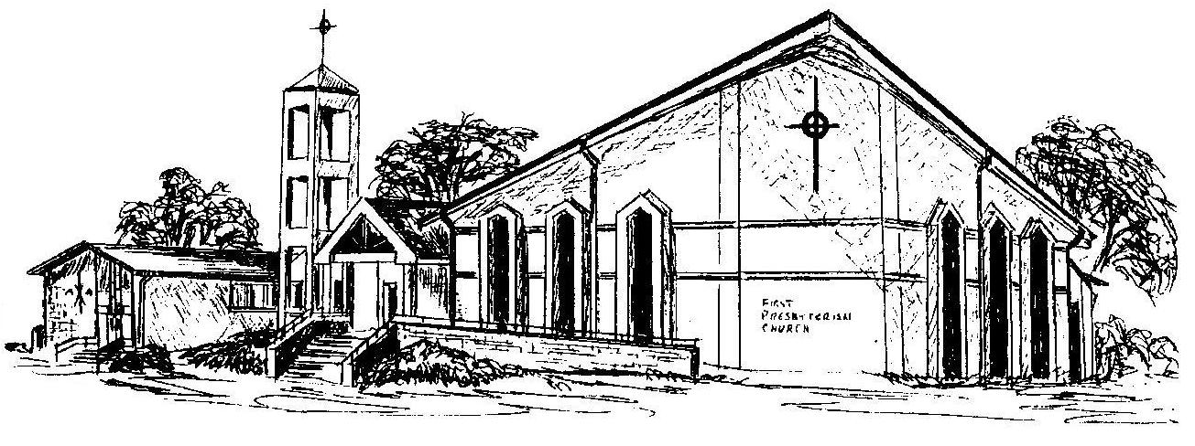

Welcome - Thank you for joining us for worship today. Please fill out a visitor information card found in the pew racks and place those in the offering plate so that we may follow up with you in the future. Your presence with us today has been a blessing to us, we hope that you have felt the presence of God and the welcome of this congregation.

