Welcome

Prelude
Let us prepare our hearts and minds for worship.

Call to Worship
Leader: The Spirit descends like a dove, bringing peace to unite the world.
People: The Spirit comes like a breath, bringing life to renew the people of God.
Leader: The Sprit spreads like fire, bringing energy for witnessing to the love of God.
People: Spirit of the living God, come to us and transform our lives by your power.

Opening Hymn* Spirit of God, Decscend Upon My Heart, Red Hymnal #249

Prayer of Confession* (Unison)
God of amazing love and unexpected grace, Open our eyes that we may see You especially in those times when we feel abandoned and alone; Forgive us that we so easily allow circumstance to blind us to Your Presence. Touch our lives that we may know You especially in those times when we feel unable to cope; Forgive us that we too frequently mistrust Your power. Fill our hearts that we may become like You; Forgive us that we forget who we are: children of God with Your Spirit in us. In the name of Jesus, we pray. Amen.

Silent Reflection*

Assurance of Pardon*

Gloria Patri* Glory Be to the Father, Red Hymnal #623

Children’s Time

Ron & Connie Crabbs Recognition

Scripture 1 Corinthians 12:4-14, 27 Page 1785
Acts 2:1-8, 12, 14, 16-18, 21 Page 1692
Leader: The word of the Lord.
People: Thanks be to God.

Solo ‘Rushing Wind’ by Keith Green Soloist Mike McGuire
Accompanied by Robyn Forkner

Sermon Pentecost, Rev. Kimby Young

Profession of Faith* The Apostle's Creed, Red Hymnal, inside back cover
I believe in God, the Father almighty, Maker of heaven and earth, and in Jesus Christ His only Son, our Lord; who was conceived by the Holy Ghost, born of the Virgin Mary, suffered under Pontius Pilate, was crucified, dead, and buried; He descended into hell; the third day He rose again from the dead; He ascended into heaven, and sitteth on the right hand of God the Father almighty; from thence He shall come to judge the quick and the dead. I believe in the Holy Ghost; the holy catholic Church; the communion of saints; the forgiveness of sins; the resurrection of the body; and the life everlasting. Amen

Hymn* Spirit of the Living God, Red Hymnal #247

Pastoral Prayer & Lord’s Prayer
Pray your prayers aloud when invited.
Close your prayer with “Lord, in your mercy.”
The Congregation will respond to each: “Hear Our Prayers”

Offertory Meditation

Doxology*

Prayer of Dedication*

Closing Hymn* Eternal Father Strong to Save, Red Hymnal #575

Benediction*

Postlude
*Those who are comfortable will please stand.
Rev. Kimby Young, Pastor; Corey Schramm, Worship Assistant
Robyn Forkner, Pianist; Harlan Plunkett, Organist
Mike McGuire and Brad Cornell, Slide Production; Kim Liu, Sound

Childcare is always available in the nursery (off the hall to the west of the sanctuary). Children are welcome to stay in the sanctuary through the whole service, or to leave at any time. Allison Perry is our primary childcare attendant.

Worship Bags for Children are available outside the north door to the sanctuary. Choose books, crayons, pencils, Legos, stuffed toys and other items to fill your bag to use during worship.

Offering Plates are at the entrance of each aisle for your contributions to the work of the church.

Fair Trade Products for Sale on Sundays. Coffee, tea, chocolate, nuts, olive oil, dried fruit, baking products, and a few other items are for sale each Sunday at church.

Gardner Multi Service Center collection is ongoing every week and is always in need of any non-perishable food. Bring something every week or once a month.

Harvesters Food Distribution is always seeking volunteers. Every 2nd and 3rd Saturday at Trade Net Parking lot. Volunteers may sign up for shifts between 9 a.m. and 3 p.m.

Joy Closet - Our mission center thrift store provides free clothing to a variety of needs. Our church provides all volunteers on the fourth Saturday of each month.

Join Us to Celebrate Kimby's retirement Sunday, May 31, immediately following the 10:00 a.m. service in the Fellowship Hall. Bring a salad, vegetable, side dish, or casserole to share.

YABS - Young Adult Bible Study 18-25 yrs Sundays 3:00 p.m. Join us. Invite a friend. Youngadultbiblestudy47@gmail.com.

Three weeks of combined services at 10:00 a.m. May 24, May 31 and June 7

Volunteer Help Wanted - Video Processing of Worship Services - contact pastor Kimby.

Mission Pillar Hygiene Kits Packing Party at Heart to Heart International - Saturday June 27. To contribute, mark your donations "Mission Kits."

Join Us to Celebrate Connie's Retirement today, immediatelyfollowing the 10:00 a.m. service in the Fellowship Hall.
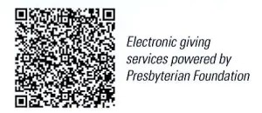

First Presbyterian Church
In the heart of Gardner since 1866 ~ Serving from the heart of God

Sunday, May 24, 2026
10:00 AM

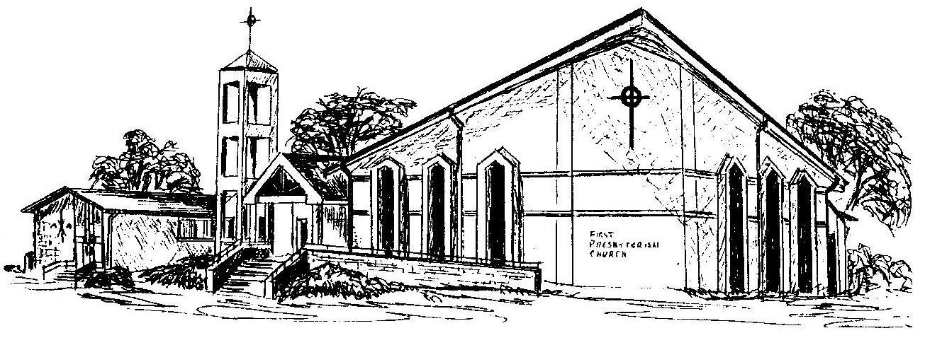

Welcome - Thank you for joining us for worship today. Please fill out a visitor information card found in the pew racks and place them in the offering plate so that we may follow up with you in the future. Your presence with us today has been a blessing to us, we hope that you have felt the presence of God and the welcome of this congregation.

