First Presbyterian Newsletter April 2026

Staff Transitions – by Kimby Young
Comings and goings have started. (see several articles below.) We have hired a new children’s education and ministry director. We just accepted Connie Crabbs resignation and will be seeking her replacement. On April 12 the congregation will vote on my resignation and on electing a Pastor Nominating Committee (PNC) to begin the process of finding a new pastor.

The pastor call process will last at least a year and maybe up to two years. During that time, session has decided to hire two people – a full time Bridge pastor and a part time Parish Associate. A transition team of personnel is currently working on those hires. The full time Bridge pastor (approved by Presbytery) will fill the pastoral role for up to 9 months, preaching, leading session and committees, planning and administrative duties. The part time Parish Associate will cover pastoral care, occasional preaching, and some other duties as needed. There is no end date for the Parish Associate so this person could continue after the new pastor is here.

This is an exciting time at the church. Though staff is changing, the leadership of session and deacons remains consistent. You have many dedicated gifted and faithful volunteers who are making wise decisions to move this congregation forward in powerful purposeful ways. I am so impressed with the ways people have stepped forward to work for the good of this congregation. Further, I can see God’s hand shaping the future as the right things happen at the right time. I am confident the right people will be here just as God is ready for them to take their place on the ministry team of First Presbyterian Church. This is a time of blessing and fulfillment. It is a joy to watch God’s work unfold before us. Thank you to all of you who are sharing your gifts and serving our God in countless ways.

Holy Week Worship Schedule
March 29 – Palm Sunday – 10 a.m. – One Service with Cantata
April 2 – Maundy Thursday – 7 p.m. – Worship and Communion
April 3 – Good Friday– 7 p.m. – Worship Service
April 5 – Easter – 10 a.m. – One Service - Celebration of the Resurrection

Sermon Series for Easter Season
April 5 – Easter – What is Resurrection? John 20:1-10
April 12 – John 20:11-18 - Mary Magdeleine – I Have Seen Jesus!
April 19 – Luke 24:13-35 – Emmaus Road
April 26 - Luke 24:36-49; John 20:19-29 – Easter Evening
May 3 – John 21:1-14 - Fish Fry
May 10 - Mother's Day - John 21:15-19 - Feed My Sheep
May 17 – Ascension - Luke 24:50-53; Acts 1:1-11 - Last Call

Monthly Financial Report
At the end of February 2026 our records indicate:
total income this month is $ 37,713.33
total expenses this month is $ 31,362.20
The session and finance/operations pillar thank each of you for your contributions to the church – financial or any other contribution. A complete line-by-line expense report is available upon request. We will close finances for March after April 6.

Recycle Help Needed
Anyone willing to regularly take recycling home or to a recycling center, please contact Pastor Kimby. We collect paper, plastic and cardboard in the office. We can set up another recycling area if needed. If several people volunteer, we can set up a rotation.
Congregational Meeting – Sunday, April 12 at 9:45a.m.
Session has called a Congregational Meeting for Sunday, April 12 at 9:45a.m. for four purposes:
1)To accept the resignation of Pastor Kimby Young for retirement and to dissolve the pastoral relationship effective May 31, 2026 (including reading Presbytery “covenant of departure”);
2)To receive the report of the church nominating committee and to elect a Pastor Nominating Committee (PNC);
3)To acknowledge the resignation of church secretary Connie Crabbs and to thank her for her 20 years of service;
And 4) To share plans and status updates for future staffing and pastoral coverage.

Church Administrative Assistant – Connie Crabbs Resigned
Connie Crabbs has served as Secretary or Administrative Assistant for the church for 20 years. (Hired on April 1, 2006). Session accepted Connie’s resignation effective on March 31. A staff transition team of session is working on a job description and a process for hiring a replacement. Meanwhile we are planning to thank Connie and recognize her for years of service at the congregational meeting on April 12 and with the fellowship reception following. This date may be changed for medical reasons if needed.
Connie has served cheerfully and faithfully through many seasons of church life and transition. Connie and Ron will remain active members of the church, so they will still be at church often.
We pray God's blessing for Connie in this time of transition.

New Children’s Education and Ministry Coordinator Hired
Please welcome Zayda Bruss as our new Children’s Education and Ministry Coordinator. This is the job previously held by Marsha Cooper and more recently briefly by Amanda Rooney. The Children's Ministry job is to manage Sunday school and special events for children, and to strengthen summer programming for children’s education.
Zayda has been around FPC for a few years, including participating in our youth program and now Young Adult Bible Study. Zayda brings training in education as her college major, and enthusiasm for children’s ministry and engagement in the life of faith.
This job may evolve during the pastoral transition to provide continuity as we seek to strengthen our ministry for children and families. Zayda begins work on April 1 and will be introduced on the Sunday after Easter. Be sure to welcome and introduce yourself when you are able.

Arbour Season – Free Concert – Wednesday, April 22, 6:30 p.m.
Join us for a Free Concert. Wednesday, April 22 6:30p.m. A free will donation will be received. Arbour Season website says, “We are an indie/folk husband and wife duo who draw inspiration from the incredible adventures we experience all across North America in our converted school bus/home. Our unique journey inspires the ambient folk sound that captures the serenity of the Western vistas, the rhythms of the Eastern coastlines, and the brilliance of the national forests. We express our passion for life through music and invite you to travel with us by listening to the intricate instrumentation, layered harmonies and lyrics that tell our stories.” They may bring along another friend or two who are touring as musicians. Rachel Schramm stumbled into a concert in Branson at Silver Dollar City. She continued to follow them and connected them to the church so we could be a part of their tour. Please join us on April 22 and invite friends. All are welcome.

Volunteer Help Wanted
Video Processing of Worship Services
If you would be interested in uploading, editing and posting worship videos each Sunday, or being a part of a team who works on videos, please contact pastor Kimby to volunteer.

Woodwork Cross for Easter - “He is Risen”
Over thirty handmade crosses have been designed for the church by Mike McGuire with Matthew 28:6 etched in the cross. “He is Risen” is the central message. The crosses are available in the narthex while supplies last. A donation to mission may be made and mission pillar will decide where the donation goes when they know how much money was raised. Mike made a similar offering at Christmas with a woodwork nativity.

Picture Directory
For over a year the deacons have been trying to set up an online picture directory for our church members and friends. We are using Instant Church Directory. About half of our regular attendees have signed up. Please sign up if you have not done so already.
We have printed our first draft of the directory which has several mistakes. You may pick up a copy of the directory outside the church office at any time. If you are in the directory, please check that everything is correct. If something is incorrect, please make corrections on the print copy on the directory table, or go on line to make corrections. If you are not in the directory, please sign up now. Contact Carl Frahme who is in charge of the project. An instruction sheet is beside the printed directories.

Prayer Request Rhonda Krehbiel, Karen Elliott, Junior Wilson, Bob Knoche, Barbara Sweetwood, Larry Atwater, Brian & Karen Erwin, Kim Liu, Dave Sinclair, Harlan Plunkett, Nick McSwane, Baby Arley John, Justin Hamilton, Cliff Schick, Ron Carroll, Ronnie Duchene, Ron Anderson, Sharon Frahme, Robert Mashburn, Susan Gash, Susan Wilson-Dierksen, Abe Portenier, LeMoyne Zimmerman, Jon Deiley, Amanda Allen, Dozer Reed.

The Presbyterian Youth Fellowship will be hosting a Chicken & Noodles dinner on Sunday, April 19th. Food will be served from 11:30-1:00 p.m. There is no set cost for the meal, but donations will be accepted to support the next youth group mission trip in the summer of 2027. Come enjoy lunch and fellowship with your church family. Invite your friends!

Men’s Breakfast Perkins April 14 at 7:00 a.m. It is an opportunity to get to know one another and build a stronger community of Faith.

Ushers for April 2025 8:45 a.m.
Larry & Merle Schick, Karl & Kim Allen

Communion Servers Sunday 10:00 a.m. April 5 Easter
Mitch McSwane
Patricia Pacey
Larry Schick
Lynn Moldrup
Ron Crabbs
Devon Mason
Eric Gourley
Ginger Crist

Presbyterian Women
Women Fellowship Group will have their first meeting for 2025 on Wednesday, April 1 at 10:00 a.m. in Fellowship Hall. The women’s Fellowship Group meets from March through November in Fellowship Hall. This group is open to ALL women of the church. Our purpose is to provide care and support for the mission and service projects of the church.

PW will be hosting our Annual Spring Brunch on Saturday, April 25th, at 9:30am! Our guest speaker is Nina Kimbrough, Executive Director for Johnson County Christmas Bureau. We hope everyone can make plans to attend. Sign up sheets are in the Narthex.


Store Hours
MONDAY 10 – 7
TUESDAY 10 – 7
WEDNESDAY 10 – 4
THURSDAY 10 – 7
SATURDAY 10 – 2

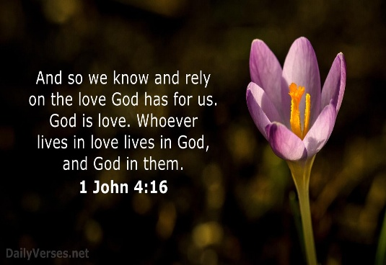    2026 |   JOY Closet  Best Thrift Store in Johnson County for 2026  Based on customer reviews and satisfaction.

We need you!

Here is your opportunity to really make a difference. The donations are waiting! We receive so many clothes for kids, often in great condition. Likely the items have been outgrown too quickly and have little wear. Help us get those nice jeans and dresses hanging in the store. Experienced trainers will get you going!

Toy sorters needed. It is amazing the great toys that come through our building, and you will have the satisfaction of knowing the excitement on some child’s face will be because you cared to help. You will soon be a toy expert, and you’ll be trained by the best!

Bring a friend and talk to Cindy, Ginger, Cathy, or Margaret about training!
We look forward to welcoming you!

Our Designated Donations for February
February Designated Donations for New Horizon Ranch amounted to $1,100. NHR currently offers a variety of programs including Hippotherapy, Therapeutic Riding, Equine Assisted Learning, Equine Assisted Psychotherapy, and Summer Day Camp programs to individuals of all ages with physical, cognitive, social, emotional and learning disabilities.
Additional information: New Horizon Ranch | Hippotherapy, Therapeutic Riding

March & April Designated Donations will go to the Joy Closet Scholarship Fund!

In May, JOY Closet will honor six high school seniors at GEHS with scholarships in the amount of $2,000 toward the first year of college or technical school.
This year, we have expanded the program to also award two high school seniors from Wellsvile.


On many Fridays, while JOY Closet is closed to shoppers, an officer from the JOCO Sheriff’s office brings a small group of three to four work-release participants from the Adult Residential Center at New Century who are being reintegrated into the business world. They work responsibly and are supervised as part of their community service performance. Thanks to manager Margaret Drovetta for her help in providing this opportunity. They have been a great help with emptying the blue bins, hanging coats, and sorting items. We appreciate their help and wish them well in the future.
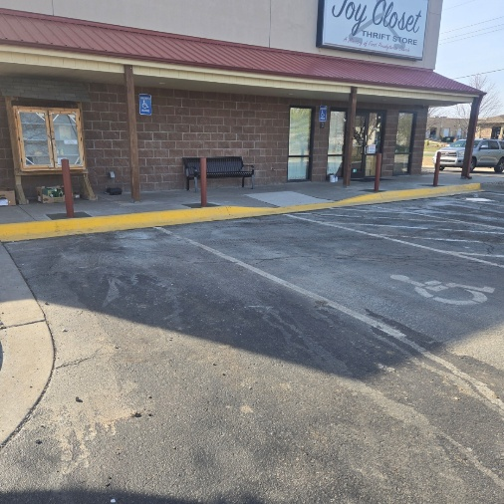
Safety Precautions

Protective Pillars set in concrete have been added to the parking spaces facing the front of the building, providing safety for people on the sidewalk or inside the building from vehicle accidents while entering or leaving the parking spaces.
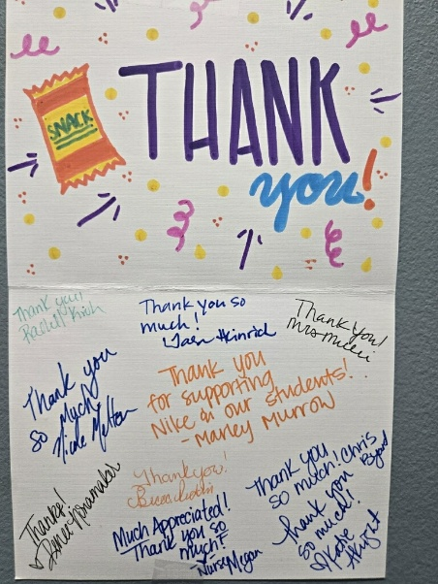
Connecting to the community:
A thank you note (left) from Nike Elementary. JOY Closet provided snacks for students at Nike Elementary. In return, we have enjoyed having students and staff volunteer at our mission.

Nike classrooms held a Penny War competition, where classrooms competed for a prize and the monetary donations were given to JOY Closet.

From a thank you note written to Nike Elementary:
“On behalf of the JOY Closet Board, I would like to extend our thanks to the students at Nike Elementary for their generous donation to JOY Closet. Your gift of $632.58 from your recent Penny Wars Project shows the power of young people and their families working together to make a difference in our community. Helping the community is also what JOY Closet is proud to be able to do.”
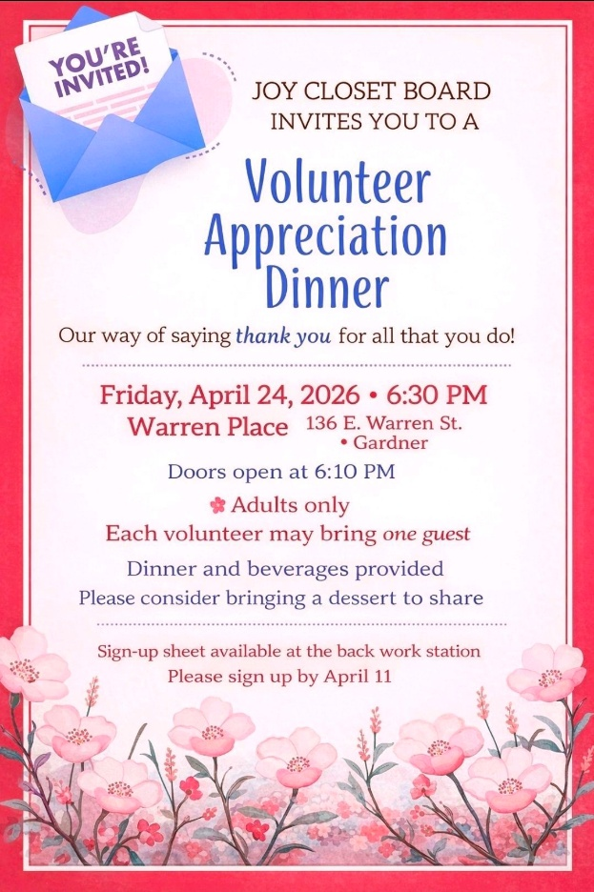

Volunteers – We look forward to an evening of relaxation and getting to know you even better.

We are so proud of your hard work and great love for our community and our mission.

Let us celebrate YOU and the things we have accomplished together!
Please sign up by April 11th.


For I was hungry, and you gave me something to eat, I was thirsty, and you gave me something to drink, I was a stranger and you invited me in, I needed clothes, and you clothed me.

Matthew 25:35-36 NIV

JOY Closet Is a ministry of

First Presbyterian Church of Gardner, KS

Serving our comunity since 2013

