Welcome
Prelude “Alleluia! Alleluia!” Arr. by Albin C. Whitworth
Let us prepare our hearts and minds for worship.

Call to Worship
Leader: As we look at the cross of Jesus Christ, we see many things.
People: We see the love of God lived in a man of true compassion – Jesus Christ.
Leader: We see the willingness of Jesus to take on our burdens and to suffer that we might be saved.
People: As we look at the cross, we see God’s grace in action and we respond in grateful praise.

*Opening Hymn: “When I Survey the Wondrous Cross” Red Hymnal, #185

*Prayer of Confession (Unison)
God of Mercy and Compassion, suffering breaks our hearts and we want to turn away. Sometimes we forget that your heart is wounded by the pain we inflict on others, by the ways we ignore the tragedies of our world, by the times we walk away from need when we could offer help. Forgive us for our part in the suffering of the world, and for the pain we cause you by our insensitivity. Remind us of your call to healing and reconciliation. Empower us to share your grace in the world, through Jesus Christ our Lord. Amen.

* Silent Reflection

* Assurance of Pardon

* Gloria Patri (Glory Be to the Father…) Red Hymnal, #623

Children’s Choir “Climb, Climb Up Sunshine Mountain” Arr. by Hal Wright

Children’s Time

Scripture “Matthew 9:35-38” (page 1510)
“Matthew 27:27-31” (page 1547)
“Romans 5:1-11” (page 1752)
Leader: The word of the Lord.
People: Thanks be to God.
Music “Jesus Loves Me” Arr. by Michael Hassell

Sermon “Cross: Suffering and Compassion ” Rev. Kimby Young

*Profession of Faith The Apostle's Creed The Hymnal, inside back cover
I Believe in God the Father Almighty, Maker of heaven and earth, And in Jesus Christ his only Son our Lord; who was conceived by the Holy Ghost, born of the Virgin Mary, suffered under Pontius Pilate, was crucified, dead, and buried; he descended into hell; the third day he rose again from the dead; he ascended into heaven, and sitteth on the right hand of God the Father Almighty; from thence he shall come to judge the quick and the dead. I believe in the Holy Ghost; the holy catholic Church; the communion of saints; the forgiveness of sins; the resurrection of the body; and the life everlasting. Amen

*Hymn “What Wondrous Love Is This” Red Hymnal, #177

Pastoral Prayer & Lord’s Prayer

Offertory Meditation: “Jesus, the Very Thought of Thee”
John B. Dye, (Camille Saint-Sae), Arr. by Marilyn Ari

*Doxology

*Prayer of Dedication

*Closing Hymn: “Be Still, My Soul” Red Hymnal, #347

*Benediction

Postlude
*Those who are comfortably able will please stand.

Rev. Kimby Young, Pastor; Susan Rushing, Worship Assistant
Dean Faulk, Music Ministries
Chancel Choir; Children’s Choir
Robyn Forkner, Pianist; Harlan Plunkett, Organist
Mike McGuire and Brad Cornell, Slide Production; Kim Liu, Sound

Childcare is always available in the nursery (off the hall to the west of the sanctuary). Children are welcome to stay in the sanctuary thru the whole service, or to leave at any time. Allison Perry is our primary childcare attendant.

Worship Bags for Children are available outside the north door to the sanctuary. Choose books,
crayons, pencils, Legos, stuffed toys and other items to fill your bag to use during worship.

Offering Plates are at the entrance of each aisle for your contributions to the work of the church.

Fair Trade Products for Sale on Sundays Coffee, tea, chocolate, nuts, olive oil, dried fruit, baking products, and a few other items are for sale each Sunday at church.

Remember, Each One, Bring One collecting food, basket in the narthex. Food goes to Hope Market Food Pantry.

YABS – Young Adult Bible Study 18-25 yrs Sundays 3p.m. Join us. Invite a friend. Youngaddultbiblestudy47@gmail.com.

Per Capita for 2026 is $45.91 per person.

Men’s Breakfast Tuesday, March 10, 7:00 a.m. at Perkins.

Black Out Drapes - For Lent each year we raise curtains over the stained glass windows as reminders of the deepening season. As a Lenten discipline we are called to awareness of light and darkness in the world as we seek God's presence in our daily lives, and as we look forward in hope to the celebration of the resurrection of Jesus Christ.

Pastor Kimby Bible Study Psalms Thursday’s 10-11:30 a.m.

Presbyterian Women Annual Spring Brunch on Saturday, April 25 at 9:30 a.m.

Presbyterian Book Club “The Homecoming” by Dan Walsh at Linda Jenson, April 9 6:30 p.m.

Palm Sunday, March 29, Cantata 10:00 a.m. Potluck at 11:00 a.m. Fellowship Hall.

Holy Week Schedule
April 3 7:00 p.m. – Maundy Thursday Communion
April 4 7:00 p.m. – Good Friday
April 5 10:00 a.m. – Celebration of the Resurrection – Easter

Flowering the cross – On Easter Sunday, bring a fresh flower from your garden to flower the cross in memory of a loved one. We will have flowers if you do not have one to bring.

OGHS collection is received on April 5, Easter – Or anytime before. Mark checks OGHS.
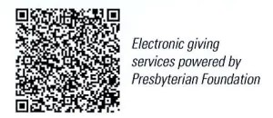
First Presbyterian Church
In the heart of Gardner since 1866 ~ Serving from the heart of God

Sunday, March 8, 2026
Gifts of Women
Third Sunday of Lent
8:45 AM

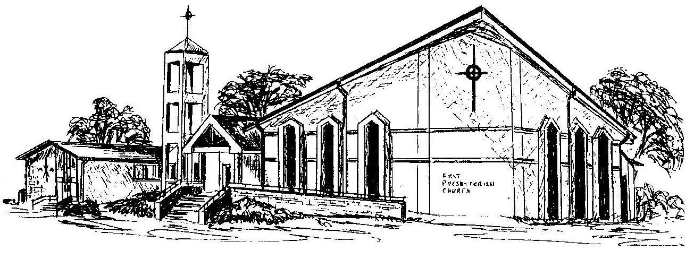

Welcome - Thank you for joining us for worship today. Please fill out a visitor information card found in the pew racks and place those in the offering plate so that we may follow up with you in the future. Your presence with us today has been a blessing to us, we hope that you have felt the presence of God and the welcome of this congregation.

