Welcome

Prelude “Intermezzo” Marianne Kim
Let us prepare our hearts and minds for worship.

Call to Worship
Leader: We see a cross before us and gather to worship.
People: We remember a cross on a hill far away and we thank God for life.
Leader: We hear Jesus call us to take up our cross to follow and we wonder what that means.
People: Let us seek Jesus Christ and receive God’s grace as we worship together today.

*Opening Hymn: “In the Cross of Christ I Glory” Red Hymnal, #184

*Prayer of Confession (Unison) (adapted from RE-Worship Blog)
Merciful God, You call us to follow; to turn away from our own selfish interests, and to take up our cross and follow after You. You call us to follow, even if the path is difficult to see, or is heading in a direction we would never have chosen for ourselves. Forgive us for being so quick to question and so hesitant to follow. Help us to see with the eyes of faith. Teach us to follow without fear, knowing that You are always with us, leading the way. Amen.

* Silent Reflection

* Assurance of Pardon

* Gloria Patri (Glory Be to the Father…) Red Hymnal, #623

Children’s Time

Scripture “Mark 15:20-39” (page 1583)
“Revelation 1:8” (page 1913)
Leader: The word of the Lord.
People: Thanks be to God.

Music “My Tribute”
Text and Music: Andrae Crouch
Sermon “Cross: End and Beginning ” Rev. Kimby Young

*Profession of Faith The Apostle's Creed The Hymnal, inside back cover
I Believe in God the Father Almighty, Maker of heaven and earth, And in Jesus Christ his only Son our Lord; who was conceived by the Holy Ghost, born of the Virgin Mary, suffered under Pontius Pilate, was crucified, dead, and buried; he descended into hell; the third day he rose again from the dead; he ascended into heaven, and sitteth on the right hand of God the Father Almighty; from thence he shall come to judge the quick and the dead. I believe in the Holy Ghost; the holy catholic Church; the communion of saints; the forgiveness of sins; the resurrection of the body; and the life everlasting. Amen

*Hymn “Beneath the Cross of Jesus” Red Hymnal, #183

Pastoral Prayer & Lord’s Prayer

Offertory Meditation: “The Holy City”
Stephen Adams, Arr. by Albin C. Whitworth

*Doxology

*Prayer of Dedication

*Closing Hymn: “Nearer, My God, to Thee” Red Hymnal, # 393 vs 1, 2, 5

*Benediction

Postlude “Sheep May Safely Graze”
From the Birthday Cantata by J. S. Bach, Arr. by E. Power Biggs

*Those who are comfortably able will please stand.

Rev. Kimby Young, Pastor; Harlan Plunkett, Worship Assistant
Rhonda Atwater, Soloist; Dean Faulk, Music Ministries
Robyn Forkner, Pianist; Harlan Plunkett, Organist
Mike McGuire and Brad Cornell, Slide Production; Kim Liu, Sound

Childcare is always available in the nursery (off the hall to the west of the sanctuary). Children are welcome to stay in the sanctuary thru the whole service, or to leave at any time. Allison Perry is our primary childcare attendant.

Worship Bags for Children are available outside the north door to the sanctuary. Choose books,
crayons, pencils, Legos, stuffed toys and other items to fill your bag to use during worship.

Offering Plates are at the entrance of each aisle for your contributions to the work of the church.

Fair Trade Products for Sale on Sundays Coffee, tea, chocolate, nuts, olive oil, dried fruit, baking products, and a few other items are for sale each Sunday at church.

Remember, Each One, Bring One is collecting food, basket in the narthex for Hope Market.

YABS – Young Adult Bible Study 18-25 yrs Sundays 3:00 p.m. Join us. Invite a friend. Youngaddultbiblestudy47@gmail.com.

Black Out Drapes - For Lent each year we raise curtains over the stained glass windows as reminders of the deepening season. As a Lenten discipline we are called to awareness of light and darkness in the world as we seek God's presence in our daily lives, and as we look forward in hope to the celebration of the resurrection of Jesus Christ.

Presbyterian Women Annual Spring Brunch on Saturday, April 25, at 9:30 a.m.

Presbyterian Book Club “The Homecoming” by Dan Walsh at Linda Jenson, April 9, 6:30 p.m.

Palm Sunday, March 29, Cantata 10:00 a.m. Potluck at 11:00 a.m. Fellowship Hall.

Holy Week Schedule
April 3 7:00 p.m. – Maundy Thursday Communion
April 4 7:00 p.m. – Good Friday
April 5 10:00 a.m. – Celebration of the Resurrection – Easter

Flowering the cross – On Easter Sunday, bring a fresh flower from your garden to flower the cross in memory of a loved one. We will have flowers if you do not have one to bring.

OGHS collection is received on April 5, Easter – Or anytime before. Mark checks OGHS.

Congregational Meeting on Sunday, April 12, at 9:45 a.m. between services.

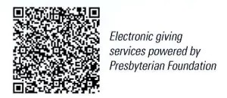

First Presbyterian Church
In the heart of Gardner since 1866 ~ Serving from the heart of God

Sunday, March 22, 2026
Fifth Sunday of Lent
8:45 AM

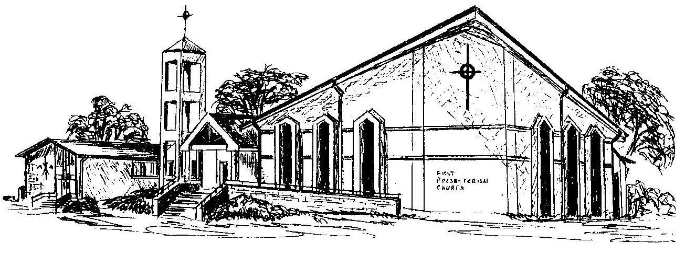

Welcome - Thank you for joining us for worship today. Please fill out a visitor information card found in the pew racks and place those in the offering plate so that we may follow up with you in the future. Your presence with us today has been a blessing to us, we hope that you have felt the presence of God and the welcome of this congregation.

