First Presbyterian Newsletter March 2026

Lent and Easter – by Kimby Young
Lent is a season of anticipation. Waiting for Spring. Preparing for Easter. Lent began during medieval days as a time for new converts to Christianity to study before baptism and confession of faith at Easter. It has evolved into a season for all Christians to be intentional about our spiritual practices, to renew our faith and grow as Christians. We examine ourselves and make new commitments. We strive to be better and do better. We remember all that Christ has done for us. We practice our faith. We work together for the common good. In daily living in the US today, Lent gets mixed up with Spring and Spring break and busy-ness and things to do. The mad rush forward distracts us from our spiritual lives and we sometimes forget to take time to listen for God’s Word in our lives. Our invitation this season of Lent is to pause, to breathe, to take time to be holy, to listen for God’s messages, to notice God’s grace. May you be blessed in the month ahead as you experience God’s love in Jesus Christ. May you share God’s love in the world.

Worship Schedule - Lenten Sermon Series on the Meaning of the Cross
February 22 - Cross: Identity and Belonging - Genesis 12:1-3; Isaiah 43:1-3a; Luke 9:18-27
March 1 - Cross: Repentance and Forgiveness - Psalm 51; Matthew 18:15-35
March 8 - Cross: Suffering and Compassion - Matthew 9:35-38, 27:27-31; Romans 5:1-11
March 15 - Cross: Commitment and Mission - Luke 9:57-62; Matthew 16:13-26; John 19:16-19
March 22 - Cross: End and Beginning - Mark 15:20-39; Revelation 1:8

Holy Week Worship Schedule
March 29 – Palm Sunday – 10 a.m. – One Service with Cantata
March 29 – Palm Sunday – 11 a.m. – Potluck Brunch
April 2 – Maundy Thursday – 7 p.m. – Worship and Communion
April 3 – Good Friday– 7 p.m. – Worship Service
April 5 – Easter – 10 a.m. – One Service - Celebration of the Resurrection

Children’s Sunday School and Children’s Choir Schedule
March 1 – Regular Sunday School schedule at 10 a.m. Children’s choir Rehearsal at 9:45a.m.
March 8 - Children’s choir SINGS at 1st service. Practice 8:15a.m. Regular Sunday School 10 a.m.
March 15 – no class or choir – out for Spring break.
March 22 – Regular Sunday School schedule at 10 a.m. but no children’s choir.
March 29 and April 5 – No Sunday School or children’s choir – One worship service at 10a.m.

Children's Education and Ministry Coordinator
Discipleship Pillar is now accepting applications for the part time position of coordinator for our children's ministry. (Specifically for Sunday School and other expanding programs.) This is the position held by Amanda Rooney who resigned in January. A job description and task list is available. To apply send a resume to Pastor Kimby Young in the church office. For questions, speak to Kimby, or elders Ginger Crist, or Mitch McSwane. Deadline for application is March 9.

Monthly Financial Report
At the end of January 2026 our records indicate:
total income this month is $ 29,642.51
total expenses this month is $ 24,542.09
The session and finance/operations pillar thank each of you for your contributions to the church – financial or any other contribution. A complete line-by-line expense report is available upon request. We will close finances for February after March 2.

Sunday, March 8, 2026 - Daylight Saving Time Starts – clocks turn forward 1 hour.
One Great Hour of Sharing
One Great Hour of Sharing is an ecumenical Christian offering that makes the love of Christ real for individuals and communities around the world who suffer the effects of disaster, conflict, or severe economic hardship, and for those who serve them through gifts of money and time. Today, projects are underway in more than 100 countries. One Great Hour of Sharing funds make possible disaster relief, refugee assistance, development aid and more. One Great Hour of Sharing Projects are intended to empower, provide water, supply food, and give relief from disasters. A gift to One Great Hour of Sharing enables the church to share God’s love with our neighbors-in-need around the world by providing relief to those affected by natural disasters, provide food to the hungry, and helping to empower the poor and oppressed. “Fish” Bank Boxes and Calendars are available to children, youth, families or adults for collection of coins throughout the season. Some people choose to collect coins at meal time in thanksgiving for all of our blessings and in an effort to combat world hunger. At First Presbyterian Church of Gardner, we will be receiving the One Great Hour of Sharing Offering throughout Lent and will present our gifts in worship on Easter Sunday.

Pastor Kimby's Bible Study – Psalms – Thursday mornings 10-11:30 a.m.
– 9 week study - March and April
Join us each week, or any week you are able, for a study of the Psalms – a collection of hymns, songs, poems, prayers and worship material. We will discuss several Psalms each week as we look at categories, including lament, worship, history, etc. Pastor Kimby Young will be teaching. The only book or curriculum is the Bible in any version. Participants are encouraged to bring commentaries and study Bibles. We have great discussions on a wide range of faith topics. You can miss some sessions. Friends, members and guests are welcome. Men and women, singles and couples. All ages. Everyone may join us. Invite a friend. All are welcome.

Celebrating the Gifts of Women, Sunday, March 8, 2026
Worship at 8:45 and 11:00 a.m.
This year on March 8, the annual Sunday designated by the PCUSA to celebrate the gifts of women in the church.

Black Out Drapes - For Lent each year we raise curtains over the stained glass windows as reminders of the deepening season. As a Lenten discipline we are called to awareness of light and darkness in the world as we seek God's presence in our daily lives, and as we look forward in hope to the celebration of the resurrection of Jesus Christ.

Prayer Request: Pam McSwane, Doc Bob Knoche, Amanda Allen, Brian & Karen Erwin Family, Kim Liu, Barbara Sue Sweetwood, Phil Lenahan, Dave Sinclair, Lois Barber, Harlan Plunkett, Nick McSwane, Junior Wilson, Cliff Schick, Ron Carroll, Leigh Sullivan, Lori Fraser, Ronnie DuChene, Ron Anderson, Amy Foster, Lin Swartz Uncle Tom, Robert Mashburn, Susan Gash, Susan Wilson – Dierksen, Abe Portenier, Rhonda Krehbiel, Sharon Frahme, Jon Deiley, LeMoyne Zimmerman, Karen Elliott, Dozer Reed.

PW Happenings
Presbyterian Women sponsor the Birthday Offering every year, in the Spring, to celebrate the blessings in our lives. The offering funds up to 5 projects every year. In 2026, the recipients of the offering will include a Women’s and Children’s Crisis Shelter in Ohio and a Rural Food Assistance Program in North Carolina. The stack of 2 boxes and birthday card are in the Narthex for your donations. Your donations are very much appreciated for this very worthy cause.

PW will be hosting our Annual Spring Brunch on Saturday, April 25th, at 9:30am! More information will be coming soon. We hope everyone can make plans to attend.

PW’s Book Club plans to read “The Homecoming” by Dan Walsh and gather at Linda Jensen’s home on Thursday, April 9th at 6:30pm.
Women Fellowship Group will have their first meeting for 2026 on Wednesday, March 4 at 10:00 am. in Fellowship Hall. We will enjoy a morning of fellowship, including devotions by Teri Winegar, refreshments will be provided by Vera Beach. The women’s Fellowship Group meets from March through November in Fellowship Hall. This group is open to ALL women of the church. Our purpose is to provide care and support for the mission and service projects of the church.

Men’s Breakfast on Tuesday, March 10, at 7:00 a.m. at Perkins. It is an opportunity to get to know one another and build a stronger community of Faith.

The Gardner Police Department is currently accepting applications for this spring’s Citizen’s Police Academy, and we are looking for a few good men and women to participate. We respectfully ask that you share the attached information with your congregation.

The Citizen’s Police Academy is an eight-week program held on Tuesday evenings from 6:00–9:00 p.m. at the Gardner Justice Center. Participants will receive an in-depth look at local law enforcement operations and will take part in tours of Johnson County Dispatch, the Johnson County Crime Lab, and the Adult Central Booking Facility in downtown Olathe.

The first class will be held on Tuesday, March 31. Additional program details will be provided on the first evening. Participants must be 18 years of age or older.

A Youth Academy will be offered during the summer months. Additional information about that program will be announced in the coming months.

Anyone interested in applying for the Citizen’s Police Academy may contact Ofc. Kyle Sissom #763, Community Policing Officer of the Gardner Police Department.

Young Adult Bible Study is going strong. YABS went to Winterjam three weeks ago, served at JOY Closet last Sunday, and have moved into a classroom downstairs where we meet weekly. Our group is preparing for a mission trip to West Virginia. June 13-21 we will be in Philippi and Moatsville, WV, serving at a World Vision site and working at New Vision Village.
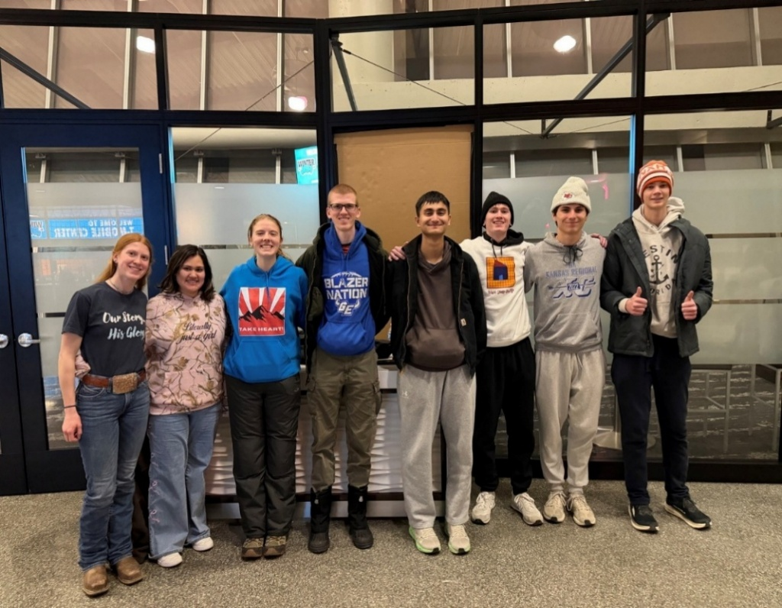
Church Color Picture Directory- February Edition
The First Edition of the new Church Picture Directory has been printed and is available in the Narthex. Please pick up a copy and check your listing. If there are any errors, there is a B&W copy next to the color copies in which you can note corrections.
You can view the Directory on your computer and edit your information by logging into members.instantchurchdirectory.com and entering the email listed in the printed directory. You will be asked to verify your login. This version is not quite the same format as the printed version, but it has all the pictures and information. You can edit any information on your page by clicking on the “Edit My Info” button at the bottom of your page. This will appear only on your page. You cannot edit information for anyone else, and no one but the Administrator can change your information.
The First Edition is incomplete, since many members and friends did not submit information or photos. Please help us fill in the blanks! If your last name and email are listed, you are registered with Instant Church Directory and can access your private account and enter information. If you are not listed, contact Carl Frahme via email at cfrahme@prodigy.net or by text at (913) 636-4162. Send your name and preferred email address, and he will get you registered. Once we get more people listed, we will send out PDF copies via email, and at some point we will print a Second Edition.
To fill out your page after you sign in, enter information you want to appear, like your address, preferred email, anniversary, and phone. Click on “SAVE”. Then on the right side, you can add adult names and youth names. For each you can enter a birthday, whether a church member, whether pictured, phone and email. Be sure to “SAVE” each. On the left, you can download a photo from your computer or smartphone. As an alternative, get a paper photo to Carl Frahme, and he will enter it.
You can get the Instant Church Directory App for your phone.
Download the Instant Church Directory App
- For iPhone/iPad: Download on the App Store
- For Android devices: Get it on Google Play
Look for this icon:

If you have problems or questions, please contact Carl!


Store Hours
MONDAY 10 – 7
TUESDAY 10 – 7
WEDNESDAY 10 – 4
THURSDAY 10 – 7
SATURDAY 10 – 2

2027   |   March brings our 50% off winter sale and the gradual restocking with spring/ summer merchandise  New merchandise daily!

We have immediate openings in our toy department!
If you find toys and puzzles interesting and are good at organizing, we’ve got room for more than one volunteer. Our faithful toy experts are still on hand and will be glad to give you information to help you get started.

Come and talk to Cindy, Ginger, Cathy, or Margaret!
We look forward to welcoming you!
Our Designated Donations were plentiful with $1125.00 donated at the register in January toward student lunch accounts! JOY Closet Board voted to match that donation and $2,250.00 is being sent to USD 231 to assist in paying off student lunch accounts. Our customers are so generous with their support and we appreciate the help. Thank you!

Our PROM DRESS EVENT was a huge success this year with 264 free dresses given to shoppers and 105 additional dresses sold for a total of 369 dresses! Free jewelry and shoes were also available! This was our second year and we learned a lot our first year so that the process was streamlined. Our thanks to so many volunteers who stepped up for extra duty.
Additional dresses will be for sale at JOY Closet!
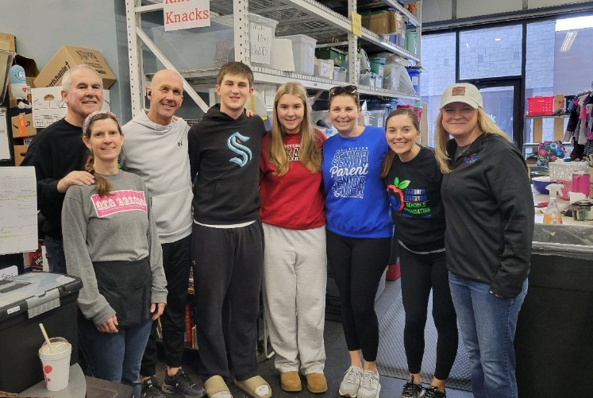
Volunteers from the Gardner Edgerton Foundation, which JOY Closet helps support, were here in early February and back again later in the month.

Thanks for your help!
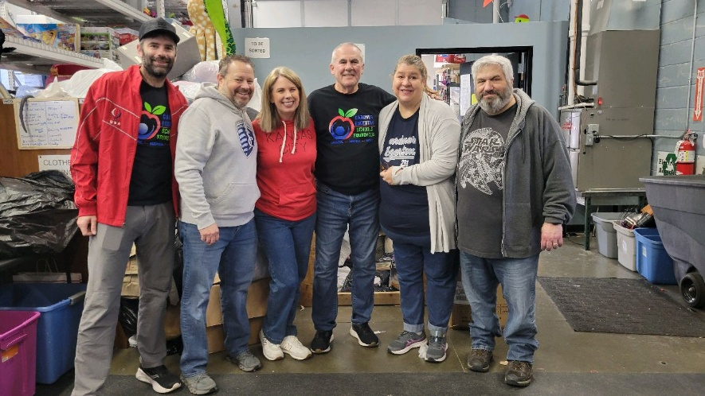
We’re all stronger together.

Nike Student Council and sponsors volunteered for us.
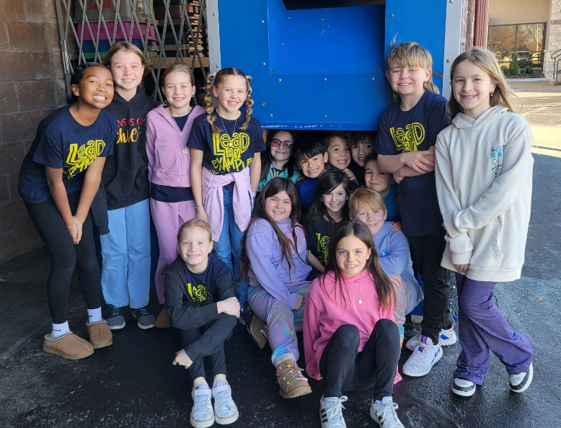
Great job! Thanks to each of you!
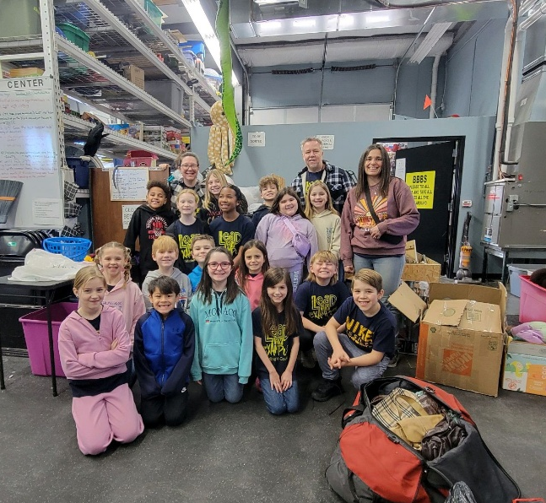
PYF - THANK YOU!
When there is a project to be done, our Youth Group comes through. Here they make a divided bin for sorting. This helps the initial sorters place soft goods on one side and other items on the other side.
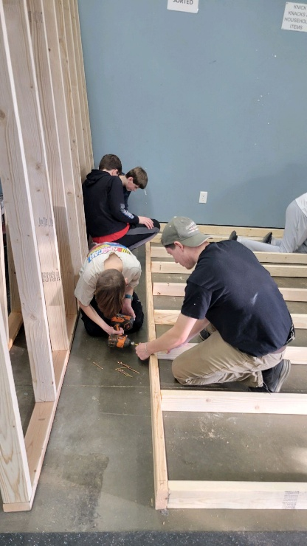
Gaining skills, learning how to work together, and providing something for a cause that helps people. That’s a win! PYF, you are so appreciated!
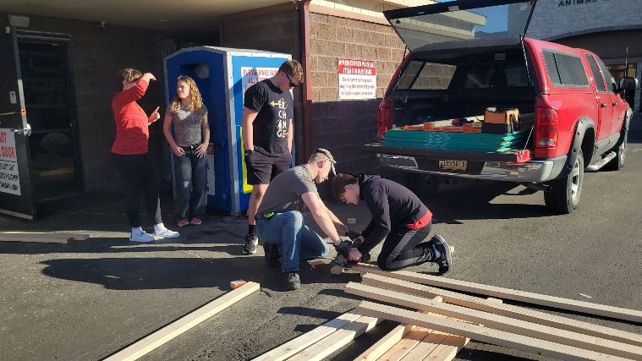

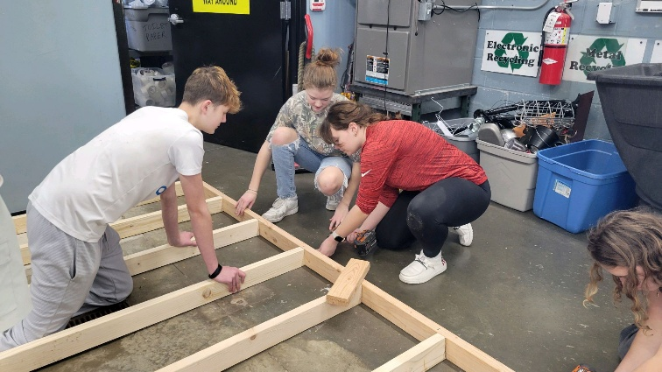
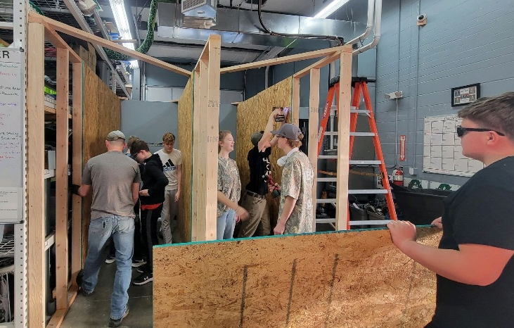
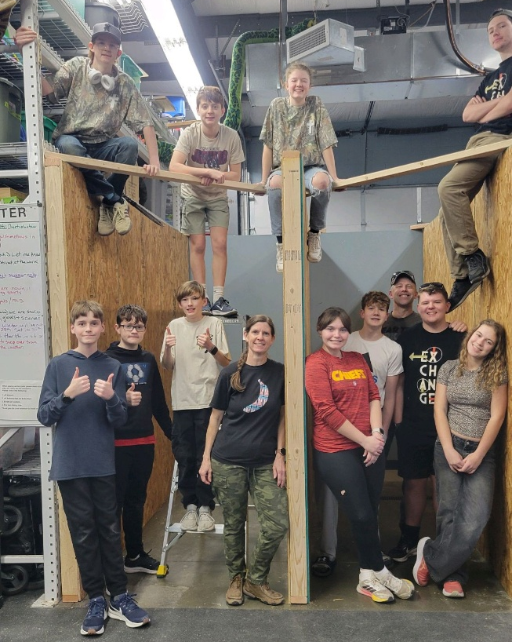

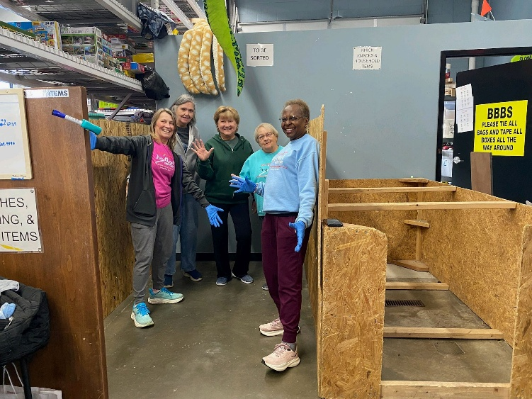
Shown here are some of our regular volunteers enjoying that rare moment… finding the
bottom of the bin!

Awesome work, ladies!
For I was hungry, and you gave me something to eat, I was thirsty, and you gave me something to drink, I was a stranger and you invited me in, I needed clothes, and you clothed me.  Matthew 25:35-36 NIV  JOY Closet Is a ministry of  First Presbyterian Church of Gardner, KS  Serving our comunity since 2013 |  | 

