Welcome

Prelude:
Let us prepare our hearts and minds for worship.

Call to Worship
Leader: Marked by a cross, cherished and forgiven,
People: We belong to God.
Leader: Called by a cross, challenged and empowered,
People: We belong to God.
Leader: Saved by a cross, reborn and filled with God’s Spirit,
People: We belong to God.

*Opening Hymn: “A Mighty Fortress Is Our God” Red Hymnal, #26

*Prayer of Confession (Unison)
Merciful God, You call us to turn away from behaviors and attitudes that belong to the darkness, to live honest and transparent lives as children of the light. We confess the times when we have failed, giving in to our darker thoughts and desires; and acting in ways that did not bring honor to Your name. Lord, in Your mercy, forgive us. Teach us how to live as children of the light. Give us hunger to know You more, so that we may do Your will and walk in Your ways, to the glory of Your name. Amen.

*Silent Reflection

*Assurance of Pardon

*Gloria Patri (Glory Be to the Father…) The Hymnal, #623

Children’s Time

Scripture Reading “Psalm 51:1-17” (page 889)
“Matthew 18:15-35” (page 1527)
Leader: The word of the Lord.
People: Thanks be to God.

Music “Power to Redeem”
Words & Music by Justin Ebach, Lauren Daigle, & Paul Mabury: Arr. by Jay Rouse
Sermon: “Cross: Repentance and Forgiveness” Rev. Kimby Young

*Profession of Faith The Apostle's Creed The Hymnal, inside back cover
I Believe in God the Father Almighty, Maker of heaven and earth, And in Jesus Christ his only Son our Lord; who was conceived by the Holy Ghost, born of the Virgin Mary, suffered under Pontius Pilate, was crucified, dead, and buried; he descended into hell; the third day he rose again from the dead; he ascended into heaven, and sitteth on the right hand of God the Father Almighty; from thence he shall come to judge the quick and the dead. I believe in the Holy Ghost; the holy catholic Church; the communion of saints; the forgiveness of sins; the resurrection of the body; and the life everlasting. Amen

*Hymn “O Sacred Head, Now Wounded” The Hymnal, #178

Offertory Meditation

*Doxology The Hymnal, #625
The Sacrament of Holy Communion
Invitation
Great Prayer and The Lord’s Prayer
Words of Institution – Breaking of Bread
Communion of the People
Prayer of Thanksgiving

*Closing Hymn: “Amazing Grace” The Hymnal, #202

*Benediction

*Postlude:
*Those who are comfortably able will please stand.

Rev. Kimby Young, Pastor; Brenda Jones, Worship Assistant
Dean Faulk, Music Ministries; Chancel Choir
Harlan Plunkett; Organist; Robyn Forkner, Pianist
Mike McGuire and Brad Cornell, Slide Production; Kim Liu, Sound

Childcare is always available in the nursery (off the hall to the west of the sanctuary). Children are welcome to stay in the sanctuary thru the whole service, or to leave at any time. Allison Perry is our primary childcare attendant.

Worship Bags for Children are available outside the north door to the sanctuary. Choose books,
crayons, pencils, Legos, stuffed toys and other items to fill your bag to use during worship.

Offering Plates are at the entrance of each aisle for your contributions to the work of the church.

Gardner Multi Service Center collection is ongoing every week and is always in need of any non-perishable food. Bring something every week or once a month.

Fair Trade Products for Sale on Sundays Coffee, tea, chocolate, nuts, olive oil, dried fruit, baking products, and a few other items are for sale each Sunday at church.

Harvesters Food Distribution is always seeking volunteers. Every 3rd Saturday at Trade Net Parking lot and every 2nd Thursday at Divine Mercy Parish. Distribution begins at 1 p.m.

Joy Closet – Our mission center thrift store provides free clothing to a variety of needs. Our church provides all volunteers on the fourth Saturday of each month.

A "Suggestion Box" is outside the office for ideas, comments, questions and thoughts. Contents will be reviewed at session meetings on the 2nd Monday of each month.

Remember, Each One, Bring One collecting food, basket in the narthex. Food goes to Hope Market Food Pantry.

YABS – Young Adult Bible Study 18-25 yrs Sundays 3p.m. Join us. Invite a friend.
Youngaddultbiblestudy47@gmail.com.

Per Capita for 2026 is $45.91 per person.

Black Out Drapes - For Lent each year we raise curtains over the stained glass windows as reminders of the deepening season. As a Lenten discipline we are called to awareness of light and darkness in the world as we seek God's presence in our daily lives, and as we look forward in hope to the celebration of the resurrection of Jesus Christ.

Women’s Fellowship Group March 4, 10:00 a.m. in Fellowship Hall. All women welcome.

Pastor Kimby Bible Study Psalms, starting March 5, Thursday’s 10-11:30 a.m.

Sunday, March 8, 2026 - Daylight Saving Time Starts – clocks turn forward 1 hour.

Sunday, March 8, 2026, Gifts of Women Sunday at 8:45 and 11:00 a.m.
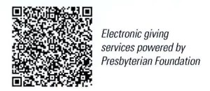
First Presbyterian Church
In the heart of Gardner since 1866 ~ Serving from the heart of God

Sunday, March 1, 2026
Second Sunday of Lent
8:45 AM

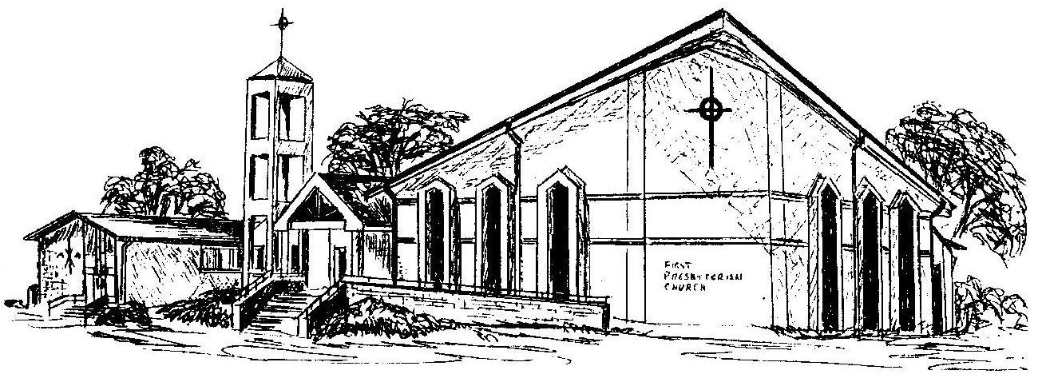

Welcome - Thank you for joining us for worship today. Please fill out a visitor information card found in the pew racks and place those in the offering plate so that we may follow up with you in the future. Your presence with us today has been a blessing to us, we hope that you have felt the presence of God and the welcome of this congregation.

