Welcome
Prelude “Baptism Hymn” by Crawford Gates, Arr. by Jon Schmidt
Let us prepare our hearts and minds for worship.

Call to Worship
Leader: In the beginning, God’s Spirit moved over the waters.
People: Even today, the Spirit of God moves through water to remind us of God’s grace.
Leader: In baptism, we are touched by God’s Spirit, enfolded in a community of grace, and empowered to go forth sharing God’s love in the world.
People: Let us celebrate God’s grace, remembering our baptisms and accepting our call to serve God in Jesus Christ our Lord.

*Opening Hymn: “Amazing Grace” Red Hymnal, #202

*Prayer of Confession (Unison) (adapted from Stephen Fearing, Wild and Precious Life.)
God of our baptismal waters, You sent John the Baptist to point to Your Son, and You sent Your Son who pointed always to You. But too often, we point only to ourselves or our own concerns. Forgive us, Lord, for pointing in all the wrong directions. Hold our gaze on your baptismal promise sealed in the life, death, and resurrection of your Son. Through the power of your Spirit, give us the courage to speak what we have seen and point to the One who takes away the sins of the world. In the name of your son, Jesus Christ, we pray. Amen.

* Silent Reflection

* Assurance of Pardon (from 1 John 3:1 and baptism liturgy)
Leader: God hears our prayers and responds with everlasting grace.
People: We remember God’s love and accept God’s forgiveness in Jesus Christ.
Leader: See what love God has for us that we should be called children of God.
People: We are God’s beloved and we have received new life in Christ. Thanks be to God!

* Gloria Patri (Glory Be to the Father…) Red Hymnal, #623

Children’s Time

Ordination & Installation Elder Bob McVey

Scripture “Matthew 3:13-17” (page 1499)
“Mark 1:9-11” (page 1552)
“Luke 3:21-22” (page 1594)
“John 1:29-34” (page 1647)
Leader: The word of the Lord.
People: Thanks be to God.
Music “I Then Shall Live” by Gloria Gaither

Sermon “Baptism Lessons” Rev. Kimby Young

*Hymn “There Shall Be Showers of Blessing” Red Hymnal, #289

Reaffirmation of Baptism Covenant:
Trusting in the gracious promises of God, do you renounce sin and the power of evil in your life and in the world?
Do you turn again to Jesus Christ and accept Jesus as your Lord and Savior?
Do you intend to be Christ's faithful disciple, obeying God’s Word, showing God’s love and sharing God’s grace in the world?

Pastoral Prayer & Lord’s Prayer

Offertory Meditation: “Brightest and Best”
By James Harding, Arr. by Mark Hayes

*Doxology

*Prayer of Dedication

*Closing Hymn: “I Am Thine, O Lord” Red Hymnal, #358

*Benediction

Postlude “Joyful, Joyful, We Adore Thee”
By Beethoven, Adapted by Edward Hodges
*Those who are comfortably able will please stand.

Rev. Kimby Young, Pastor; Judy Mason, Worship Assistant
Chesley Jones, Soloist; Dean Faulk, Music Ministries
Robyn Forkner, Pianist; Harlan Plunkett, Organist
Mike McGuire and Brad Cornell, Slide Production; Kim Liu, Sound

Childcare is always available in the nursery (off the hall to the west of the sanctuary). Children are welcome to stay in the sanctuary thru the whole service, or to leave at any time. Allison Perry is our primary childcare attendant.

Worship Bags for Children are available outside the north door to the sanctuary. Choose books,
crayons, pencils, Legos, stuffed toys and other items to fill your bag to use during worship.

Offering Plates are at the entrance of each aisle for your contributions to the work of the church.

Gardner Multi Service Center collection is ongoing every week and is always in need of any non-perishable food. Bring something every week or once a month.

Fair Trade Products for Sale on Sundays Coffee, tea, chocolate, nuts, olive oil, dried fruit, baking products, and a few other items are for sale each Sunday at church.

Harvesters Food Distribution is always seeking volunteers. Every 3rd Saturday at Trade Net Parking lot and every 2nd Thursday at Divine Mercy Parish. Distribution begins at 1 p.m.

Joy Closet – Our mission center thrift store provides free clothing to a variety of needs. Our church provides all volunteers on the fourth Saturday of each month.

A "Suggestion Box" is outside the office for ideas, comments, questions and thoughts. Contents will be reviewed at session meetings on the 2nd Monday of each month.

Remember, Each One, Bring One collecting food, basket in the narthex. Food goes to Hope Market Food Pantry.

YABS – Young Adult Bible Study 18-25 yrs Sundays 3p.m. Join us. Invite a friend. Youngaddultbiblestudy47@gmail.com.

Men’s Breakfast on Tuesday, January 13, 2026, at Perkins 7:00 a.m.

Annual Congregation Meeting, Sunday, January 25, 2026, at 9:45 a.m.

Per Capita for 2026 is $45.91 per person.

Souper Bowl of Caring Collection on Super Bowl Sunday February 8. Bring non-perishable food items and loose change for our Noisy offering for the multiservice food pantry.

Women’s Bible Study is scheduled to begin on February 12th - March 26th at 6:30 p.m. Poppy Zurcher and Maureen Allinder will be teaching the study from “The Well - Watered Woman” by Gretchen Shaffler. Please sign up in the Narthex and plan to join us! Poppy has preordered the books for our study and will have them available to sell ($15.99 each) on Sunday’s.
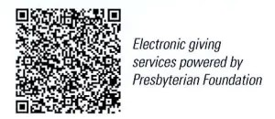

First Presbyterian Church
In the heart of Gardner since 1866 ~ Serving from the heart of God

Sunday, January 11, 2026
Baptism of the Lord Sunday
8:45 AM

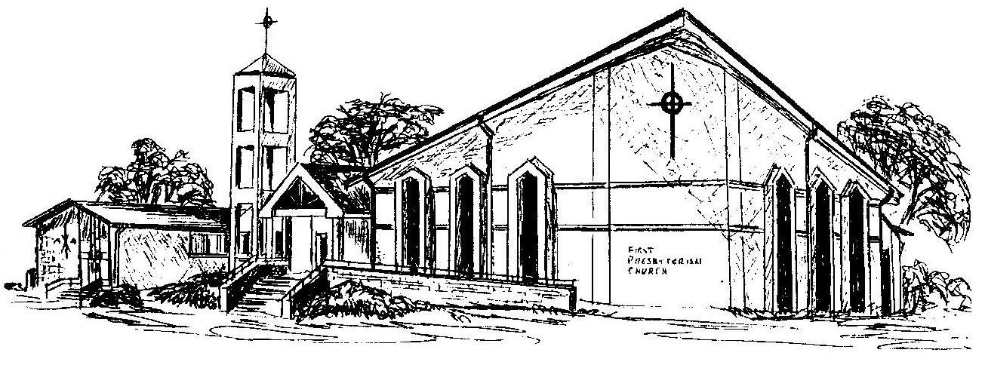

Welcome - Thank you for joining us for worship today. Please fill out a visitor information card found in the pew racks and place those in the offering plate so that we may follow up with you in the future. Your presence with us today has been a blessing to us, we hope that you have felt the presence of God and the welcome of this congregation.

