First Presbyterian Newsletter February 2026

The Cross – by Kimby Young
Some of you know that I collect crosses. Some of you have seen those crosses. Some of you have given me crosses. Each is a treasure. Each is unique. Each says something about who God is and how Christ loves. The crosses bring back memories of the time received or the person giving. They are more than decorations. They are meaningful reminders of the gift of God in Jesus Christ our Savior.
As I approach retirement, I have been downsizing. I have more than 100 crosses and will have no where to display them. Packing them into boxes seemed wrong. I decided that I will start giving them away. That way these gifts can be reminders to others of God’s faithfulness and God’s call to serve in the world. I hope that none of you who have given me crosses feel bad about this. I hope you will see it as sharing the call and message of Jesus Christ.
I decided that during Lent I will preach about the meaning of the cross and will display all of my crosses. At the end of Lent, you will be invited to take a cross or even more than one cross that will be meaningful for you. “Take up your cross and follow Jesus.” If you have given me a cross and would like to have it back, please claim it early by putting your name by that cross on the display. At the end of March and for Holy week you will be invited to choose and take a cross home to use or display. I hope that these crosses will be as great a blessing to you as they have been and will continue to be to me.
In worship during Lent, we will be talking about the cross and the meaning of the cross in worship. Please join us for worship at any of our services.

Worship Schedule
February 1 – Jeremiah 29:4-12; Romans 8:24-28 – Future with Hope
February 8 – Guest Preacher – Kristen Austew
February 15 – Transfiguration Sunday – Exodus 24:12-18; 2 King 2:9-11; Luke 9:28-35.
February 18 – Ash Wednesday Worship – Psalm 51
February 22 – First Sunday of Lent – Begin sermon series on the meaning of the Cross.

Lenten Sermon Series on the Meaning of the Cross
February 22 - Cross: Identity and Belonging - Genesis 12:1-3; Isaiah 43:1-3a; Luke 9:18-27
March 1 - Cross: Repentance and Forgiveness - Psalm 51; Matthew 18:15-35
March 8 - Cross: Suffering and Compassion - Matthew 9:35-38, 27:27-31; Romans 5:1-11
March 15 - Cross: Commitment and Mission - Luke 9:57-62; Matthew 16:13-26; John 19:16-19
March 22 - Cross: End and Beginning - Mark 15:20-39; Revelation 1:8

Vacation for Pastor Kimby
Kimby will take a week of vacation from February 1-8. Guest preacher for the week February 8 will be Kristin Austew who is a chaplain at St. Luke’s on the Plaza. Kristin has preached for us once before. Kristin is a Presbyterian minister ordained in 2014, married, mother and gifted in many ways. Be sure to come and welcome Kristin to worship.

Monthly Financial Report
At the end of December 2025 our records indicate:
total income this month is $ 34,973.63
total expenses this month is $ 39,533.98
We ended the year with $6003.70 income over expenses. Session returned $3000 to the building fund and disbursed $3000 to Presbytery local mission.
The session and finance/operations pillar thank each of you for your contributions to the church – financial or any other contribution. A complete line-by-line expense report is available upon request. We will close finances for January after February 2.
Souper Bowl of Caring Collection on Super Bowl Sunday – Tackle Hunger
Sunday, February 8
We will join millions of people from all across the nation in support of this fundraiser to end hunger. Started by a Presbyterian youth group in 1990, Souper Bowl of Caring has since grown all over the world, collecting more than $100 million donated back into their own communities. “Souper Bowl of Caring” works to mobilize those looking to fight hunger and poverty around the time of the Super Bowl football game. Bring non-perishable food items on or before Sunday, February 8. You may also make a financial contribution designated to "Souper Bowl of Caring." We will have soup pots ready to collect money on Sunday, February 8. Bring your loose change, noisy offering to add. Food Donations will be divided between the Johnson County Multi-Service Center of Gardner and the Joy Closet parking lot outdoor free food pantry. Money will go to the Multi-Service Center. Let’s defeat hunger!!

Noisy Offering – February 8
Our loose change offering for this quarter will fall on Super Bowl Sunday, February 8 and will be given to the Souper Bowl of Caring. This offering which is collected by our children and youth during worship is a fun way to “Make a Joyful Noise to the Lord” and to remember that little gifts add up when shared together. Each noisy offering is designated for a specific cause, usually something that benefits children and youth in our community and world. This month’s offering is for Souper Bowl Sunday – Tackle Hunger. Remember to bring your coins to worship on Sunday, February 8 and help us “make a joyful noise.”

ASH WEDNESDAY – February 18 - Two Options
Drive through prayer and sacrament – 5:30-6:30 p.m.
Worship in the Sanctuary – 7:00-8:00 pm.
Imposition of Ashes and Communion
Come, and invite a friend!
In addition to worship in the sanctuary with music, scripture, prayer and meditation, we will offer communion and imposition of ashes to participants in cars in the parking lot for those not able to come in for worship. Join us as we begin this season of reflection and spiritual growth.

KC Gospel Big Band Concert on February 22 at 6: 00 p.m.
We have been given the opportunity to host the KC Gospel Big Band for a worship concert at the beginning of Lent on February 22 at 6:00 p.m. in the sanctuary. The concert is free and open to the public. Bring a friend. Invite a neighbor or coworker. There will be a freewill offering if you care to contribute. We invite members of other churches and other people in the community who love good music. It’s a wonderful way to celebrate our faith and enjoy good fellowship. Join us on Sunday evening, February 22 at 6:00 p.m. in the sanctuary.

Lent Devotion Books
Devotion books will be available in the narthex for adults, children and families. Help yourself to a resource and follow along reading and praying during the season of 40 days plus Sundays.

One Great Hour of Sharing
One Great Hour of Sharing is an ecumenical Christian offering that makes the love of Christ real for individuals and communities around the world who suffer the effects of disaster, conflict, or severe economic hardship, and for those who serve them through gifts of money and time. Today, projects are underway in more than 100 countries. One Great Hour of Sharing funds make possible disaster relief, refugee assistance, development aid and more. One Great Hour of Sharing Projects are intended to empower, provide water, supply food, and give relief from disasters. A gift to One Great Hour of Sharing enables the church to share God’s love with our neighbors-in-need around the world by providing relief to those affected by natural disasters, provide food to the hungry, and helping to empower the poor and oppressed. “Fish” Bank Boxes and Calendars are available to children, youth, families or adults for collection of coins throughout the season. Some people choose to collect coins at meal time in thanksgiving for all of our blessings and in an effort to combat world hunger. At First Presbyterian Church of Gardner, we will be receiving the One Great Hour of Sharing Offering throughout Lent and will present our gifts in worship on Easter Sunday.

Traveling Day Camp - June 15-19, 2026
Register Now!
Registration has just opened for Traveling Day Camp 2026.
Be sure to get your children and grandchildren, neighbors and friends registered. We have limited enrollment through our contract with Heartland Camp and Conference center. We always fill up long before summer.
Students are eligible if they have completed kindergarten through 6th grade. Youth and adult volunteers are welcome. Contact Robin Tropansky or Marsha Cooper to volunteer or for more information.
To register go to Heartland Camp - TDC. Find the Gardner camp and click thru to register:
https://www.heartlandcamps.org/fpc-gardner

Weather Cancellation Policy
Usually, we try to worship if possible. We may modify worship or cancel Sunday school. Even if we don’t cancel. Be smart. Be cautious. Don't take any chances. Even if a church event is not cancelled, if you do not feel comfortable getting out, you are excused. If you have a duty, we will find someone to cover for you.
Generally, midweek if school is cancelled, events are cancelled. But discretion is given to event leaders to cancel if needed. Check with the event leader to be sure.
Check emails, Facebook or the website (www.fpcgardner.church) for announcements about cancellation. Also check KMBC-TV notices.
Call Kimby 913-481-7076, or Connie 913-244-8185.

Ushers for February 2026 8:45 a.m. Service
Tina Fraser, Lynn Moldrup, Kelly Johnson, Bob Bergene
Prayer Request the family of Jerry Lane, Ron Carroll, Barbara Sweetwood, the family Leigh Sullivan and Lori Fraser family of Karen McHenry, Ron Anderson, Ronnie is the daughter of Robin Gilmore, Judah family, Phil Lenehan, family of Char Bergene, Junior Wilson, Kyndra Locke, Jerry Beach, Brian Erwin, Dave Sinclair, Paula Waters, Lois Barber, Harlan Plunkett, Nancy Falkner, Mark Perry, Juanita Murrow, Joyce Pattrick, Nick McSwane, Karen Elliott, Brenda Jones, Sue Hendeson, family of Ron Krehbiel, Martha Samuels, San Juanita Leal, Amy Foster, Karen & Rex Roney, Campbell Moldrup, Alice Christensen, Lin Swartz’s Uncle Tom, Ronnie DuChene, Robert Mashbum, Susan Gash, Susan Wilson-Dierksen, Abe Portenier, Rhonda Krehbiel, Sharon Frahme, LeMoyne Zimmerman, Jon Deiley, Amanda Allen, Dozer Reed.
Presbyterian Women’s Bible Study will begin Thursday, February12th - March 26th, each Thursday for 7 sessions. They will be meeting at 6:30 pm in the Fellowship Hall. Poppy Zurcher and Maureen Allinder will be teaching the study from “The Well Watered Woman” by Gretchen Shaffler. All Ladies are welcome!

Presbyterian Women’s Fellowship Group meets the first Wednesday of every month at 10:00 am in the fellowship hall (excluding December, January and February). Our first meeting of the calendar year is scheduled for March 4th. Terri Winegar has volunteered to lead the devotions and Vera Beach has volunteered to provide refreshments. This group is open to all women and we would welcome your participation.

Men’s Breakfast on Tuesday, February 10 at 7:00 a.m. at Perkins. It is an opportunity to get to know one another and build a stronger community of Faith.

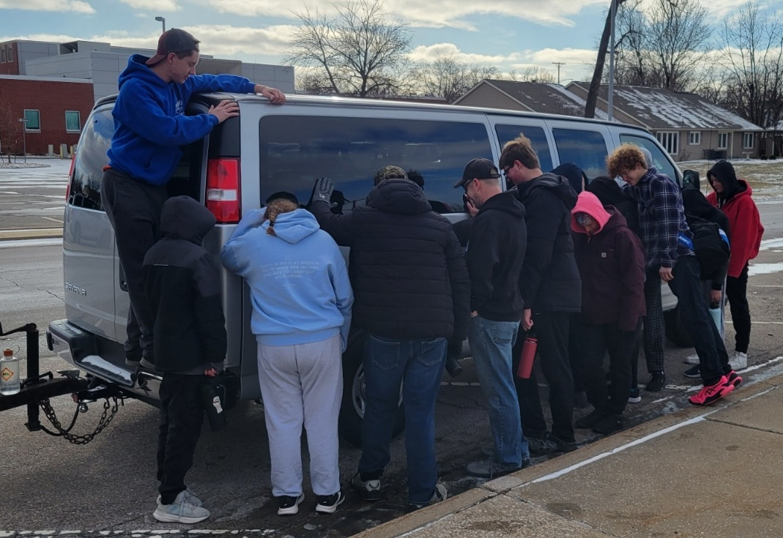
Church Van
Session approved and Joy Closet purchased a 15 passenger van for use by the church. Policies are being written for any church group to request use of the van. Dave and Cindy Rollf are managing the calendar and thprocess. They will also attend to maintenance and upkeep. The van is currently being parked at Joy Closet because the outdoor security is better there with lighting and cameras. PYF inaugurated the van on its first trip with their winter retreat to Heartland Center Camp on January 17-19. Groups can check out the van to use for trips. We hope the van will be used by youth groups and the young adult group for mission trips, and by many other groups for many other trips for years to come.
Annual Congregational Meeting - Rescheduled for Sunday, February 1 at 9:45a.m.
Since we had a snow day and did not have a quorum of members present, the session has rescheduled the annual congregational meeting for this Sunday, February 1 at 9:45a.m. at the end of the first worship service. The purpose of the meeting is to receive our annual reports from staff, committees, groups and pillars, to approve an action item from our associate pastor nominating committee to dissolve the committee, and to approve the annual terms of call for pastor Kimby Young for 2026. The report papers are available to pick up in the office and will be available at the meeting. They were sent out by email. They are posted on our website and can be accessed on the link above.

Store Hours
MONDAY 10 – 7
TUESDAY 10 – 7
WEDNESDAY 10 – 4
THURSDAY 10 – 7
SATURDAY 10 – 2

2026  February   | Thank you to our great volunteers!  Extra thanks for the people who bring donations in and sorters who worked so hard to go through the tremendous amound of donations the past month. Please know that you are very much appreciated!

Volunteers needed:
Please come and join this great group. We still need help in most of our sections - from clothing to toys! You’ll find an area that suits you!
Come and talk to Cindy, Ginger, Cathy, or Margaret! We look forward to welcoming you!


Our Formal Dress Giveaway has been rescheduled Feb. 20th and 21st!
There are so many dresses, plus shoes and jewelry. Pass the word along to your friends.
Cleaning out your closets?
This is a great time to donate gently used clothing for spring and summer! This includes shoes and jackets. We like to be prepared and we very much appreciate your donations!


For I was hungry, and you gave me something to eat, I was thirsty, and you gave me something to drink, I was a stranger and you invited me in, I needed clothes, and you clothed me.

Matthew 25:35-36 NIV

JOY Closet Is a ministry of

First Presbyterian Church of Gardner, KS

Serving our comunity since 2013

