Welcome

Prelude:
Let us prepare our hearts and minds for worship.

Call to Worship
Leader: People of God, rejoice! The Light of the World has come!
People: The light shines in the darkness, and the darkness has not overcome it.
Leader: People of God, give thanks!
We have received this Light of life and are called to share that light in the world.
People: Arise, Shine, Our Light has come!

*Opening Hymn: “We Three Kings” Red Hymnal #166 verses 1 & 5

*Prayer of Confession (Unison_
God of light and darkness, we have seen the glimmer of your star-light beckoning to us, but we have turned away and followed other paths. We have heard the wisdom of prophets and sages, but we have ignored their call. We have experienced the glorious grace of our Savior, but we have neglected to tell the good news. Forgive us. Enlighten us again. Empower us to dream. Inspire us to live the love of Jesus and to be witnesses to your love in the world that all may see your glory and come to worship you. Amen.

*Silent Reflection

*Assurance of Pardon

*Gloria Patri (Glory Be to the Father…) The Hymnal, #623

Children’s Time

Scripture Reading “Isaiah 60:1-6” (page 1156)
“Matthew 2:1-12” (page 1497)
“Matthew 5:14-16” (page 1501)
“John 8:12” (page 1662)
Leader: The word of the Lord.
People: Thanks be to God.

Sermon: “Seeking the Light - Epiphany” Rev. Kimby Young

*Profession of Faith The Apostle's Creed The Hymnal, inside back cover
I Believe in God the Father Almighty, Maker of heaven and earth, And in Jesus Christ his only Son our Lord; who was conceived by the Holy Ghost, born of the Virgin Mary, suffered under Pontius Pilate, was crucified, dead, and buried; he descended into hell; the third day he rose again from the dead; he ascended into heaven, and sitteth on the right hand of God the Father Almighty; from thence he shall come to judge the quick and the dead. I believe in the Holy Ghost; the holy catholic Church; the communion of saints; the forgiveness of sins; the resurrection of the body; and the life everlasting. Amen

*Hymn “As With Gladness Men of Old” The Hymnal, #163

Offertory Meditation

*Doxology The Hymnal, #625
The Sacrament of Holy Communion
Invitation
Great Prayer and The Lord’s Prayer
Words of Institution – Breaking of Bread
Communion of the People
Prayer of Thanksgiving

*Closing Hymn: “O Word of God Incarnate” The Hymnal, #269

*Benediction

*Postlude:
*Those who are comfortably able will please stand.

Rev. Kimby Young, Pastor; Larry Schick, Worship Assistant
Dean Faulk, Music Ministries; Harlan Plunkett; Organist; Robyn Forkner, Pianist
Mike McGuire and Brad Cornell, Slide Production; Kim Liu, Sound

Childcare is always available in the nursery (off the hall to the west of the sanctuary). Children are welcome to stay in the sanctuary thru the whole service, or to leave at any time. Allison Perry is our primary childcare attendant.

Worship Bags for Children are available outside the north door to the sanctuary. Choose books,
crayons, pencils, Legos, stuffed toys and other items to fill your bag to use during worship.

Offering Plates are at the entrance of each aisle for your contributions to the work of the church.

Gardner Multi Service Center collection is ongoing every week and is always in need of any non-perishable food. Bring something every week or once a month.

Fair Trade Products for Sale on Sundays Coffee, tea, chocolate, nuts, olive oil, dried fruit, baking products, and a few other items are for sale each Sunday at church.

Harvesters Food Distribution is always seeking volunteers. Every 3rd Saturday at Trade Net Parking lot and every 2nd Thursday at Divine Mercy Parish. Distribution begins at 1 p.m.

Joy Closet – Our mission center thrift store provides free clothing to a variety of needs. Our church provides all volunteers on the fourth Saturday of each month.

A "Suggestion Box" is outside the office for ideas, comments, questions and thoughts. Contents will be reviewed at session meetings on the 2nd Monday of each month.

Remember, Each One, Bring One collecting food, basket in the narthex. Food goes to Hope Market Food Pantry.

YABS – Young Adult Bible Study 18-25 yrs Sundays 3p.m. Join us. Invite a friend.
Youngaddultbiblestudy47@gmail.com.

Annual Congregation Meeting, Sunday, January 25, 2026, at 9:45 a.m.

Per Capita for 2026 is $45.91 per person.

Souper Bowl of Caring Collection on Super Bowl Sunday February 8. Bring non-perishable food items and loose change for our Noisy offering for the multiservice food pantry.

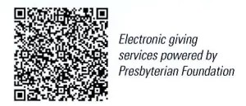

First Presbyterian Church
In the heart of Gardner since 1866 ~ Serving from the heart of God

Sunday, January 4, 2026
Epiphany Sunday
8:45 AM

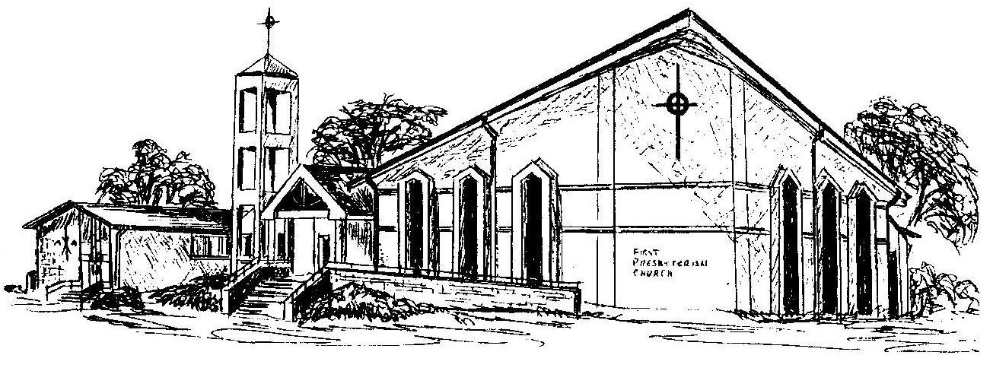

Welcome - Thank you for joining us for worship today. Please fill out a visitor information card found in the pew racks and place those in the offering plate so that we may follow up with you in the future. Your presence with us today has been a blessing to us, we hope that you have felt the presence of God and the welcome of this congregation.

