Welcome

Prelude:
Let us prepare our hearts and minds for worship.

Call to Worship and Lighting of the Advent Wreath -
Leader: Jesus said, “I am the Light of the World, whoever follows me will not walk in darkness, but will have the light of life.”
People: As we light the first candle again in our Advent wreath, we remember the prophet’s hope based on God’s promise: To send a Messiah who would bring peace and love to the world.
Leader: As we light the second candle, we remember the peace of Christ that calms our fears and inspires us to reach out to others,
People: The light reminds us that Christ has come to set our hearts on fire. Get up and make ready, for Jesus Christ comes.
Leader: Let us prepare for the coming of the Lord.
People: Let us praise Jesus Christ, Light of the World!

*Opening Hymn: “O Come, O Come, Emmanuel” Red Hymnal #123

*Prayer of Confession (Unison_
Prince of Peace, Light in our darkness, help us to hear your message and answer your call. We know your promises come in many ways, yet we look for the familiar, the material, the comforting and the certain. Inspire us to listen and to look beyond the obvious, that we might see your glory and receive your grace, through Jesus Christ who loves us beyond our understanding. Amen.

*Silent Reflection

*Assurance of Pardon

*Gloria Patri (Glory Be to the Father…) The Hymnal, #623

Children’s Time

Ordination & Installation Elders and Deacons
Elders: Bob McVey, Patricia Pacey, Tony Waites, Devon Mason, Vera Beach
Deacons: Holly Applegarth, Connie Neneman, Joe Neneman, Alice Rollf, Merle Schick

Scripture Reading “Isaiah 40:1-11” (page 1119)
“Mark 1:1-8” (page 1551)
Leader: The word of the Lord.
People: Thanks be to God.

Music:

Sermon: “Prepare!” Rev. Kimby Young

*Profession of Faith The Apostle's Creed The Hymnal, inside back cover
I Believe in God the Father Almighty, Maker of heaven and earth, And in Jesus Christ his only Son our Lord; who was conceived by the Holy Ghost, born of the Virgin Mary, suffered under Pontius Pilate, was crucified, dead, and buried; he descended into hell; the third day he rose again from the dead; he ascended into heaven, and sitteth on the right hand of God the Father Almighty; from thence he shall come to judge the quick and the dead. I believe in the Holy Ghost; the holy catholic Church; the communion of saints; the forgiveness of sins; the resurrection of the body; and the life everlasting. Amen

*Hymn “It Came Upon the Midnight Clear” The Hymnal, #128

Offertory Meditation

*Doxology The Hymnal, #625
The Sacrament of Holy Communion
Invitation
Great Prayer and The Lord’s Prayer
Words of Institution – Breaking of Bread
Communion of the People
Prayer of Thanksgiving

*Closing Hymn: “Angels We Have Heard on High” The Hymnal, #132

*Benediction

Postlude:
*Those who are comfortably able will please stand.
Rev. Kimby Young, Pastor; Judy Mason, Worship Assistant; Chancel Choir
Dean Faulk, Music Ministries; Harlan Plunkett; Organist; Robyn Forkner, Pianist
Mike McGuire and Brad Cornell, Slide Production; Kim Liu, Sound
Childcare is always available in the nursery (off the hall to the west of the sanctuary). Children are welcome to stay in the sanctuary thru the whole service, or to leave at any time. Allison Perry is our primary childcare attendant.

Worship Bags for Children are available outside the north door to the sanctuary. Choose books,
crayons, pencils, Legos, stuffed toys and other items to fill your bag to use during worship.

Offering Plates are at the entrance of each aisle for your contributions to the work of the church.

Gardner Multi Service Center collection is ongoing every week and is always in need of any non-perishable food. Bring something every week or once a month.

Fair Trade Products for Sale on Sundays Coffee, tea, chocolate, nuts, olive oil, dried fruit, baking products, and a few other items are for sale each Sunday at church.

Harvesters Food Distribution is always seeking volunteers. Every 3rd Saturday at Trade Net Parking lot and every 2nd Thursday at Divine Mercy Parish. Distribution begins at 1 p.m.

Joy Closet – Our mission center thrift store provides free clothing to a variety of needs. Our church provides all volunteers on the fourth Saturday of each month.

A "Suggestion Box" is outside the office for ideas, comments, questions and thoughts. Contents will be reviewed at session meetings on the 2nd Monday of each month.

Remember, Each One, Bring One collecting food, basket in the narthex. Food goes to Hope Market Food Pantry.

YABS – Young Adult Bible Study 18-25 yrs Sundays 3p.m. Join us. Invite a friend.
Youngaddultbiblestudy47@gmail.com.

Pictorial Directory Nalleli Rollf will take pictures after church services today and December 21.

Men’s Breakfast Tuesday, December 9th, Perkins, at 7 a.m.

One Worship Service at 10:00 a.m. December 14, December 21 and December 28.

Potluck brunch, Sunday, December 14, 11:00 a.m. after the Cantata.

Christmas Caroling, Sunday, Dec. 21, 4:00–6:00 p.m. Hot chocolate in Fellowship Hall.

Christmas Eve Service, Wed. Dec. 24 at 4:30 p.m. Communion & Candlelight Worship.
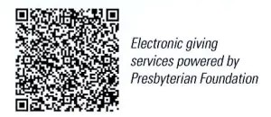

First Presbyterian Church
In the heart of Gardner since 1866 ~ Serving from the heart of God

Sunday, December 7th, 2025
Second Sunday of Advent
8:45 AM

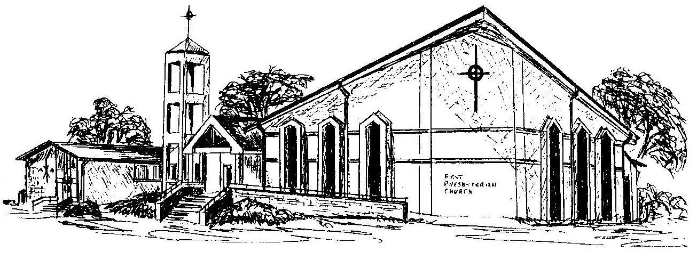

Welcome - Thank you for joining us for worship today. Please fill out a visitor information card found in the pew racks and place those in the offering plate so that we may follow up with you in the future. Your presence with us today has been a blessing to us, we hope that you have felt the presence of God and the welcome of this congregation.

