Welcome

Prelude:
Let us prepare our hearts and minds for worship.

Leader: Have you heard the glorious news?
People: Jesus Christ is born! Emmanuel, God is with us!
Leader: Indeed, wonder of wonders, the Word became flesh and has come to dwell among us.
People: And we have seen Christ’s glory, full of grace and truth!
Leader: Glory to God in the highest,
People: And on Earth peace among all whom God favors!

*Opening Hymn: “Good Christian Men, Rejoice” Red Hymnal #151

*Prayer for the day (Unison) (from Bread for the Journey by Ruth Duck)
Amazing God, you have confounded the wisdom of the world by coming to us in the form of a human baby, frail and vulnerable. Help us to comprehend the great love with which you open yourself to our world, that we in turn may risk to open ourselves in love toward all your children, and that we may find the source of our lives in Jesus Christ and the folly of the cross. Amen.

*Gloria Patri (Glory Be to the Father…) Red Hymnal, #623

Children’s Time

*Hymn “Angels, from the Realms of Glory” Red Hymnal, #131
Scripture Reading “Luke 2:19-40” (page 1591)
Leader: The word of the Lord.
People: Thanks be to God.

Praise Band “Mary Did You Know?”
By Buddy Greene & Mark Lowry

Sermon: “Pondering” Rev. Kimby Young

*Hymn “What Child is This?” The Hymnal, #137

Pastoral Prayer & Lord’s Prayer
Pray your prayers aloud when invited.
Close your prayer with “Lord, in your mercy.”
The Congregation will respond to each: “Hear Our Prayers.”

Offertory Meditation:

*Doxology The Hymnal, #625

*Prayer of Dedication

*Closing Hymn: “Go, Tell It On the Mountain” The Hymnal, #138

*Benediction

Postlude:
*Those who are comfortably able will please stand.

Rev. Kimby Young, Pastor; Bob Bergene, Worship Assistant
Dean Faulk, Music Ministries; Harlan Plunkett; Organist; Robyn Forkner, Pianist
Mike McGuire and Brad Cornell, Slide Production; Kim Liu, Sound
Praise Band; Mick Dean, Tom Dean, Paul Chedda, Doug Judah, Dean Faulk
Praise Vocals; Nancy Falkner, Bea Judah, Jason Hopper
Oliver Schwab, Jenny Waites, Ella Falkner

Childcare is always available in the nursery (off the hall to the west of the sanctuary). Children are welcome to stay in the sanctuary thru the whole service, or to leave at any time. Allison Perry is our primary childcare attendant.

Worship Bags for Children are available outside the north door to the sanctuary. Choose books,
crayons, pencils, Legos, stuffed toys and other items to fill your bag to use during worship.

Offering Plates are at the entrance of each aisle for your contributions to the work of the church.

Gardner Multi Service Center collection is ongoing every week and is always in need of any non-perishable food. Bring something every week or once a month.

Fair Trade Products for Sale on Sundays Coffee, tea, chocolate, nuts, olive oil, dried fruit, baking products, and a few other items are for sale each Sunday at church.

Harvesters Food Distribution is always seeking volunteers. Every 3rd Saturday at Trade Net Parking lot and every 2nd Thursday at Divine Mercy Parish. Distribution begins at 1 p.m.

Joy Closet – Our mission center thrift store provides free clothing to a variety of needs. Our church provides all volunteers on the fourth Saturday of each month.

A "Suggestion Box" is outside the office for ideas, comments, questions and thoughts. Contents will be reviewed at session meetings on the 2nd Monday of each month.

Remember, Each One, Bring One collecting food, basket in the narthex. Food goes to Hope Market Food Pantry.

YABS – Young Adult Bible Study 18-25 yrs Sundays 3p.m. Join us. Invite a friend.
Youngaddultbiblestudy47@gmail.com.

If you want to make a donation that is recorded for 2025, it must be in by Sun., December 28.

Church Office hours:
Office Closed:
January 1, 2, 2026

Emergency - If you need Pastor Kimby when the church office is closed, call on her cell phone 913-481-7076. Leave a message for call back.



First Presbyterian Church
In the heart of Gardner since 1866 ~ Serving from the heart of God

Sunday, December 28th, 2025
10:00 AM

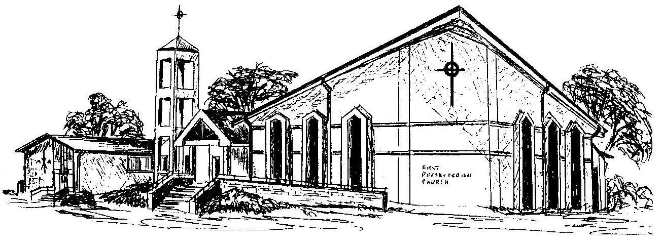

Welcome - Thank you for joining us for worship today. Please fill out a visitor information card found in the pew racks and place those in the offering plate so that we may follow up with you in the future. Your presence with us today has been a blessing to us, we hope that you have felt the presence of God and the welcome of this congregation.

